AP Problems

FR 1-Qual/Quan

A ring shaped space-station, far away from any other mass, is spinning on about its central axis.

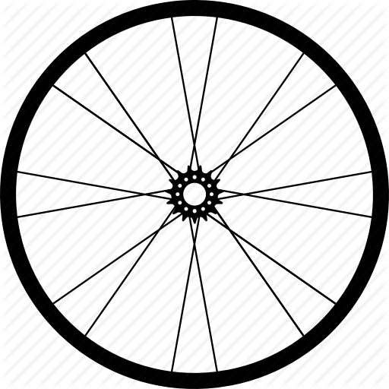

- If the station is 10 km in diameter, what tangential velocity will emulate earth’s gravity?

Justify your answer.

- If a physics student travelled from the ring to the central hub, will the space station rotate:
  - Faster
  - Slower
  - The Same

- A biology student with poor physics understanding, is 5m from the hub and releases a tennis ball. Describe the motion of the ball.

