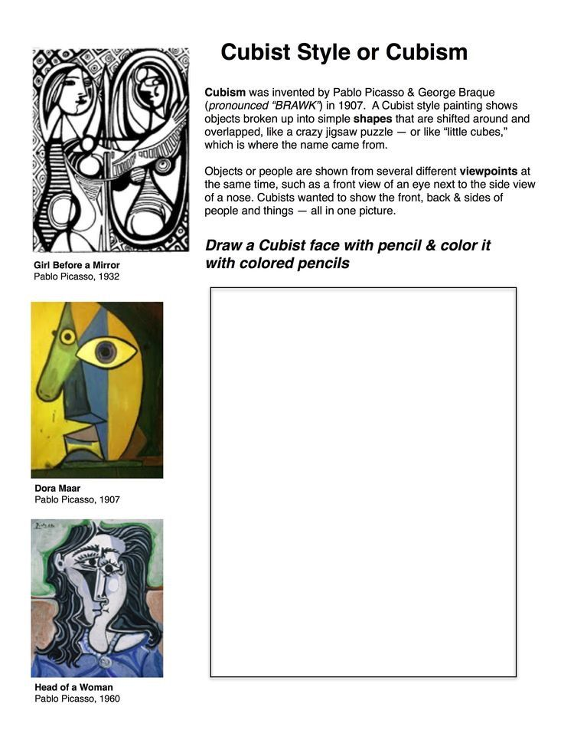
Art I, II, & III: Packet Days 22-31
Packet Day 22

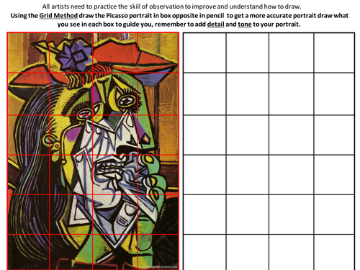
Packet Day 23

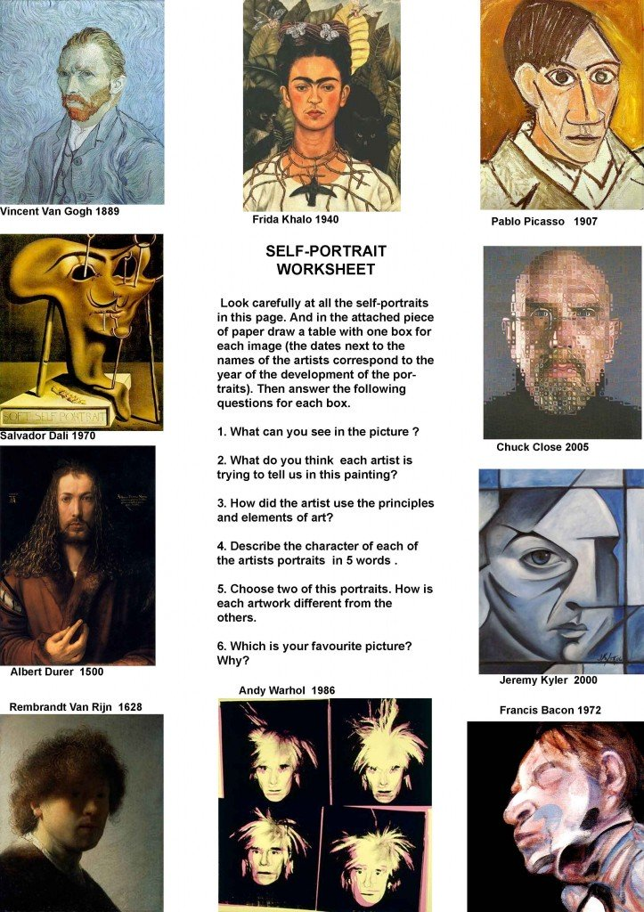
Packet Day 24
Packet Day 24 Continued… Answer the questions above in the boxes below that correspond with the artists and their self-portraits. The First 3 I have started for you….
Van Gogh 1889  1.  2.  3.  4.  5.  6. | Frida Khalo 1940  1.  2.  3.  4.  5.  6. | Pablo Picasso 1907  1.  2.  3.  4.  5.  6.
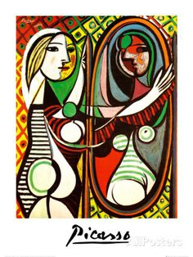
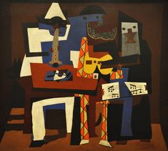
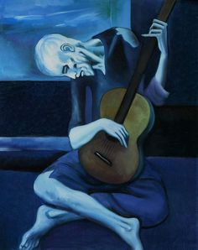
Packet Day 25- Read & Draw an image below for Packet 26
Pablo Picasso (1881-1973)
Picasso is one of the most famous artists from the 20th century. He showed a lot of talent at an early age, and by 19 years old he had moved from Spain to Paris to find success as an artist.
Picasso went through many styles as an artist. He started as a painter, making scenes that were somewhat realistic. However, by the end of his career, though, he had helped develop many new styles of art, including collage and cubism. When asked what his goals were as an artist, Picasso said, “ It took me four years to be able to paint like Raphael, and a lifetime to paint like a child.”
Picasso’s very early work is often called his “Blue Period.” He painted realistic looking scenes of people, usually seeming hurt, by only used shades of blue an green. This gave them a very sad appearance.
Cubism was a new form of painting that Picasso helped invent with a few other artists. In cubist paintings, a person or object is drawn, but the canvas is divided into a grid of many small squares. In each square a different perspective of the subject is painted. The end result is supposed to show the subject from an many views as possible, all in one painting.
Collage, a popular form of art that is still used today, was made popular by Picasso as well. Picasso would take scraps of wood, sheet music and other found things, and assemble them into a single piece of art. It was a new idea at the time, and it gave paintings more texture than they had ever had before. Henri Matisse was an arist that also gave way to a form of collage that inspired many as well.
Throughout all of Picasso’s caree, through all his different styles, he was also an illustrator. He would produce drawings, sometimes for books, that used fast-drawn lines that were then brushed with ink. These illustrations were very simple, and often only used very few times, but a person could always tell just what Picasso wanted to show. In all of his many styles, he was always trying to find a way to show the world how he saw things in his imagination.
Packet 25- Create Your Own Picasso Face and ADD Music! Finish it with colored pencils/ markers/ regular pencils!
Try making your own collage drawing or collage of paper & drawing on top just like Picasso! Add an illustrated version of music that you like to add a touch of your personality. Show images in all angles!
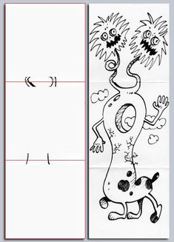
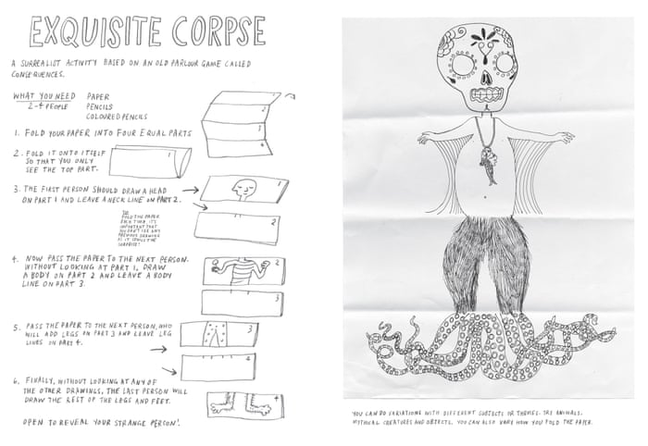
Packet 26 – Drawing the Exquisite Corpse
Today Draw the Top Part of your exquisite corpse!- Choose something different each day to draw!
TOP!

Packet Day 27- Draw Two Middle Parts
Top Middle:
Bottom Middle:

Packet Day 28: Draw Bottom Part of you Exquisite Corpse!
Bottom:

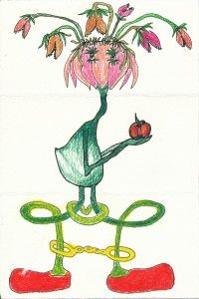
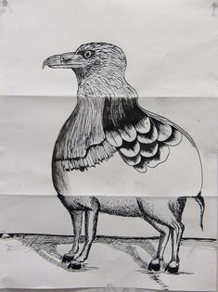
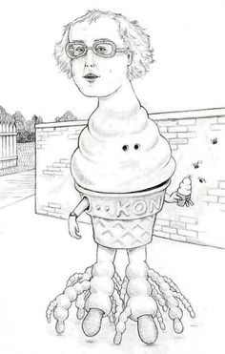
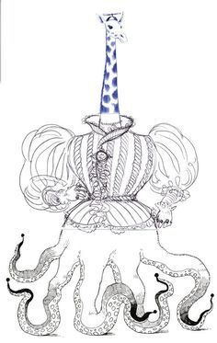
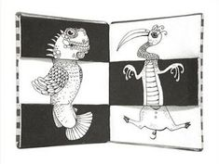
Now- Cut your drawings out, follow the rectangular boarder and tap/put your body parts together to see what you end up with!!! Some Examples Below to help your inspirations!
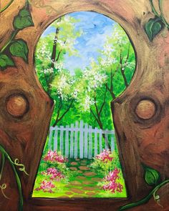
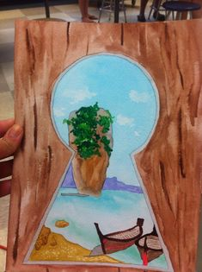
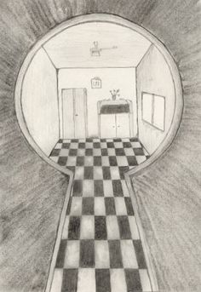
Packet Day 29 & 30 Key Whole Drawing
Below or on a separate piece of paper create an interesting key whole drawing, painting,etc

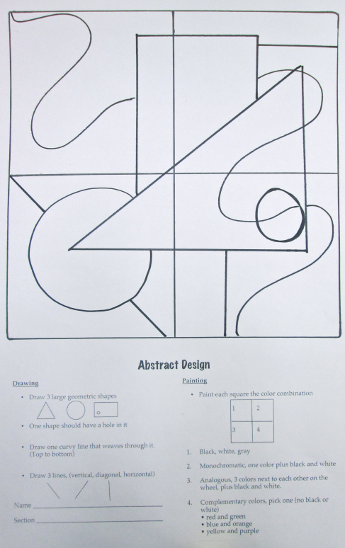
Packet Day 31 – Follow Instruction on the bottom and use the template finish the design!

