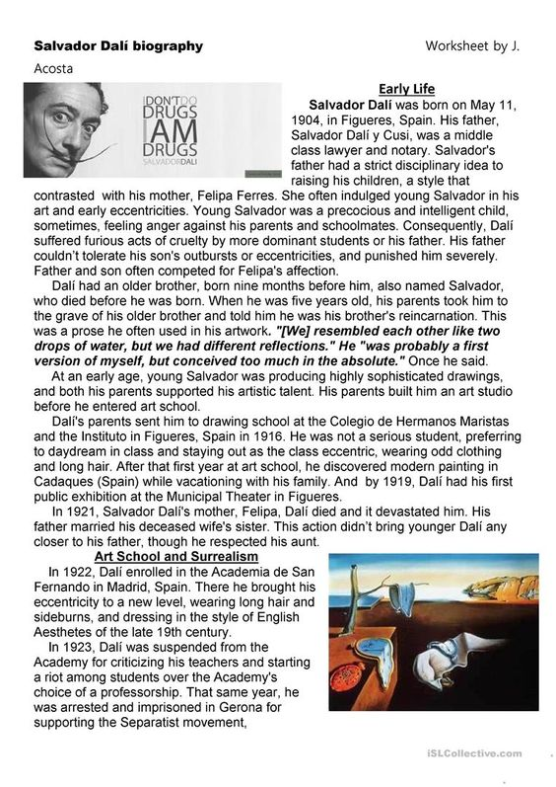
Art I, II, & III: Packet Days: 17-21
Day 17 & 18: Art I,II, & III: Read about Surrealism and the major artists behind the movement! Use the reading to help you answer the questions below.
Please also utilize: Art Scholastics; https://art.scholastic.com/issues/2019-20/120119.html
USE PASSWORK: EHSART
You will have access to all videos & resources!!!!!

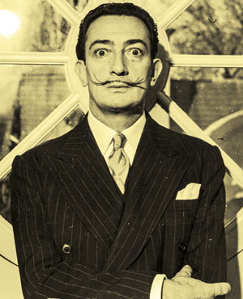
Journey Into Surrealism
How does Salvador Dalí explore the weird, troubling world of the mind?
DECEMBER 2019
Salvador Dalí: Hulton Archive/Getty Images.
Salvador Dalí

On a spring day in London in 1936, a man stands before a crowd. He wears an underwater divers helmet and wildly flails his arms. The crowd assumes it’s all part of his bizarre act, but soon someone realizes he can’t breathe. Quickly, people rescue him.
Salvador Dalí (SAL-vuh-dawr dah-LEE) wore the helmet during his performance as a symbol to show that his art developed from the “bottom of the sea of subconsciousness,” or the part the mind people are unaware of. Such dark, strange ideas were at the heart of Surrealism.
Surrealism emerged in 1920s and ’30s between the world wars. It began with a group of writers who were interested in dreams, the subconscious, and how the mind interprets reality. Soon artists started exploring Surrealism too. It was unlike anything anyone had ever seen.
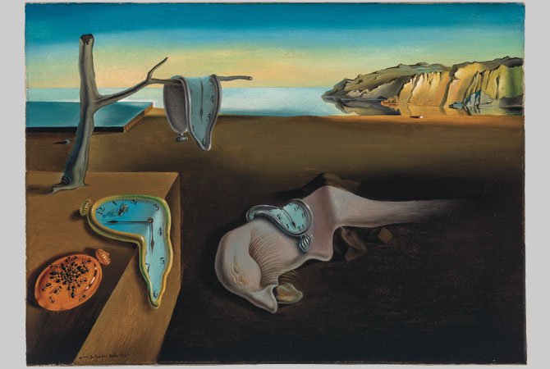
Salvador Dalí, The Persistence of Memory, 1931. Oil on canvas, 9.5x13in. (24.1x33cm). Given anonymously. Salvador Dalí, Gaia-Salvador Dalí Foundation/Artists Rights Society (ARS), New York.
How does Dalí contrast reality and dreams in this painting?

Living in a Dream
Born in 1904, Dalí spent his summers on Spain’s northeast coast. He attended art school in Madrid and became an excellent draftsman. In the late 1920s, Dalí met other Surrealist poets, writers, and painters. He became obsessed with dreams and slept with a canvas next to his bed so he could record his dreams as soon as he woke up.
In 1931, Dalí completed The Persistence of Memory, above. The artist works in a highly realistic style, yet the painting’s eerie subjects—melting clocks, swarming ants, and a distorted face that many believe is a self-portrait—contrast that realism. Today, experts believe that the landscape in the background is based on the coastal region where Dalí spent much of his youth.
In the early 1950s, Dalí revisited this dreamscape in his The Disintegration of the Persistence of Memory, cover. Geometric forms float across the fractured scene, and parts of the composition appear to be underwater. How do these details contribute to the dreamlike world Dalí creates?
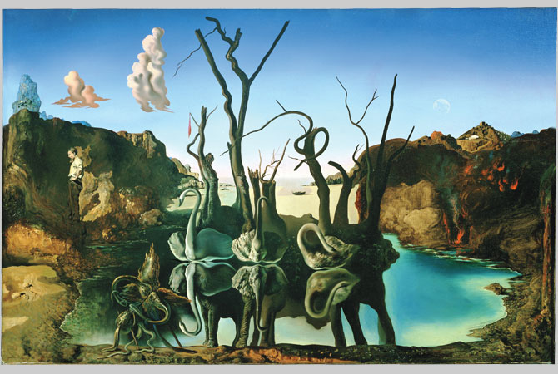
Salvador Dalí, Swans Reflecting Elephants, 1937. Oil on canvas, 20x30in. (51x77cm). Coll. Cavalieri Holding, Geneva, Switzerland. Erich Lessing/Art Resource, NY.
Why is illusion an important part of the composition above?

Master of Illusion
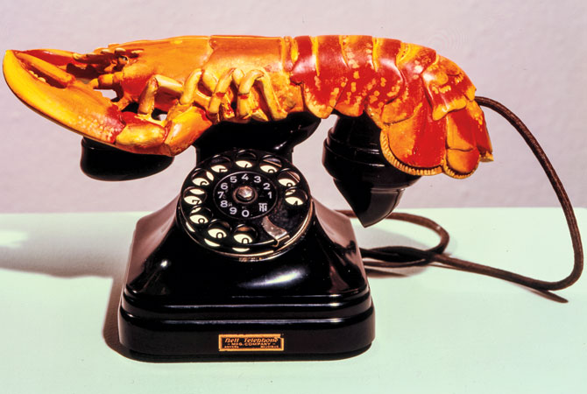
Dalí’s 1937 Swans Reflecting Elephants, above, includes a complex visual illusion. Swans float on a still blue lake as a tangle of menacing trees loom behind them. The reflection seamlessly transforms into a group of elephants. The swans’ necks and wings form the elephants’ trunks and ears, and the trees become their legs. By introducing brainteasers like this and by using other unsettling visual techniques, Dalí invites the viewer to look twice and ask questions. Is there a relationship between swans and elephants?

Salvador Dalí, Lobster Telephone, 1936. Plastic, painted plaster, and mixed media, 7x13in. (17.8x33cm). Tate Gallery, London, Great Britain, Tate, London/Art Resource, NY.
What does Dalí accomplish by juxtaposing a lobster and a telephone?

Exploring the Unexpected
Surrealist art isn’t limited to painting. In fact, Dalí experimented with drawing, printmaking, sculpture, fashion, film, and advertising.Lobster Telephone, below, features two seemingly unrelated objects juxtaposed, or paired together, to create an unexpected arrangement. This 1936 sculptural object had personal meaning for Dalí, who claimed to have strong emotional associations with both telephones and lobsters. In his strange manner, he once said: “I do not understand why, when I ask for a grilled lobster in a restaurant, I am never served a cooked telephone.”
How does Dalí invite viewers to make connections between unrelated objects in each of the works shown here? How does this relate to the subconscious?
SALVADOR DALÍ’S WEIRD, WACKY WORLD
- Dalí once brought his pet ocelot (a spotted wildcat) to a restaurant in New York City. When people complained, the artist claimed that the ocelot was just a house cat that he had “painted over.”
- The artist was afraid of trains, crossing streets, insects, and buying new shoes.
- In 1941, Dalí hosted a Surrealist ball. To decorate, he used large quantities of strange items, including: 2,000 pine trees, 2 tons of old newspapers, 24 animal heads, 24 store window mannequins, 2 truckloads of vegetables and fruit, 12,000 shoes, and some wild animals (one of which he insisted must be a tiger cub).
- Dalí once exclaimed, “The only difference between a madman and myself is that I am not mad.”
Answer these questions from the reading from above. Please answer in FULL sentences & complete thoughts! *******Remember this is for packet days 17-18*********
1) How does Salvador Dalí explore the weird, troubling world of the mind?
__________________________________________________________________________________________________________________________________________
2) How does Dalí contrast reality and dreams in this painting?
__________________________________________________________________________________________________________________________________________________________________________
3) Why is illusion an important part of the composition above?
____________________________________________________________________________________________________________________________________________________
4) What does Dalí accomplish by juxtaposing a lobster and a telephone?
____________________________________________________________________________________________________________________________________________________
5) What is Juxtapose mean and how did surrealism artist use this to create Surrealism art?
____________________________________________________________________________________________________________________________________________________
6)How does Dalí invite viewers to make connections between unrelated objects in each of the works shown here? How does this relate to the subconscious?
_______________________________________________________________________________________________________________________________________________________________________________________________________________

7) In Salvador Dali’s Biography, When was he born? Who was Dali’s father? Where Dali and his father close or not?
______________________________________________________________________________________________________________________________________________________________________________________________________________________________

8) Where did Dali go to drawing school? Where was Dali’s first art exhibition held?
____________________________________________________________________________________________________________________________________________________
9) In 1922, what school did Dali enroll into? What got Dali into trouble at this school & what was his consequence?
____________________________________________________________________________________________________________________________________________________
10) What was the prose (quote) Dali often used in his artworks that reminded him of his brother?
____________________________________________________________________________________________________________________________________________________

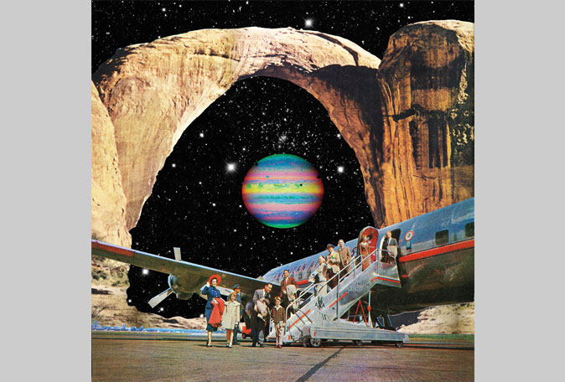
Surrealism Today: Packet Day 19: Art I,II, &III- Read & Answer ?’s.
How do these artists use elements of Surrealism to express their ideas? DECEMBER 2019
Most artistic movements occur in a particular time and place. Surrealism developed between the world wars: the 1920s & ’30s. However,artists today still integrate elements of Surrealim that feel relevant to the ideas they aim to express. Eugenia Loli (yoo-JEEN-yah LOH-lee), Inka Essenhigh (ING-kuh EHS-in-heye), and Marepe (mah-REH-peh) experiment with dreams, surprise, and unexpected juxtapositions.

Eugenia Loli (b. 1973), Destined to Destination, 2016. Digital collage, 18x18in. (46x46cm). Courtesy of the artist.
How does Loli use collage to make a familiar but strange image?

Lost in Space
Eugenia Loli was born in Greece in 1973 and now lives in California. She started out as a nurse and then became a computer programmer. She soon left the tech world because she found it cold and impersonal. Instead, Loli began making films and art.
Today the artist works in collage, using images scanned from vintage magazines and science journals to create narratives about strange yet familiar worlds. For each work, Loli begins with what she calls a base image and then builds a new scene around it. In the 2016collage Destined to Destination, above, passengers disembark from an aircraft onto a tarmac in outer space. The desolate, foreign landscape contrasts with the retro-looking plane and relaxed travelers. A bright, unnaturally hued planet hovers in the backgr-ound. By juxtaposing these images, the artist creates a strange, absurd scene.

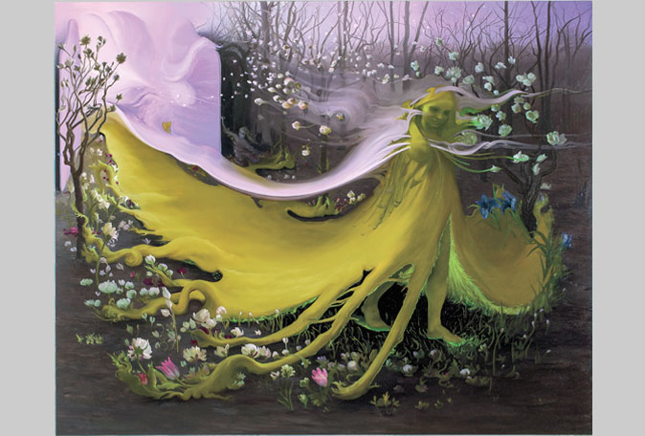
Inka Essenhigh (b. 1969), Green Goddess II, 2009. Oil on canvas, 60x72in. (152x183cm). Courtesy of the artist and Miles McEnery Gallery, New York, NY.
What elements of Surrealism does Essenhigh draw upon to create this painting?

Dream World
Inka Essenhigh, born in 1969, lives and works in New York City. She has always been interested in depicting the human figure in her art. The artist thinks of her paintings as fables or short stories featuring fantastical creatures that each convey a lesson or moral.
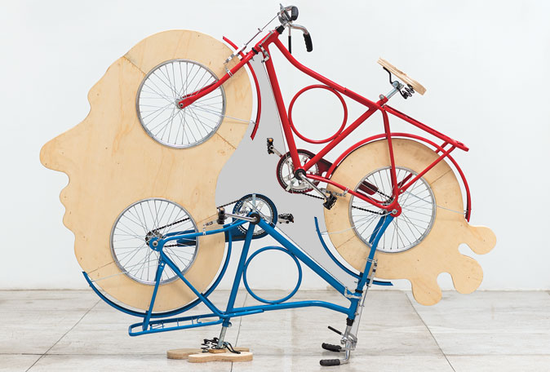
Essenhigh’s process often begins with a feeling: “I look for a mood, for something to say, then put down a brushstroke and see if it resonates,” she explains. “Then all I have to do is match that feeling.” Essenhigh painted her 2009 Green Goddess II, above, with smooth brushwork. The central figure walks across a grassy clearing in a forest, seemingly becoming one with the dreamy landscape. Her body is human-like, and her face is soft and without detail. Electric green light seems to radiate from under her feet, making her seem at once weightless and grounded as flowers drift around her.

Marepe (b. 1970), Cabeça Ciclica, 2012, Bicycles and wood, 72.5x86.125x24.75in. (184.2x218.8x62.9cm). Courtesy of the artist and Anton Kern Gallery, New York.
How does Marepe use found objects?

Brain Teaser
The Brazilian artist known as Marepe, born in 1970, creates assemblages from common found objects. He modifies each, tra-nsforming them into recognizable but useless objects. The title of his 2012 Cabeça Ciclica, above, translates to “cyclical head.” He removes the tires and seats from two bicycles and turns one of them upside down. The artist surrounds the wheels with an organic human face cut from wood.Through this whimsical arrangemet, Marepe invites viewers to see common forms in surprising new ways. Do you see the bicycles or the human profile first?
Answer these questions from the Surrealism Today Readings! Please use full sentences & thoughts!-- Packet 19
1) How do these artists use elements of Surrealism to express their ideas?
____________________________________________________________________________________________________________________________________________________________
2) How does Loli use collage to make a familiar but strange image?
__________________________________________________________________________________________________________________________________________________________________________
3) What elements of Surrealism does Essenhigh draw upon to create this painting?
__________________________________________________________________________________________________________________________________________________________________
4) How does Marepe use found objects?
__________________________________________________________________________________________________________________________________________________________________________
5) What do you think the difference is between Surrealism Today & Surrealism when artists like Dali created Surrealism? What is the difference and what is some similarities?
__________________________________________________________________________________________________________________________________________________________________________
Art I & II: Packet Day 20-21:
Sketch/write out at least 5 Ideas for Surrealism art works that you’d be interested in creating yourself. You will have two options of how you can accomplish your surrealism project!

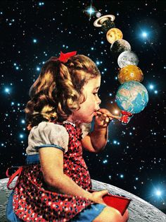
Depicting Dreams
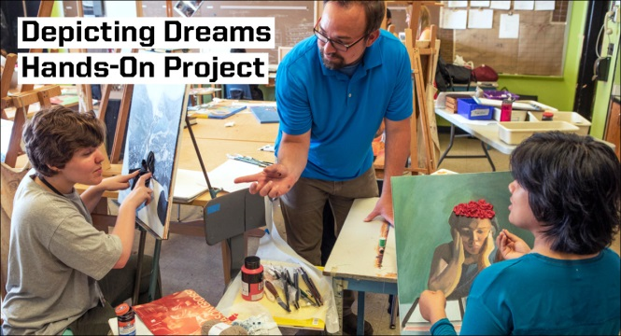

Option 1: Use what you've learned about Surrealism to create a mixed media composition using magazines, newspaper, or construction paper to make a collage of a surrealism dreamlike world. Use Juxtapose situations to help create an interesting scene just like Dali.
Option 2: Use what you have and have learned to create a drawing/painting/or colored pencil version of a surrealism dreamlike world.

Studio Project Prompt:
Develop a composition inspired by a dream you’ve had, experience you’ve had, or interesting juxtaposing images you would like to work with to intrigue different ideas/thoughts.
Parameters:
- Begin by using descriptive words to write about your dream or idea!
- Make a series of sketches illustrating what you’ve written. Allow your ideas to evolve—your sketches don’t have to resemble your dream exactly.
- Experiment with scale, space, contrast, and juxtaposition.
- Introduce mixed media
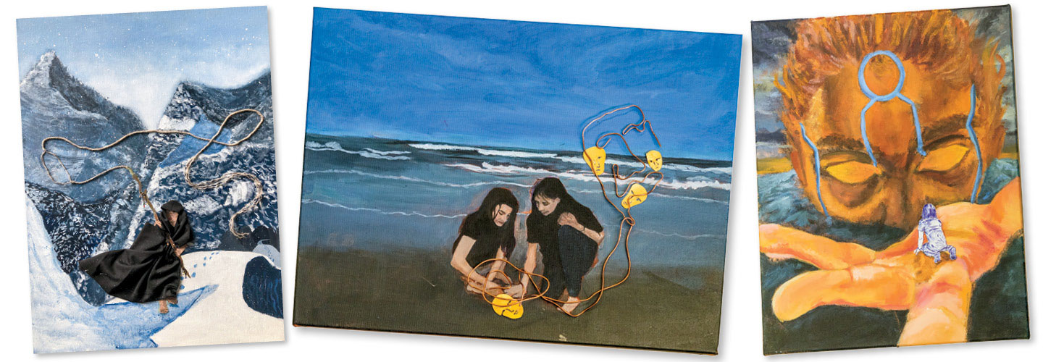
- Get weird! Dreams frequently don’t make sense—use this
as an opportunity to take creative risks.
(Below are great examples for ART III!!!)
***Everyone should Try to use the Art Scholastics Resources!!******* Password: EHSART https://art.scholastic.com/issues/2019-20/120119.html
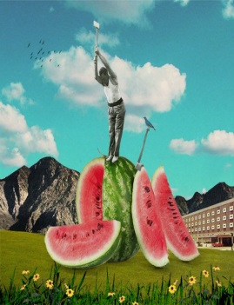
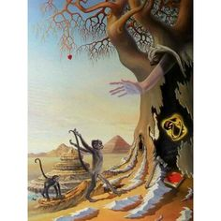
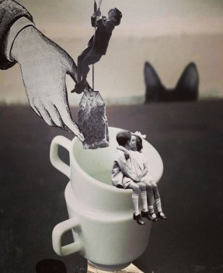
Art I & II: Procedures:
Goal: Create a surrealism collage using different magazines, newspapers, or even printed out images that you juxtapose to create different ideas like Dali. * Remember if you don’t have the means for these things you may Draw your surrealism project.
Procedure:
1) Have 5 sketches of your idea along with some written ideas of things you have brain stormed for this project.
2) Find an interesting magazines, newspapers, even print outs. You need to start by working with the background first!! Decide an image or landscape you want to work with and glue it on at least an 8x10” paper.
3) Find interesting things to cut out and glue onto your landscape or background you decided on. CUT items out exactly around the image! Do not leave areas that are not part of the shape or object on the cut out. This will ensure that your item that you have cut out looks like it belongs in your new landscape and is not from another page.
4) Art I needs at least 10 items & Art II needs 15 items cut out and put in your dream like image in order to make sure it looks surreal/dreamlike.
5) Have fun with this!! You can make up whatever you want as long as it is appropriate! Play around with ideas and make funny situations come to life! The more you can make me laugh the better.
More Examples:

Art III: Packet Day 19-21
Goal: Create a Surrealism Collage using magazines, print outs, newspapers, anything you have to use at home. You are to create a collage that is at least 5x7”- 6x10”. Your collage may be smaller than 8x10” due to you making a collage and a drawing. Then use that collage to recreate and draw a picture of that collage with pencils, colored pencils, paints, or even markers. You may use whatever you have at home that you may want to work with. Remember if you have a hard time finding these items at home, improvise and use what you have, it will not count against you!
Procedure:
1) Create a small collage of a surrealism concept that has juxtapose images to create a dreamlike world just like Dali & Eugenia Luli! Make it funny, interesting, weird, & have fun with this!
2) Remember start with a background first! Find a landscape or work background, to middle ground, to foreground with this collage it’ll make your life easier! Then find images of things you want to put in your dreamlike landscape. Make sure you cut your images out, right along the image in order for the image to look like it belongs in your landscape and is not from another page.
3) After you have finished your collage, start to draw your surrealism image out on another paper that should be at least 8x10”. Draw your image first and then when it looks as good or close to your collage then you may start to work with color or shading. You are replicating your Collage!
4) Use paint, colored pencil, pencil, or whatever you may have available to work with at your home to create an image that replicates your collage that you have created with magazines/paper.

