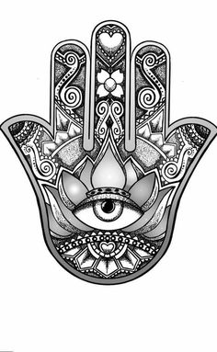
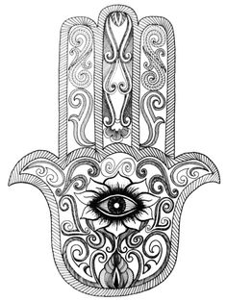
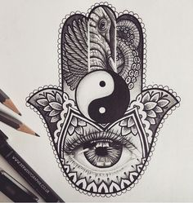
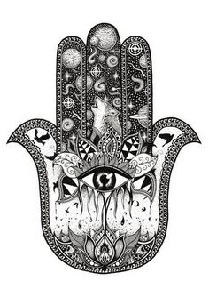
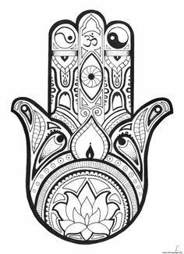
Goal: To Create a Black & White
( Positive & Negative Hamsa Hand)
Procedure:
If you still have your sketch book (Visual Journal) Great! If not, I know I collected some before you all left, so you may do this in your own sketch book or on separate pieces of paper. I felt this was perfect to get us all to relax with the times that we face right now. The Hamsa Hand will bring you luck!!

1) Research the Principle of Design: Harmony & Unity –write these definitions in your notes
2) Have at least 5 sketches of practice Hamsa Hands – Hands should be at least the size of your hands
3) Start to create your Hamsa Hand. If you need to create a paper template of how the Hamsa is shaped you can do that on a spare piece of paper. You may copy the size and shape from your computer or use you hand to help trace a very close simulation of what the Hamsa Hand shape is like. Remember size should be at least the size of your hand or bigger.
- Also Template should be folded vertically in half to help you keep the design Balanced!
- If you notice the Hamsa Hands are very symmetrical & balanced as the design on the left side of Hamsa hand mirrors the design on the Right!!! Please Make Sure You do this! Pg 2. Practice!
4) Research from Computer/Phone/ Or Next Pages that are provided what a Hamsa Hand is. The Next pages (pg.4-5) will have research for you to look through and will have questions and answers for you to do on page 5!!
Constraints: USE BLACK INK & May Watercolor the Background “IF” you have watercolors
1) Paper Size: Should be at least a 9x 12” or no bigger than a 11x14”
2) Must be FILLED with awesome positive and negative designs That Mirror each other on either side of the Hamsa Hand. Designs Like;
- Zentangle Designs
- Your own Positive/Negative Designs/
- Designs from own inspiration/ But DO NOT COPY from computer or things you look up!
This is all to be Handed IN:
- 5 Sketches of Hamsa Hands - Definitions of Harmony & Unity (Principles of Design)
- Final Hamsa Hand on Better Paper with Hamsa Hand at least size of your hand & paper 9x12 or 11x14
- Research on pg.4-5 completed with filled in complete sentences
- Practice Hamsa Hand on pg. 2 - Sketches to be done on Pg. 3
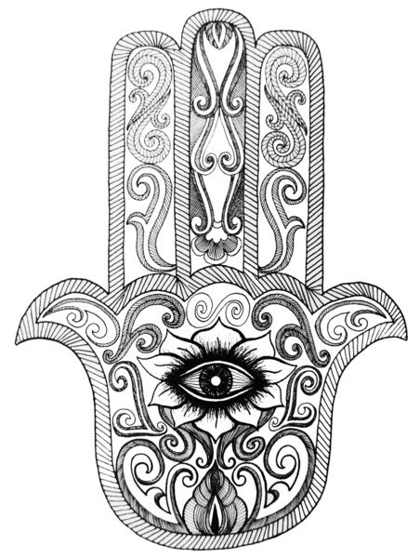
Please sketch & Finish Drawing the other half of this Hamsa Hand. Make sure to practice how to mirror the other side. If you have to fold and trace you may do that if that helps. But finial details should be added to complete the look and make it into a whole/complete Hamsa!
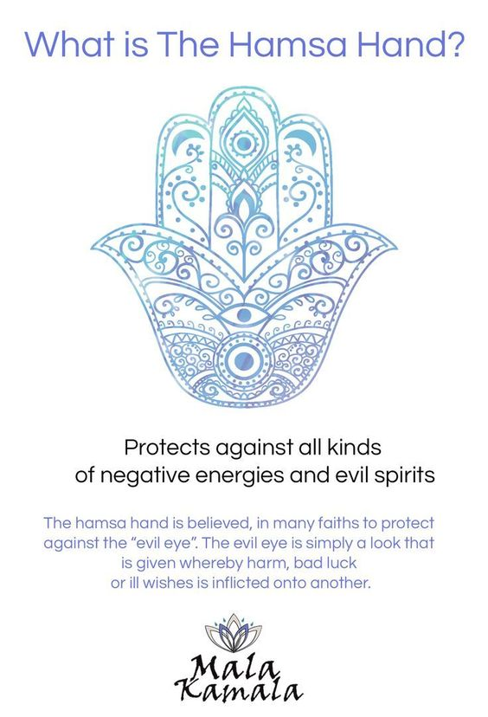
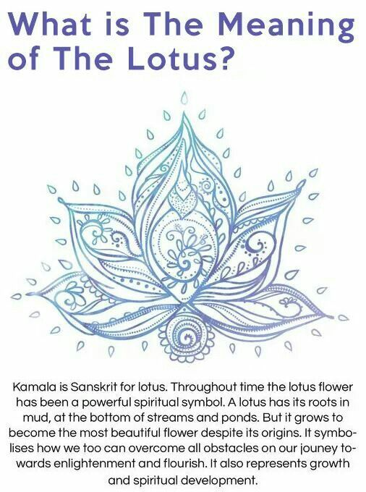
Draw/Sketch Space for Lotus Flower: Practice
Draw/ Sketch Space for Hamsa Hand: Practice

The hamsa is a hand-shaped amulet found throughout the Middle East, sometimes used for protection by Jewish and Muslim people. Hamsas are used in jewelry and wall-hangings, and also can be found on the entrances in homes or hanging in cars because of the superstition that they ward off the evil eye and protect people around them. Before making a decorative hamsa, your children can learn about this cultural object, its history and uses.
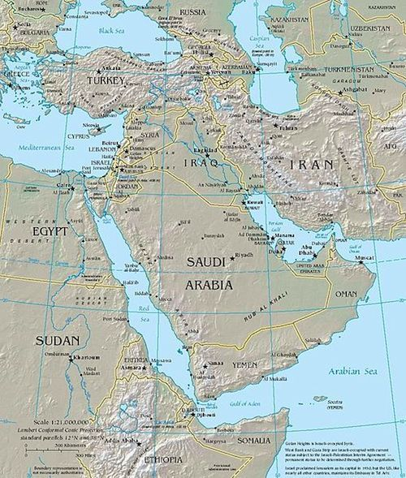
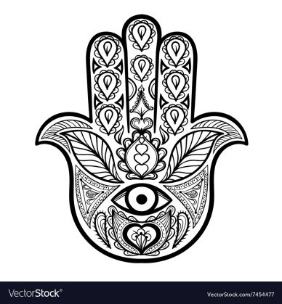
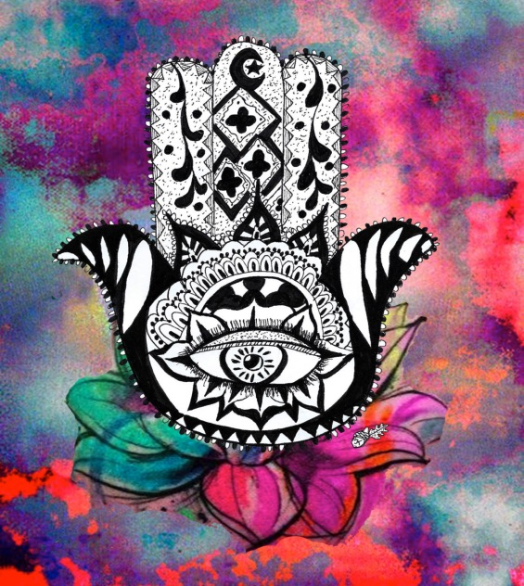
The Middle East is a group of countries in western Asia and northern Africa that is the culturally rich home to numerous ethnic groups (such as Jews, Kurds, Somalis, Arabs), and the birthplace of many religions (such as Christianity, Islam, and Judaism). The word hamsa comes from the Arabic word for the number 5, for the 5 fingers of the hand:
خمسة‎ khamsah. In Islam, the hamsa represents the hand of Fatima, Mohammed’s daughter. The five fingers also symbolize the five pillars of Islam. In Jewish tradition, the hamsa is called YAD HA’CHAMESH or the hand of Miriam, the sister of Moses. The five fingers also represent the five books of the Torah. Christians refer to the hamsa as the hand of Mary, the mother of Jesus. Thus, the open image of the right hand is a symbol of protection, blessings, and strength for the 3 major religions of the region. The light blue eye wards of evil spirits, and the silver metal it is frequently made of is believed to have magical powers. If you travel in the Middle East, or visit someone who is originally from the area, you are bound to see this symbol- and now you will understand the historical and cultural significance!
Please Answer the questions in FULL SENTENCES!!! Please FILL up the Lines that are provided!
1) What is the spiritual meaning of the Hamsa Hand? __________________________________________________________________________________________________________________________________________________________________________________________________________________________________________
2) Where did the Hamsa Hand come from and what is its importance to that culture?
________________________________________________________________________________________________________________________________________________________________________________________________________________________________________________________________________________________________________________________
3) What is the meaning of the Hamsa hand in Christianity? ____________________________________________________________________________________________________________________________________________________________
4) What is the meaning of the Hamsa Hand in Jewish Culture?
____________________________________________________________________________________________________________________________________________________________
5) What is the meaning of the Hamsa Hand in the Islam Culture?
____________________________________________________________________________________________________________________________________________________________
6) How do you think the Hamsa Hand can help in times like these as we are dealing with a large distance between our society with the COVID-19 sickness?
__________________________________________________________________________________________________________________________________________________________________________________________________________________________________________
SUGGESTIONS:
DAY 6: Do Harmony/Unity Definitions & 5 Sketches
Day 7: Sketch other Half of pg.2 Hamsa Hand & 2 Sketches of Hamsa & lotus on pg. 3
Day 8: Read Article on pg. 4 & Answer Questions on pg. 5
Day 9&10 : Create your final product of your Hamsa Hand in Pen/Ink/Sharpie/Black INK on white paper that is 9x12” or 11x14”
