**Art II & III** : Draw these on another paper or in you Visual Journal If you have it. You may also print these out if you can, if that helps. Please use good shading techniques and use this to practice proportions as well as still life and some observational drawing. These can be in colored pencils or regular drawing pencils. If you have any questions please contact me on livegrades!

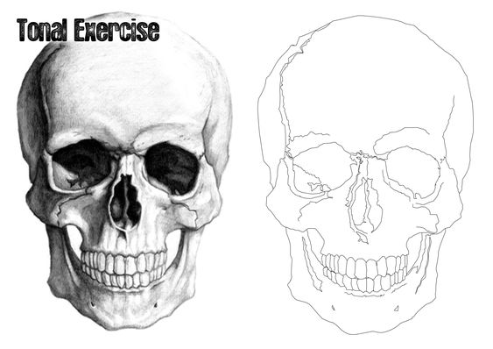

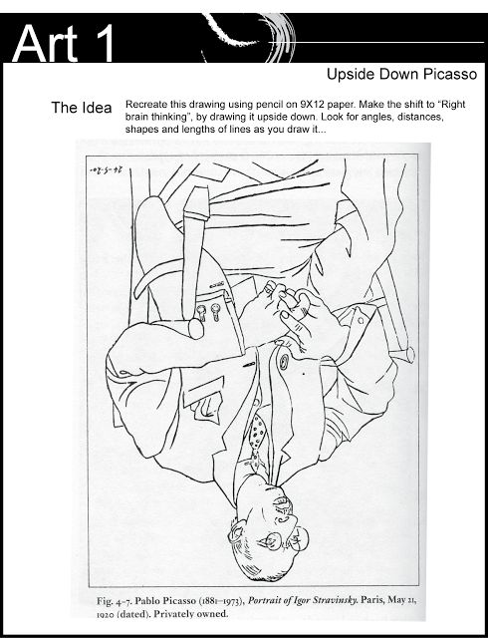

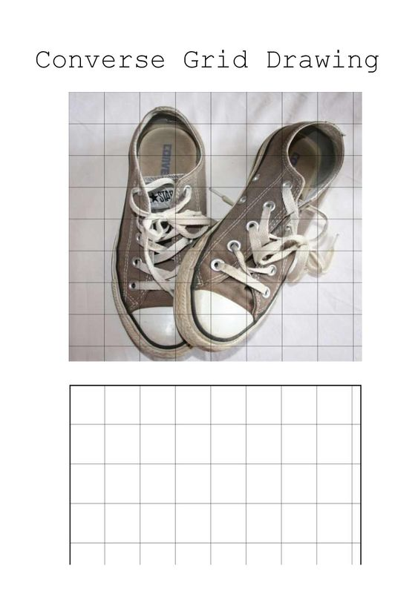

**Day 3:**  
You may use this as a guide to help you draw a pair of shoes. If you do NOT need the grid or would like to do a different pair of shoes of your choice you may!

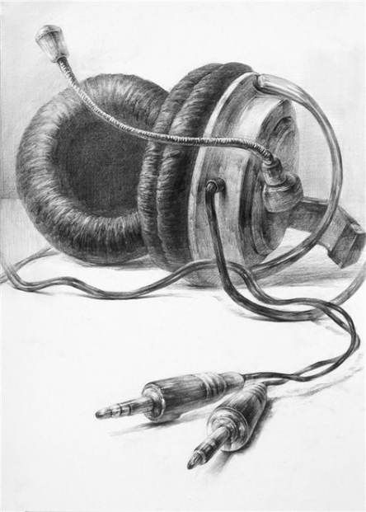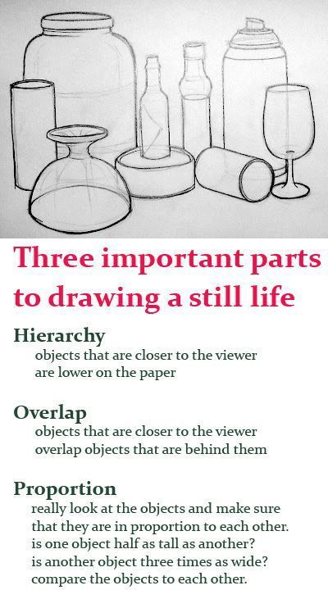

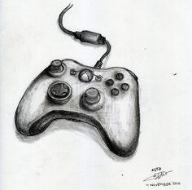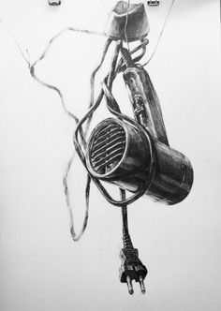

**Day 4:** Draw a still life object with anything that has a CORD! Use the cord, just like you did with your positive & negative paintings that you were working on before we left. Shade the object in accurately and if you would like to use colored pencils or pencil that is up to you. Find something interesting and put it on a 8x12 paper and fill up that paper to the best of your ability. If you have your visual journal you may also put it in there.

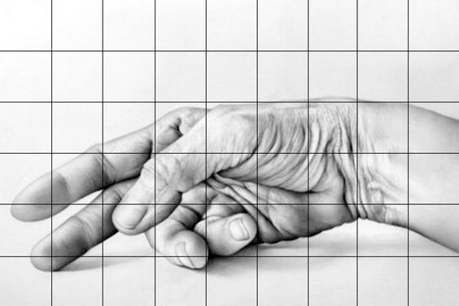

Create a Grid if you need it! If you don’t need a grid great! Day 5: Exercise is drawing a hand accurately, shading it in with pencil or colored pencil, and if you can study your own hand to help. You may study your own hand in different positions. However, make sure to shade all the folds and capture the curves and structure of your hand and fingers.