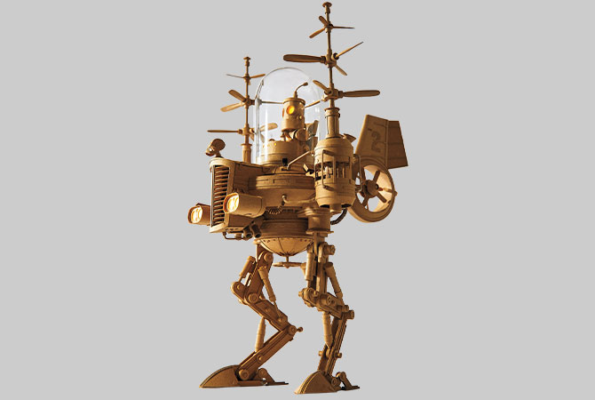
Ceramic Packet 17-21:
Packet Day 17:
Read and Answer a Question;

Use your Scholastics Resource!! It’s Free-
Password: EHSART
https://art.scholastic.com/issues/2019-20/050120.html
'Board 'Bots
MAY / JUNE 2020

Greg Olijnyk (b. 1959), #2, 2018. Cardboard, glass dome, LED lighting, electric motors for propellers. 11x7x7in. (28x18x18cm). Courtesy of Greg Olijnyk.
How does Olijnyk explore materials in his work?
When graphic designer Greg Olijnyk (OH-lay nik) finishes his workday, he continues creating—with cardboard! Inspired by science fiction and engineering, Olijnyk constructs intricate robotsculptures, above, using cardboard, tracing paper, and glue. This one has working joints, and some of his robots are kinetic, equipped with small motors and solar panels to make certain parts come to life.
Olijnyk chose cardboard as a medium because it’s an easily accessible—and easy-to-shape— material. “Each piece has the limitations and advantages of the cardboard material in mind,” the artist says. “How it bends, how strong it will be, etc.” Often he’ll build his robots to appear in mid-action sailing a ship, swinging on rope, flying a helicopter, and more. He adds details,such as eyes, using LED lights and glass accessories. Olijnyk juxtaposes an ordinary material with complex engineering design skills to make sculptures that are at once familiar and surprising.
1) How does Olijnyk explore materials in his work?
____________________________________________________________________________________________________________________________________________________
2) How did you create something like this during packets 11-16?
__________________________________________________________________________________________________________________________________________________________________________
3) Think of how you could create your own cardboard bot, or just cardboard sculpture? What would you think would be interesting to make out of cardboard if you had too?
__________________________________________________________________________________________________________________________________________________________________________
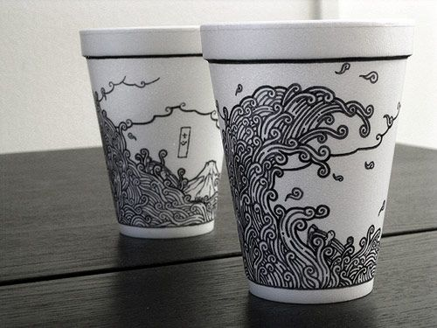
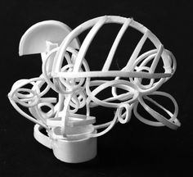
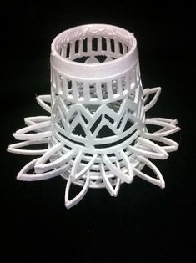
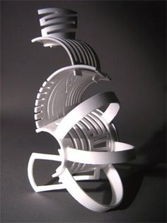
Ceramic Packet Day 18: Styrofoam cup Project
Sketch out & Design 3 Ideas for a Styrofoam Cup
3)
2)
1)

Which Idea did you like? What idea/sketch do you think you will go with, sketch 1,2, or 3? Why did you pick this sketch? __________________________________________________________________________________________________________________________________________________________________________________________________________________________________________
Ceramics Packet Day 19: Read this New York Times Article.

A Sharpie Campaign, Aimed at Teenagers, Urges Self-Expression By: Jane L. Levere July 26, 2011
SHARPIE, whose permanent markers were immortalized by NFL receiver Terrell Owens when he pulled a Sharpie out of his sock to sign a football after scoring a touchdown, is turning to more minor celebrities to promote its products.
The marker company is officially introducing a revamped Web site on Wednesday as part of its 2011 back-to-school marketing campaign, which also features avid, though lesser-known, Sharpie fans, and urges consumers to “start something” with its products. Directed at teenagers, the campaign also includes new print, TV, Internet and cinema advertising, extensive use of social media, and new packaging, markers and colors.
Sharpie, introduced in 1964 by the writing instrument manufacturer Sanford, is part of the office products business unit of Newell Rubbermaid. According to Budd Bugatch, who follows Newell Rubbermaid for Raymond James, it is the leading permanent marker and highlighter brand in the United States with a 60 percent share of the market.
Back-to-school sales are vital for these products. Jason Gere, who follows Newell Rubbermaid for RBC Capital Markets, estimated that 27 percent of sales of all Newell Rubbermaid office products — which also include Rolodex and Paper Mate, Parker and Waterman writing instruments — occur in the third quarter, during the months of July, August and September. He said this figure was even higher for Sharpie.
The new campaign, created by the Chicago office of Draftfcb, part of the Interpublic Group of Companies, expands on a theme to “uncap what’s inside” introduced by the agency in 2009.
“Sharpie can be a catalyst for self-expression,” and the new campaign “is an evolution” of this concept, said Gigi Carroll, senior vice president and creative director of Draftfcb in Chicago.
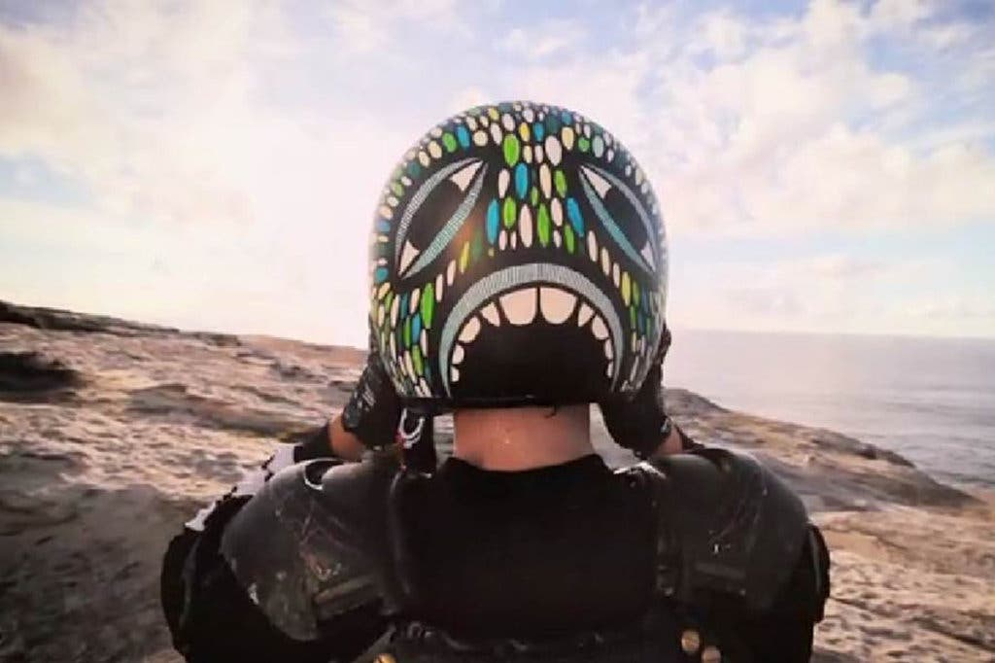
Image: A TV ad for Sharpie shows a biker's helmet painted with Sharpie markers.
The campaign is aimed at teenagers, said Sally Grimes, Sharpie’s global vice president for marketing, because they “use Sharpie in the most creative, inspiring ways. Teens have always been our primary user in the past, but we talked more to moms in the past.”
Although Sharpie traditionally has been known as the marker used by celebrities to sign autographs, “true Sharpie celebrities are everyday advocates” using the markers for creative purposes, she added.
Thus, the stars of the new campaign are four avid Sharpie users. They are Erica Domesek, a do-it-yourself aficionado who employs a new Sharpie fabric marker to turn a pencil case into a purse; Cheeming Boey, who uses pens to turn paper coffee cups into works of art that sell for as much as $900; Mark Rivard, who customizes skateboards with markers; and Marirose Weldon, a young singer and songwriter who uses a Sharpie Liquid Pencil to write lyrics.
Each featured fan appears in a magazine ad that prominently displays the fan’s creation and the Sharpie product used to make it; the ad copy says “It starts with Sharpie,” and asks, “What are you going to start?” and includes the tagline, “Uncap what’s inside.”
Running in July and August issues of teenage magazines like Seventeen and Teen Vogue, the magazine campaign includes a one-third-page ad showing the Sharpie products the fan used to create his or her work, which is shown in a full-page ad on the facing page. The smaller ads also contain QR codes that direct readers to a Sharpie mobile page with videos of fans.
One 30-second TV spot — running through Sept. 25 on national network and cable TV channels like MTV, Fuse and Nickelodeon — asks viewers what the world would be like without self-expression, and depicts Sharpie-decorated items like a black and white guitar and dirt biker’s helmet.
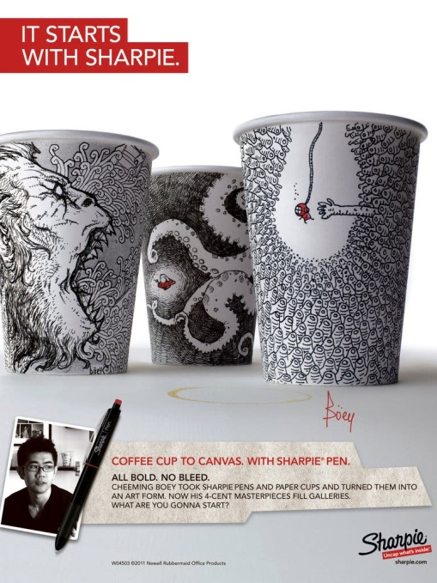
A second 30-second spot begins with a young man’s hands uncapping a pen to write “I love” on a sticky note; it ends with him creating a “Will you marry me?” sign made up of multiple sticky notes. The voiceover says, “With Sharpie’s collection of no-bleed pens, there is no limit to what you can say. Or do. What are you going to start? Sharpie. Uncap what’s inside.”

Editors’ Picks

Image
Sharpie's print ad features cups decorated with a Sharpie pen by Cheeming Boey.
The campaign includes similar digital display and video ads on teenage sites like Alloy and MTV, as well as cinema advertising, a first for Sharpie. Versions of both the TV spots and QR videos are being shown in about 1,200 movie theaters in cities like Chicago, Los Angeles and New York through late August.
Sharpie’s new Web site will display Sharpie’s “creative community” and ask visitors “What are you going to start?” It will also contain a new virtual gallery of user-generated Sharpie creations, and a new ability to search for products by color.
The culmination of the campaign — which also includes the introduction of a highlighter with gel-stick technology that prevents smearing, the fabric marker, five limited-edition colors, and packaging redesigned for easier shopping — will come on Aug. 27. On that day, Sharpie will take over YouTube’s home page with an interactive mosaic of consumer-generated artwork, the ultimate expression of “what fans have started with Sharpie,” according to Ms. Grimes.
She said Sharpie’s 2011 advertising expenditures and media mix would resemble last year’s. According to the research firm Kantar Media, Sharpie spent about $12 million on advertising in 2010, $9.26 million on television advertising, $1.8 million on magazine advertising, and $1.06 million on Internet advertising. In the third quarter of 2010, which included the back-to-school selling season, Sharpie spent $7.5 million, including $6 million on TV advertising, $551,000 on magazine ads and $909,000 on Internet advertising, Kantar Media said.
Wendy Nicholson, a Citigroup analyst who follows Newell Rubbermaid, said the new advertising was “more lively than I’ve seen in a long time. You’ve got to give Sharpie credit for trying to use the digital medium in an aggressive and creative way.”
Prof. Russell S. Winer, chairman of the marketing department at the Stern School of Business at New York University, called the advertising “a really interesting, multichannel campaign.”
However, he warned that by focusing so heavily on young buyers, Sharpie was excluding “a large group of people — older consumers who do not necessarily use writing tools for creative purposes.”
Correction: July 28, 2011
A caption on Wednesday with the Advertising column, about a marketing campaign for Sharpie markers, reversed, in some editions, the media in which two ads appear. The biker’s helmet painted with Sharpie markers appears in a television commercial, and the decorated Cheeming Boey cups are featured in a print ad.A version of this article appears in print on July 27, 2011, Section B, Page 2 of the New York edition with the headline: A Sharpie Campaign, Aimed at Teenagers, Urges Self-Expression. Order Reprints | Today’s Paper | Subscribe
Write a Paragraph 3-5 sentences or more summarizing this article. Answer the What, Why’s, Who, Where, When, questions about this article. ____________________________________________________________________________________________________________________________________________________________________________________________________________________________________________________________________________________________________________________________________________________________________________________________________________________________________________________________________________________
Ceramics Packet 20-21
Goal: Use the inspirations of both the “Board Bots” and “Cheemy Boey” to help create 2 Styrofoam works of art that you design.
- One Styrofoam is going to be a sculptural cup design and one Styrofoam cup should have a cool drawing on it! You may use colored markers or keep it black & white, it’s up to you!
* You can use ANY type of Styrofoam Cup, Coffee cup, mcdonalds, etc.
*If you can Not get styrofoam cups or have no means to sharpie markers/markers, you may draw your final product in the spaces below. I will need two sides for each project in order to see front and back if that is the case.
Let this sink in – Cheemy Boey charges $900 dollars for his Styrofoam cup art !!! What!?
Procedure:
1) Get 2 Styrofoam white cups. Use your design sketches to help, but one is a cut out sculpture that you can carve and make into whatever 3D design you think looks appealing from all angles/sides. The other Styrofoam design is strictly using markers or sharpie markers to design the entire outside or even inside of the cup.
2) Use the inspirations from these articles and I encourage you to look up more Styrofoam cup designs to really get a good idea of how you want to tackle your own original design! Use the things we are going through now to help inspire your designs as well as our world is changing.
#1: Sculptural Styrofoam Design:
Back Side
Front Side

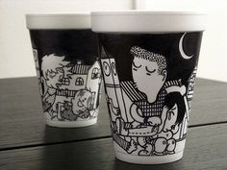
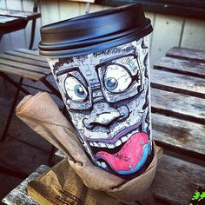
Ceramic Packet 20-21:
Drawing Styrofoam Cup Designs:
*Remember to draw at the cup & then draw your designs on it
Back Side:
Front Side:

