Ceramics Packets 11-16
Day 11:
- Our resource from Scholastics Arts Magazine is in for you guys to use!
- Go to scholastic,Entire password: EHSART - should give you access to magazines/Resources
Chihuly’s World (Newest Issue)
What events inspired this artist to take creative risks?
MARCH / APRIL 2020
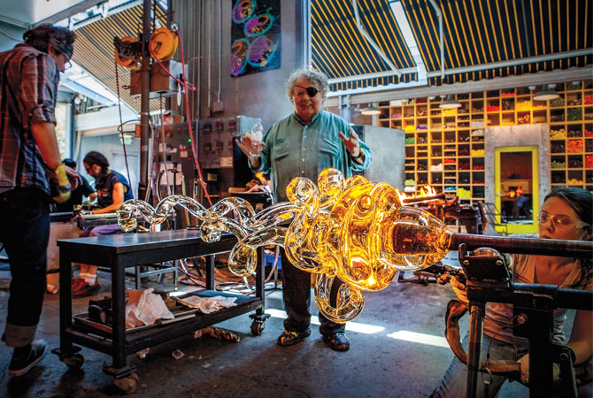
Look carefully at the artwork on the cover. What materials do you think it’s made of? Artist Dale Chihuly (dayl chuh-HOO-lee), created this vibrant work with glass! Chihuly, one of the most famous artists working in glass today, uses innovative glassblowing techniques to create works that are both familiar and strange. Some are small enough to hold in your hand and some are like other-worldly landscapes you can walk through.
James Mongrain, Dale Chihuly, and Andrea Lesnett, Rotolo in progress, The Boathouse hotshop, Seattle, 2013.
2019 Chihuly Studio/Artists Rights Society (ARS), New York. Image ©Chihuly Studio. All rights reserved.
Why does Chihuly work with a team?

Hot Stuff
Chihuly was born in 1941 in Tacoma, Washington. He didn’t plan on becoming an artist. During college, he studied interior design and architecture. While taking a weaving class, he incorporated small pieces of glass into his textile designs. He soon decided to experiment with glassblowing and quickly got hooked.
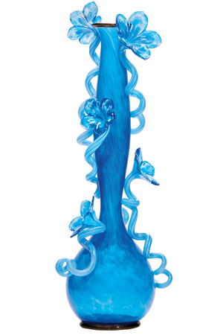
There are many ways to work with glass, but Chihuly began with a traditional process. He heated silica sand to around 2,300 degrees Fahrenheit to melt it. Then he gathered this melted substance onto one end of a long, hollow metal tube and blew into the other end of the tube. This caused the hot glass to expand like a bubble. Chihuly explored interesting ways to alter the form using heat, gravity, and human breath.
Inspiration Everywhere
Dale Chihuly, Misty Cerulean Venetian, 2011. 37x13x11in. 2019 Chihuly Studio/Artists Rights Society (ARS), New York. Image ©Chihuly Studio. All rights reserved.
What experience inspired Chihuly to make vessels like this one?
Throughout his life, Chihuly has traveled the world, finding inspiration in his experiences and the art he encounters. In 1968, Chihuly visited Italy. He studied with some of the best glassblowers in the world on the Venetian island of Murano, known for its glassmaking tradition. While there, the artist saw Art Deco sculptures made during the 1920s and ’30s. In 1988, he began working on a series called Venetians. To make his 2011 Misty Cerulean Venetian, right, Chihuly collaborated with Italian glassblower Lino Tagliapietra (LEE-noh tah-lee-oh-pee-ET-rah). Chihuly adds Art Deco
inspired floral embellishments that are fused to the vase’s surface.
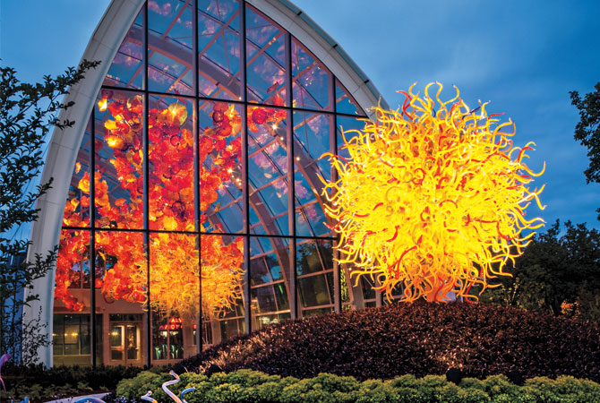
Dale Chihuly, Cobalt Float and Fiori, 2012, Glasshouse Sculpture, 2012, and Pacific Sun, 2011. Chihuly Garden and Glass, installed 2012. 2019 Chihuly Studio/Artists Rights Society (ARS), New York. Image ©Chihuly Studio. All rights reserved.
What allows Chihuly to work at this scale?

Monumental Innovations
In 1976, a terrible car accident left Chihuly blind in one eye. The artist spent weeks in the hospital recovering. During this time, he thought about his work. Instead of holding him back, he realized, the accident presented an opportunity to push his art further. Now Chihuly leads a large team that works together. (But the artistic ideas are all his!) This team approach allows Chihuly to make bigger, more complex sculptures. For example, up to 17 people work together to make the sculptures in his Rotolo series, shown in process above. The team uses up to 140 pounds of glass to make one of these sculptures.

"I want people to be overwhelmed with light and color in some way that they've never experienced."

—Dale Chihuly
Chihuly continues to experiment with his process and scale. In 2012, a long-term exhibition designed by Chihuly opened in Seattle. It includes a garden and a glass house, above. One of Chihuly’s largest installations is suspended inside the glass house. The 100-foot-long work includes red, yellow, and orange glass forms. In the garden, visitors encounter Pacific Sun shown in the photo above. To achieve the scale he wanted for each of these works, Chihuly created many small blown-glass forms at his studio. Then at the exhibition, his team mounted these smaller glass forms on a metal support, like the one shown above right, building a single monumental work.
Chihuly has always pushed the boundaries of glassblowing. What events in his life inspired him to take chances, try new techniques, and develop a seemingly impossible range of forms in his work?
Dale Chihuly, Palm House Towers, 2005. Installed outside the Palm House at Kew Gardens, London. Photo: Camera Press/Graham Turner/Redux.
Why is the hidden support important for Chihuly’s team to assemble this work?
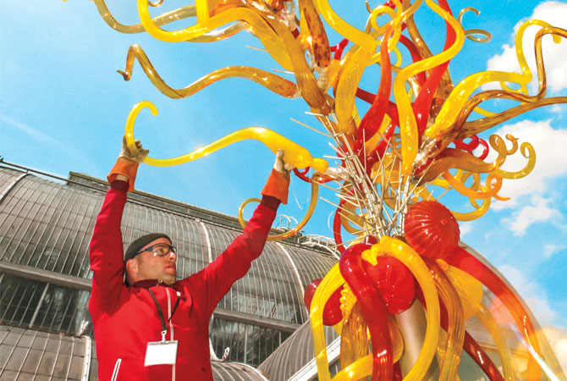
Day 11:
Glittering Glass Video Is very short, very cool, please see if you can watch it!
https://art.scholastic.com/issues/2019-20/030120.html -This should take you to the page and remember student access is EHSART.

Day 11: Read the Dale Chihuly article above and anwer these questions in Complete Sentences;
1) What events inspired this artist to take creative risks?
__________________________________________________________________________________________________________________________________________________________________________________________________________________________________________
2) Why does Chihuly work with a team?
__________________________________________________________________________________________________________________________________________________________________________________________________________________________________________
3) What experience inspired Chihuly to make vessels like this one?
__________________________________________________________________________________________________________________________________________________________________________________________________________________________________________
4) What experience inspired Chihuly to make vessels like this one?
__________________________________________________________________________________________________________________________________________________________________________________________________________________________________________
5) Why is the hidden support important for Chihuly’s team to assemble this work?
_______________________________________________________________________________________________________________________________________________________________________________________________________________________________________________________________
Day 12-14
Dale Chihuly’s Project:
If you can please log into scholastics magazines and go to art magazines and enter password: EHSART. This should provide you with all materials and resources. You should be able to access videos and the actual magazine to read or look through and find inspiration. If you can’t you can still do this project!!
Step 1: Choose materials from the selection that you have at home from interesting found objects. You can use anything from your house, extra yarn, cloth, plastics, cans, straws, old silver ware, cups, tin foil, old computer pieces, old tools; Popsicle sticks anything you can make into an interesting form. Just like Dale Chihuly does with his glass sculptures, but how can you make your sculpture original & unique?
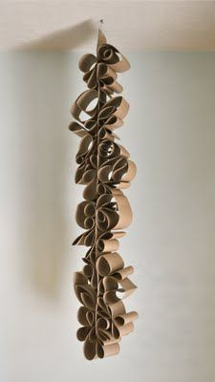
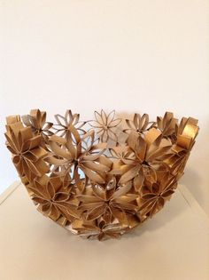
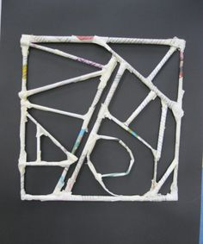
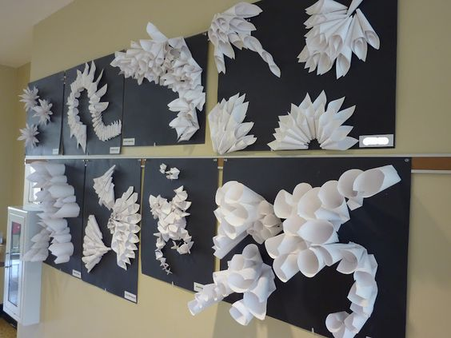
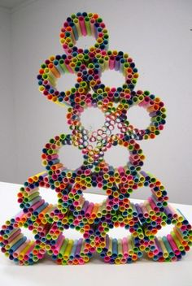
Step 2: Make few sketches of different sculpture designs that you could do with the found objects that you have decided to work with. Make notes about the materials you will use, where you will display your work, and how you will display it (suspended, tabletop, etc.). Think of being back at school, where would you hang or put your sculpture in the school if you got to choose the placement!
Step 3: Once you have your ideas sketched and your materials then you may begin creating your sculpture. Remember to embrace trial and error, adjusting materials that aren’t functioning as planned. As you work, remember to consider your works’ textures and forms.
Ask: How can you use materials to create an interesting texture?
Think about how you are going to assemble your sculpture, using glue to attach yarn, beads, chenille sticks, tape, etc., to make your work come together to form as one interesting sculpture!
OBJECTIVES: Students will study form, texture, and space by learning about Dale Chihuly’s glasswork. Students will experiment with a variety of materials to create site-specific sculptures!
MATERIALS: 1. pencils 2. Sketch paper 3. erasers 4. A variety of mixed-media materials, including found objects and natural materials (sticks/plastics/cardboard/yarn/bottles/cans/etc.) 5. craft glue, hot glue, glue guns, glue sticks 6. Coloring materials
VOCABULARY: form, found objects, glasswork, install, sculpture, site-specific, space, texture
Examples: Cardboard & paper Sculpture that you can paint, Plastics you cut & color, coffee filter you can color and put together!!!
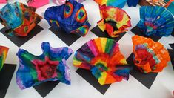
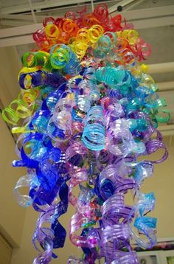

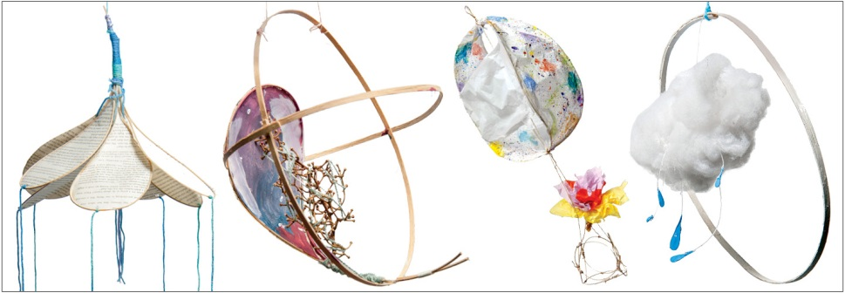
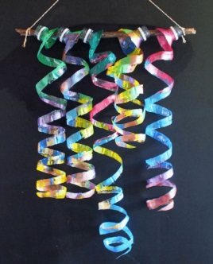

Make sure your sculpture is something with substance! It should be large enough to create an idea, a feeling, be in the space that you are picturing at school. It should be made up of at least 15 or more items that you put together to make a form with meaning. You should use what we are going through as inspiration! Maybe you make a large pill or virus sculpture, something to think about!?

Day 14: Artist Statement: Design a Marquette
1. How did you choose a location for your installation? Why do you think it makes a good spot for an artwork?
_______________________________________________________________________________________________________________________________________________________________________________________________________________________________________________________________
2) What materials did you use to make your sculpture? Why did you use them?
_______________________________________________________________________________________________________________________________________________________________________________________________________________________________________________________________
3) How did you work with form?
_______________________________________________________________________________________________________________________________________________________________________________________________________________________________________________________________
4) Describe your working process? Did you carve model or assemble your pieces?
_______________________________________________________________________________________________________________________________________________________________________________________________________________________________________________________________
5)Did you encounter any problems as you were working? How did you overcome them?
_______________________________________________________________________________________________________________________________________________________________________________________________________________________________________________________________
6) In one large Statement, explain what you came up with? How does it relate to the times, or maybe it doesn’t relate to what is going on at all? What did you enjoy about this process and what did you not enjoy? What did you add to create textures? What did you use to create interest?
____________________________________________________________________________________________________________________________________________________________________________________________________________________________________________________________________________________________________________________________________________________

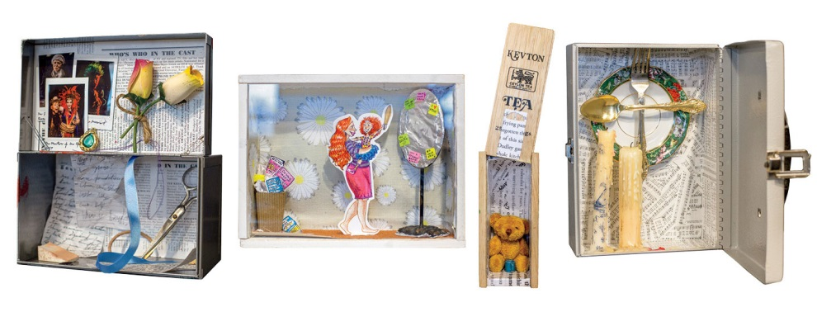
Day 14-16 Constructing a Narrative Project: Saar Family Scholastic Issue; working with narrative
Constructing a Narrative/Time Capsule Project
Step 1: Using what you just learned to be creative and make a found objects sculpture this project should be pretty fun and easier for you. This is a Narrative/ Time Capsule Project that you can or should use objects that possible represent a story of what is going on with our world right now. How can you make a piece of artwork that represents something that you could keep items that remind you or show you of what we are facing today. One day you may look back and say wow, yes, this project is when I was this old, and we went through the Covid-19 virus.
Step 2: Make sketches and think of a theme or narrative that is personally relevant to you. Maybe this is your senior year and you missed out on prom, graduation, being with friend, etc. Use this to bring to life what you are living. Make a couple sketches of ideas that you may have and start collecting some objects that you may also be able to put in the box along with your sketches and other ideas. Items you may find in the newspaper or anything that may convey certain messages will be interesting ideas to work with to put into your box.
Step 3: Once you have decided which objects you will include in your assemblages, think about embellishments you might add. These could include patterned papers or text. You might add texture with painted sandpaper, paint applied with a squeegee or sponge, or various glazing media. Don’t be afraid if you are constantly adjusting the way your using color and layering. You can start to then assemble your works and then add any final details.
Step 4: Question/Answer: How was the process of refining your work important? How can craftsmanship make a work feel complete or sloppy? Make sure to add things of interest, think about unity, balance, and all the things you worked on in Ceramics to make your pottery turn out well. The same things should be applied to this project and make it your own creative Narrative.
Objectives: Students will learn that objects can have meaning. Students will apply what they’ve learned for found objects sculpture to construct a narrative assemblage from a variety of collected or found objects.
Materials: Box of any kind! Papers that you can draw on to add narrative interest, dimension, depth, and space within the box or composition inside the box. Think about unity and balance to create a narrative or time capsule that is going to be understood.
Vocab: Assemblage, Illustrations, personal narrative, scale, symbolic, & collage
After Completing your project Please Answer Questions In Full Sentences!
1) Explain the Narrative that you decide to explore and why?
_______________________________________________________________________________________________________________________________________________________________________________________________________________________________________________________________
2) How do the found objects that you used convey the message or theme that you decided to go with?
__________________________________________________________________________________________________________________________________________________________________________

