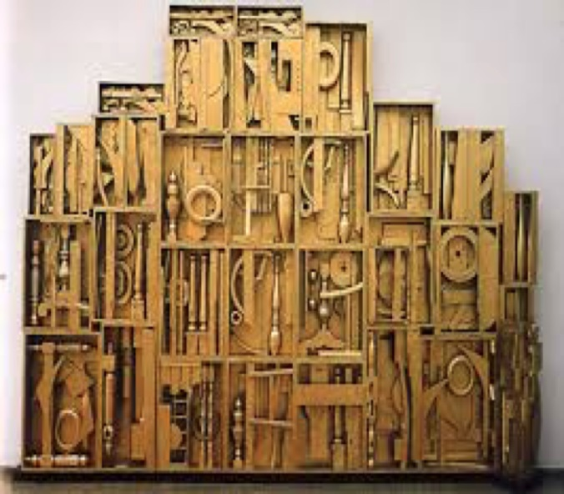
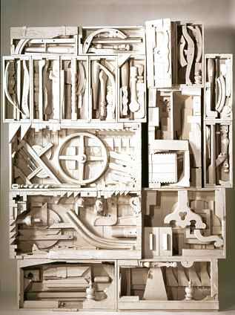
Louise Nevelson Art Project: Suggestion:
Day 6- Research & Answer questions about Louise Nevelson
Day 7- Look up: Unity & Harmony – Define them & Sketch Out 5 Designs of a Louise Nevelson Box that you would want to create
Day 8-10: Create your own Louise Nevelson Box or Boxes
Goal: To learn about the Artist Louise Nevelson and create your own version of a Louise Nevelson box sculpture using found objects from around your home, garage, etc.
Procedure:
1) Read and Learn about Louise Nevelson & Define Key Principles of Design Terms; Unity/ Harmony and Variety
2) Sketch out at least 4 sketches of ideas that you may have for your own Louise Nevelson box sculpture ( List items that you can use or find around your home)
3) Find interesting/ unique items that you can use around your home to place in a cardboard box (small, medium, large, whatever you can find)
- Once you have a bunch of items you may hot glue (anytype of glue will work), but glue your items into your box in an interesting sculptural Arrangement. Make sure you can try to fill your box up with All kinds of items that are interesting; cords, rope, lights, beads, recycled materials, you can cut up cardboard/plastics, utensils, metals, ANYTHING. (keep it SAFE)
-If you can, PAINT the entire box, items, back, front, everything with ONE solid color of your choice that you can find at your home. If you do not have paint, you can spray paint, if you don’t have anything you may leave your box unpainted. But please try!

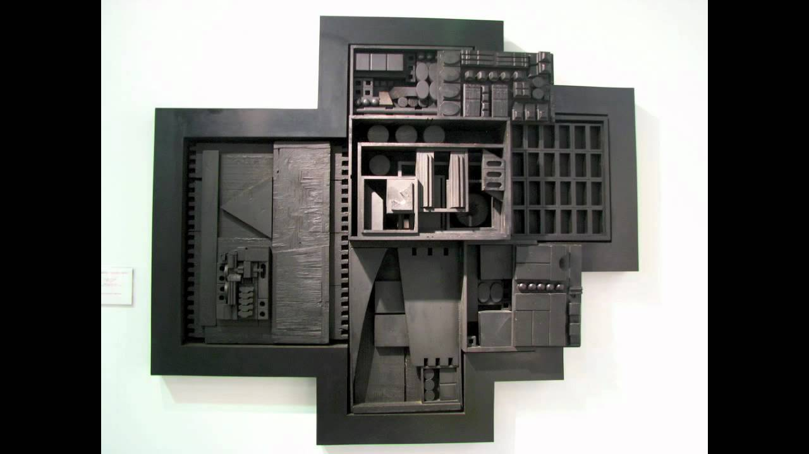
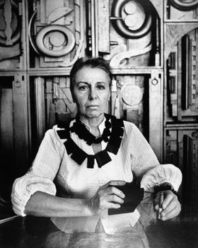
Nevelson, Louise (Day 6)
When she was a child, Louise Nevelson knew she wanted to be a sculptor, and she worked toward that goal until she achieved it. She was born Louise Berliawsky on September 23, 1900, in Kiev, Russia. In 1905 she and her family moved to Rockland, Maine. After graduating from high school, she married Charles Nevelson and moved to New York City, where she lived the rest of her life.
Nevelson traveled widely and studied at the Art Students League in New York City. She wrote poetry, performed in plays, and studied philosophy and religion. None of these activities interfered with her work as a sculptor, yet many years passed before she earned the reputation that she deserved.
During the mid-1950's, she began to gather together old wooden spoons, spindles, parts of furniture, sticks, and other everyday wooden objects. With these Nevelson created her famous assemblages, which she framed within boxlike compartments of varying sizes. She then painted each assemblage flat black or sometimes flat white or gold. Finally, by piling boxes of the same color against the wall, she produced gigantic and strikingly beautiful relief sculptures unlike anything other artists had ever done. She had created order out of disorder, and unity and visual beauty out of cast-aside junk. Pictures of assemblages by Nevelson can be found in Sculpture and United States, Art and Architecture of the.
Later in her career, Nevelson also produced plastic and metal sculptures. These have been shown in major museum collections. In addition, many of her large-scale works have been installed in public locations both in the United States and abroad. One of her best-known works is the Chapel of the Good Shepherd (1977) in St. Peter's Lutheran Church in New York City. In 1978, as a tribute to her, a public square on New York City's Wall Street was named the Nevelson Square. She died on April 17, 1988, in New York City.
Howard E. Wooden
Director Emeritus
The Wichita Art Museum More Great Info: https://www.theartstory.org/artist/nevelson-louise/
Please Answer These Questions in FULL/Complete Sentences!
1) Where did Louise Nevelson study art and when did she know she wanted to become an art sculptor?
____________________________________________________________________________________________________________________________________
2) What size was Louise Nevelson’s sculptors, large or small? Why do you think she enjoyed making them that size? What was the impact?
________________________________________________________________________________________________________________________________________________________________________________________________________________________________________________________________________
3) Where did Louise Nevelson’s work get shown off and displayed later in her career?
____________________________________________________________________________________________________________________________________
4) What was Louise Nevelson’s best known works of art? Where did these works get displayed?
____________________________________________________________________________________________________________________________________
5) What did New York City do to tribute to Louise Nevelson? Why do you think they would make such a big deal of her work and her?
______________________________________________________________________________________________________________________________________________________________________________________________________
6) Where was Louise Nevelson born? Where did she end up living and producing artwork? Finally, who did Louise marry?
______________________________________________________________________________________________________________________________________________________________________________________________________
Day 7 Fill The Boxes Below & Define – Define Harmony/Unity ____________________________________________________________________________________________________________________________________
BELOW: Draw 3 Sketches of examples of how to illustrate: Harmony/Unity.

Define Variety:
____________________________________________________________________________________________________________________________________
Below: Draw 3 Sketches of Examples of how to illustrate Variety

1) Draw 4 sketches of what you could place in your own box & draw 2 Larger
2) Write out a list of some things, items, materials, that you could find from your home to work with towards creating your own Louise Nevelson Box!

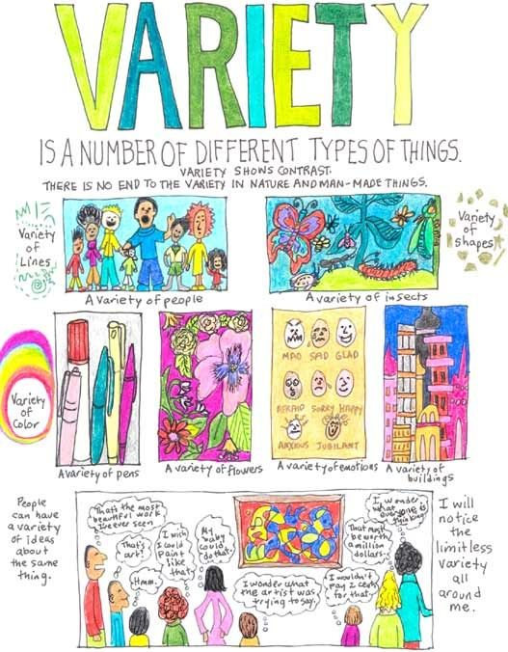
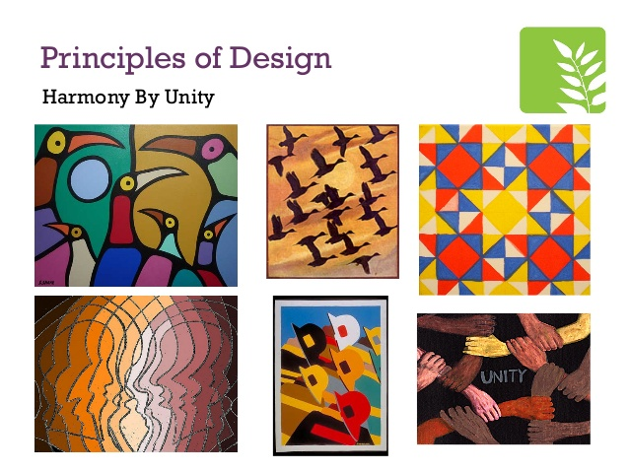
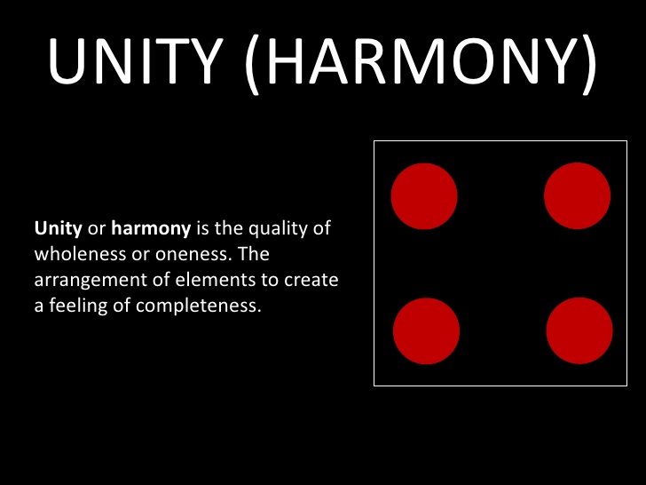
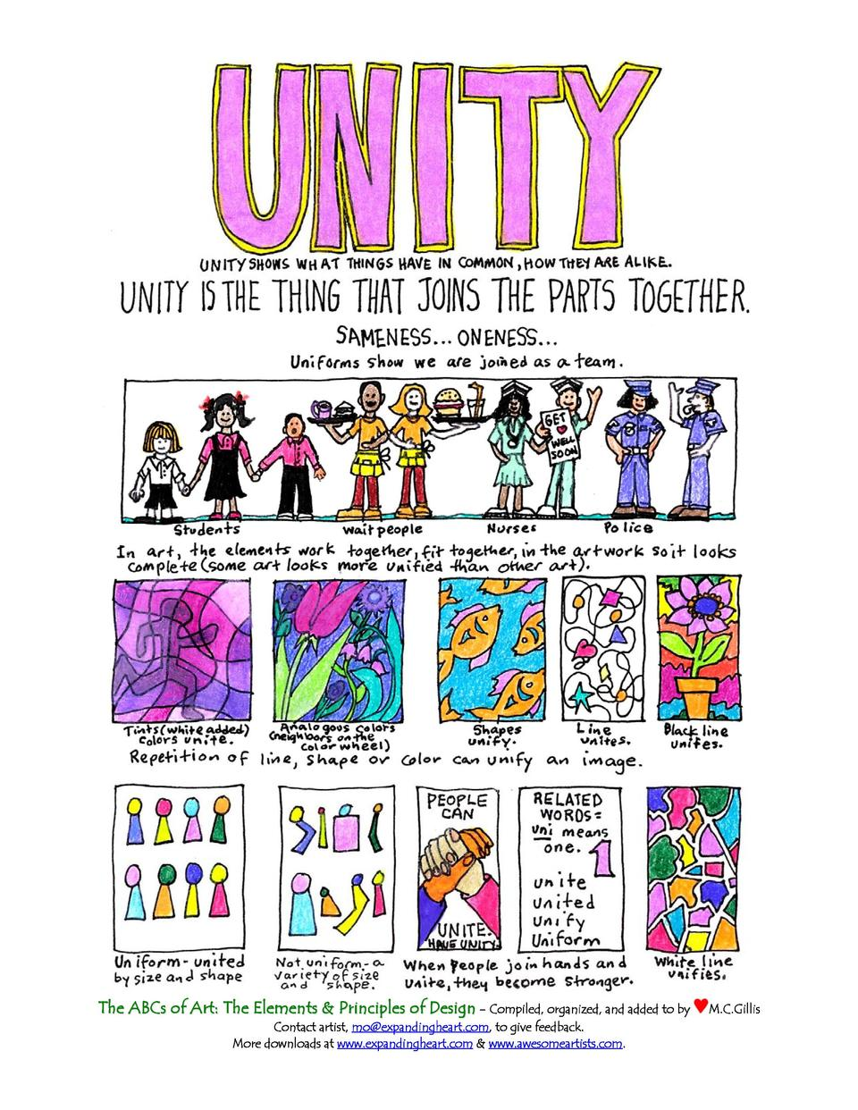
Day 8- 10 : Start to Assemble and work on Creating Your Louise Nevelson Box
“Helpful Things Below”

