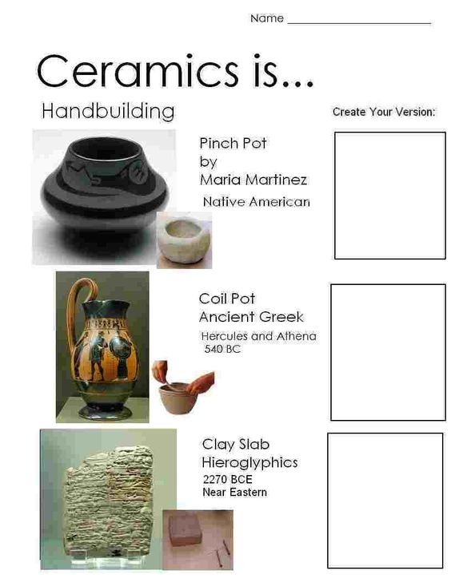

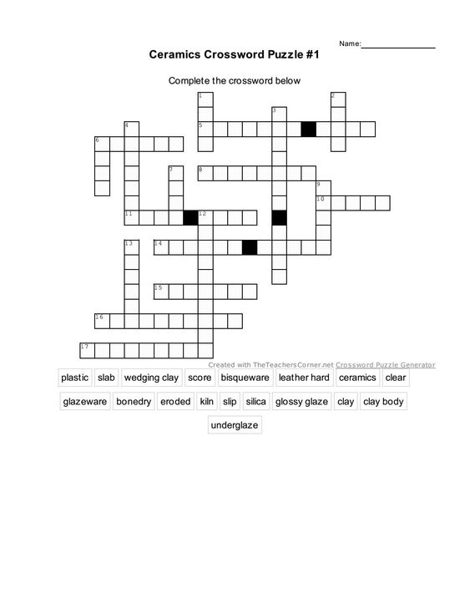

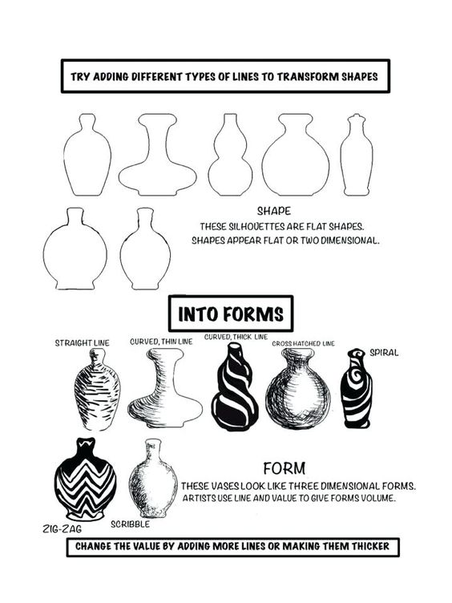

Day 3: Add Designs to these Vases that you would actually try and use as a design for a vase you would build or create in class. THEN: take the best one that you think is most interesting and create a FINAL larger version in your visual journal or on separate paper. This final should be shaded, it should indicate glaze color, and it should indicate shape of vase. You also need to tell me how you would build this vase; coil, slab, etc.

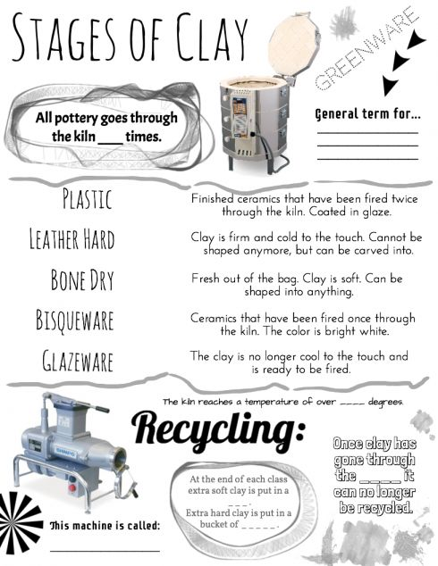

Day 4: Fill in the Blank Spaces with the information we have talked about and learned through out your ceramics class. You may see lots of information about this in your Visual Journal with your notes/papers. If you do not have your visual journal with you use your researching skills or a class mate to help you.

