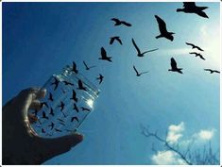
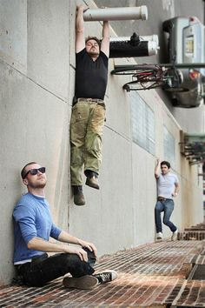
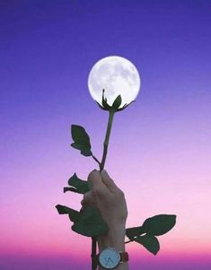
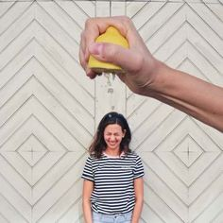
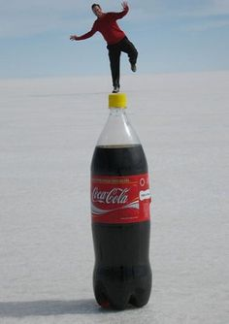
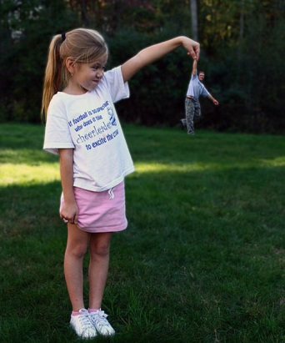
Ceramics Packets Day 22-31
Packet Day 22- Perspective in Photography
Think how creative you can be with your phones or if you have a nice camera great. Now a days your phones have great camera too! Think how you can add a different perspective to your image by using depth and placement to make something look like it is there, but it is really not.
For Packet 22-23: Collaborate and Create an unique perspective photo that you can upload to me on livegrades or send to my email acameron@k12.wv.us! Have fun with this, be creative, go outdoors, or include your family!
Did you ever wonder how did they make Frodo look so small next to Gandalf? This technique is frequently used in filmography, photography and art in general. In order to show the contrast between the sizes of objects in a picture the “forced perspective” technique is used. Some photographers choose this technique for their photos as well and it is really successful.
There is no need to use editing softwares or a professional camera, because you can use your imagination by creating outstanding effects with the right angle of the camera and the way you place objects in a picture. You can create an optical illusion by making your objects look bigger or smaller than they actually are.
Make the Eiffel Tower stand on your hand or lean on the Tower of Pissa. You can create pretty amazing and unique shots by using this technique. If you wonder how it is done, check out these inspiring photos and get creative!
Day 22-Brain Storm Box: Write, list, draw, or bubble ideas for your forced perspective photo! Work on getting your photo shot during Day 22-23!
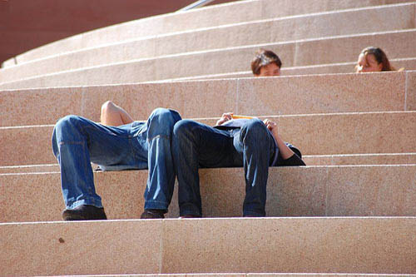

Packet Day 24: Research, Watch, and look at Photographer Rich McCor
Watch these two Youtube Videos on London Photographer - Rich McCor.
Video 1: https://www.youtube.com/watch?v=l36lV-mEF-Y
Video 2: https://www.youtube.com/watch?v=rp-LOeFV-o8
*aka PaperBoyo in Vienna - Check him out on: Instagram.com/paperboyo
Answer These questions about the artist using the videos or extra research.
1) What did Rich McCor use to make his forced perspective photos stand out or be different from the photos above? ____________________________________________________________________________________________________________________________________________________________
2) How many followers does Rich McCor have on Instagram? ___________________________
3) When did this all start for Rich McCor, what was his “Aha Moment” What was his intentions? ____________________________________________________________________________________________________________________________________________________________
4) What was his first photo project inspiration that he took on? ______________________________________________________________________________
5) What would he post on Instagram along with his photos? _____________________________
6) Who contacted him on Instagram that wanted him to take more photos? __________________
7) What book did he collaborate and collect these photos into? ___________________________
8) What companies did this lead to Rich McCor collaborating with? ______________________________________________________________________________
Packet Day 25:
Write a Thank you letter to Mary Alice Milnes, who donated money towards giving our art classes Art Scholastics Magazines. Which are coming in handy right now. Please make sure to start with Dear Mary Alice Milnes, have at least 3-5 sentences, say how you appreciate her donation, how does it affect our art program, what does it help with, etc… You may type it, hand write it and turn it into my box at school, or email it typed to acameron@k12.wv.us
Dear Mary Alice Milnes,
_________________________________________________________________________________________________________________________________________________________________________________________________________________________________________________________________________________________________________________________________________________________________________________________________________________________________________________________________________________________________________________________________________________________________________________________________________________________________________________________________________________________________________________________________________________________________________________________________________________________________________________________________________________________________________________________________________________________________________________________________________________________________________________________________________________________________________________________________________________
Thank you So Much For your kind Donation,
Sincerely,

Packet Day 26: Clay Review of Stages & Process:
Using the words from the box to help, you need to complete the following questions, which some answers can be found in your visual journals, or research online.
1. Where does Clay come from? ____________________________________________________________________________________________________________________________________________________________
2. What is clay made up of? ____________________________________________________________________________________________________________________________________________________________
3. Describe the qualities of clay? ____________________________________________________________________________________________________________________________________________________________
4. List 5 things at your home that are made out of clay?
1) ____________________________ 2) _______________________3)____________________
4)______________________________ 5)________________________________
5) What is the enemy of clay? Explain why and how this affected you while created art? __________________________________________________________________________________________________________________________________________________________________________________________________________________________________________
6) Describe the correct method of joining pieces of clay together in your projects? Please use the correct vocabulary to explain. __________________________________________________________________________________________________________________________________________________________________________________________________________________________________________
In These boxes sketch out the three different process of making or putting clay together;
Slab | Coil | Pinch Pot
6. Once you have built and made your art project, you must leave it out to dry? Why is this important? Also, Once the clay has completely dried where does it go? __________________________________________________________________________________________________________________________________________________________________________________________________________________________________________
Packet Day 27: Review Continued of Clay & Clay Process
7. Name the 5 Stages of Clay in the correct order of how the process goes? Describe what the clay is like in each stage? (Bisqueware, Glazeware, Leatherhard, Greenware, Plastic Stage)
1)______________________________________________________________________________________________________________________________________________
2)_____________________________________________________________________________________________________________________________________________
3)______________________________________________________________________________________________________________________________________________
4)______________________________________________________________________________________________________________________________________________
5)______________________________________________________________________________________________________________________________________________
8) Slip is…
a) scratching the clay to increase surface area
b) liquid clay used as glue “to join pieces together”
c) wet clay that is moldable and shapeable
d) liquid that is painted on after the bisque fire
9) Scoring is…
a) putting the clay on a wheel and creating pottery
b) scratching the clay to increase surface area
c) carving designs into the clay
d) smoothing the clay with hard plastic
10) The first time that the clay is fired is the ________________ firing.
11) What are the 3 process of making and hand building clay?
1)________________________ 2)______________________3)____________________
12) At this stage ALL physical water is gone?
a) leather hard
b) bone dry
c) bisqueware
d) glazeware
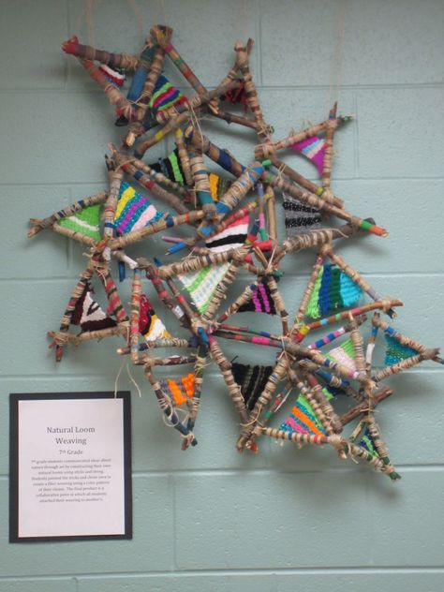
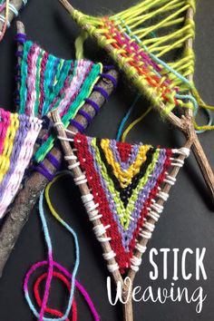
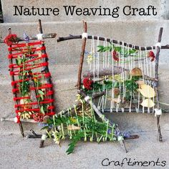
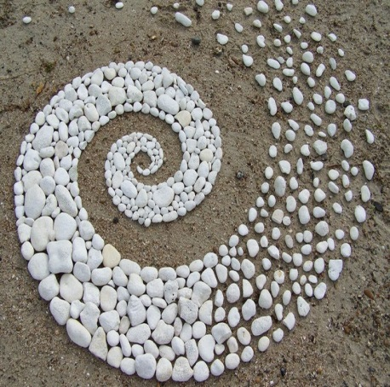
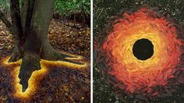
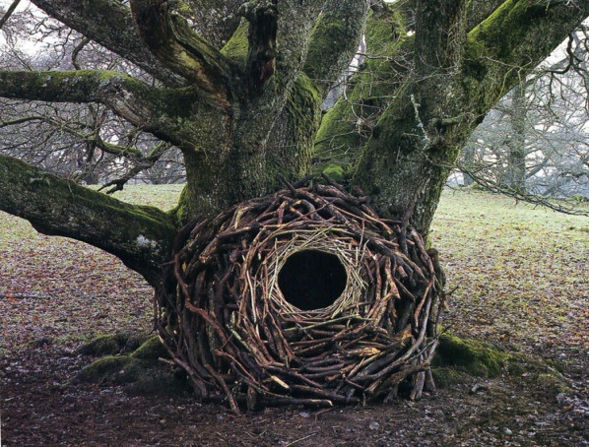
Packet Day 28:
I am sad our Ceramics class was cut short! We had a great class with students who enjoyed the ceramics process. For Packet Day 28, I want us to go back and reflect on what we got to do as a ceramics class, what we liked, disliked, and so on.
1) What was the one project that you thought turned out the best out of the projects that we accomplished in ceramics class? Please explain why? ________________________________________________________________________________________________________________________________________________
2) What was the one project that you thought was the hardest project to create? Why? ________________________________________________________________________________________________________________________________________________
3) What was the one project that you thought did not turn out and was the worst project that you created this ceramics class? Please Explain why? ________________________________________________________________________________________________________________________________________________
4) What was the one project that you thought was the easiest project you created? Why? ________________________________________________________________________________________________________________________________________________
5) If you could go back and do an ceramic project in class now, what would you want to make and why? ________________________________________________________________________________________________________________________________________________
6) If there was one project that you loved before you glazed it? What could you have done to change the outcome? Does glaze make a difference in your final result, why? ________________________________________________________________________________________________________________________________________________
7) If there was one thing you could say to a NEW ceramics student, what would you give them as advice before they take this class or start their first project? ________________________________________________________________________________________________________________________________________________
8) Would you take ceramics again if you had a chance too? If you are a senior or can’t take another ceramics class, do you think this is something you would enjoy taking classes in once you get older? ________________________________________________________________________
Packet Day 29-30: Create a 3D art stick weaving
If you don’t have a lot of yarn, you can use anything at outside in nature or even fishing line. Be creative and natural with your resources.
* Putting three stick diagonally together or four sticks together in a square seems to work best
* Be creative with colors, flowers, leaves, sizes of sticks, etc.
* Make sure if you do this please take a picture of your creation and send it to me on livegrades or acameron@k12.wv.us
* You may also hand this in at school, but please attach your name on your artwork somewhere!!!
https://www.youtube.com/watch?v=u9lUuNK2HyI – This youtube video helps to show you how you can start to weave your thread, fish line, or what-ever you can use on your stick.
https://www.youtube.com/watch?v=jIUU-ESiDAg- This youtube video is a bit longer, nothing exciting, but it does show you how to weave or work with your weaving after you have started with a base thread.
Packet Day 31: Inspiration for Stick Weaving; Artist: Andy Goldsworthy

AndyGoldsworthy
Scottish sculptor Andy Goldsworthy creates transitory works of art by arranging leaves, sticks, rocks or anything else he can find outside.
Most of Goldsworthy’s art is considered transient and ephemeral, causing people to perceive it as a criticism on the Earth’s fragility. However, for Goldsworthy, the meaning is more complicated.
“When I make something, in a field or street, it may vanish but it’s part of the history of those places,” he says in an interview.
“In the early days my work was about collapse and decay. Now some of the changes that occur are too beautiful to be described as simply decay. At Folkestone I got up early one morning ahead of an incoming tide and covered a boulder in poppy petals. It was calm and the sea slowly and gently washed away the petals, stripping the boulder and creating splashes of red in the sea. The harbor from which many troops left for war was in the background.”
Short Bio
Born in Cheshire, England in 1956, Andy owes his love towards nature to his family, who introduced him to agriculture at a very tender age. Since then, he had the idea of creating sculptures using already existing elements of nature. He is a meticulous sculptor producing site-specific land art situation in natural and uban settings.
-Bradford College of Art (1974–1975); Preston Polytechnic (now University of Central Lancashire) (1975–1978)
-Scottish Arts Council Award (1987); honorary degree from the University of Bradford (1993
-Andy Goldsworthy was given the title Officer of the British Empire, OBE, in 2000
-Besides England and Scotland, his work has been created at the North Pole, in Japan, the Australian Outback, in the U.S. and many others
-He currently lives in Scotland.
-His net worth is 1-5 million dollars/ He is worth over 240 million dollars
Great Resource: https://www.livingyourwildcreativity.com/art-gallery-1-mitchell-1
Look up Andy Goldsworthy and Answer these short questions about this artist
1) Who is Andy Goldsworthy? What kind of art does he do? Why do you think he does it?__________________________________________________________________________________________________________________________________________________________
2) Where is Andy Goldsworthy from? Where did he go to school? ____________________________________________________________________________________________________________________________________________________________
3) Where does Andy Goldsworthy make his art? ____________________________________________________________________________________________________________________________________________________________
4) What did Andy receive in 2000 that was a pretty interesting thing to get? ______________________________________________________________________________
5) What do you think of Andy Goldsworthy’s art? Do you think this is art or do you think this is not art? Why? ____________________________________________________________________________________________________________________________________________________________
6) How much is Andy Goldsworthy worth? __________________________________________
7) What other places has Andy Goldsworthy created artwork? ______________________________________________________________________________
8) Do you have more fun creating artwork in nature or creating artwork inside? Do you like to make hands on sculptures or 3D projects? Or do you insist on 2D drawing projects? ____________________________________________________________________________________________________________________________________________________________

