Digital Literacy Grade 12, Lesson 3, “Retouching Reality” (Adapted from Common Sense Media)
Lesson Objectives:
•Consider both the creative benefits and ethical drawbacks of digital photo manipulation.
•Understand the importance of purpose and context in evaluating digitally edited images.
•Think critically about how the Internet allows users to both celebrate and regulate our “copy-change-paste” culture.

Essential Question: What are the creative and ethical aspects of digital photo manipulation?
Key Vocabulary:
•digital photo manipulation: using digital technology to change the content or appearance of a photo
•deceive: to mislead someone into believing something that’s not true
•retouching: to improve a photo by adding or changing small details
•controversy: public disagreement or debate
•context: the setting in which something develops or occurs

**This lesson may take more than one day depending on discussion.**

Warm Up:
•Ask: Have you ever been fooled by an image online that you thought was real but turned out to be fake?
•Go over vocabulary
•Tell students that as a class they are going to explore the role that digitally manipulated photos play in our 21st century world, and to keep the following questions in mind throughout the lesson:
• Where do we draw the line between creativity and deception? • How do the purpose and context of photo editing affect how we feel about it? • What role does the Internet play in allowing us to share, inspire, and critique images that have been edited?

Procedure:
Discuss photo-editing. Ask students to share a personal experience they have had using tools to edit a photo (removing red-eye or cropping a photo). What other “photoshop” techniques have they used?
Explain: that today you are going to look at digital editing that can be fun and creative, and editing that can cause controversy.

1. Show the students the two photos of the dog (original and photoshopped) on the next page and discuss the questions that follow. This was from a webpage from The Pioneer Woman blog. She has a photo editing contest, just for fun, there are no prizes:
• What are some different editing techniques that you see?
• Which photos are meant to look artistic? Which ones are meant to look funny?
• Which photos look real, and which don’t? Why?

2. Retouching can be viewed as a form of creative self-expression, however it can cause particular controversy in regard to journalism and advertising. People expect the information they receive to be factual.
Display the pictures on pg. 3 and read over the article, then discuss with the following:
• Is there a difference between a digitally manipulated image in an advertisement and one in a news article? Does it depend on context?
• Some people wondered if Microsoft changed the photo in order to appeal to a mostly white Polish audience. Would that be a valid reason to manipulate the photo? Do you think what they did was ethical?
• Do you think we should have rules about how photos are digitally manipulated? Why or why not? If so, what would they be?

Wrap Up:
1. Where do we draw the line between creativity and deception?
2. How do the purpose and context of photo editing affect how we feel about it?
3. What role does the Internet play in allowing us to share, inspire, and critique images that have been edited?

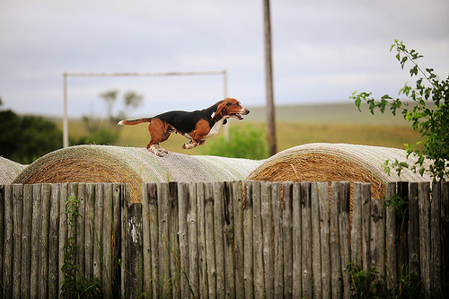
The original
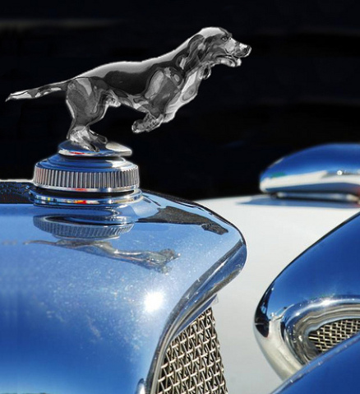

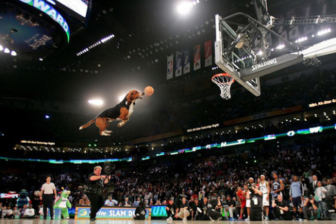

Microsoft Ad Changes Man’s Race
In August, the blogosphere went wild over an image in a Microsoft Corp. ad that had been edited to change a man’s race from black to white.
In a photo featured on the company’s U.S. Web site, three colleagues – one white, one black and one Asian – sit around a conference room table. But in the same photo on the company’s Polish site, the face of the black man had been replaced with the face of a white man.
The gaffe sparked quite the discussion online, as bloggers and commenters wondered if the change was racially motivated, the result of poor judgment or both. Some people suspected that the computer technology giant changed the Polish image so that it matched the country’s own racial composition.
It even inspired the popular tech blog TechCrunch to launch a contest to see who can manipulate the funniest head onto the Microsoft ad.
“So get Photoshop fired up and make your funniest (and yet not in any way offensive) version of the Polish Microsoft head replacement. No rules. Replace all the heads you want to. Add costumes and props. Add text bubbles,” it said on its site. The winner gets a Bing (Microsoft’s search engine) T-shirt in the mail.
Ultimately, the affair elicited an apology from Microsoft, which said in a statement, “We are looking into the details of this situation. We apologize and have replaced the image with the original photograph.”
Article and Photo: Heussner, Kai Mae. “11 Photo-Editing Flubs: Digitally Altered Photo Disasters.” ABCNews. com, Oct. 8, 2009. Web.

