Natural Resources Management
Packet # 11

Name: ________________________________ Date: ____________________

1. Which of your germinated seeds have grown the tallest?

_________________________________

2. How tall is their average height?

_____________________________

3. According to your research, would these plants be good to seed for wildlife food?

______________________________________________________________

4. Why or why not?

______________________________________________________________

______________________________________________________________

5. What other elements might these plants provide? Cover, nesting places, food that draws other species to the area?

________________________________________________________________

________________________________________________________________

Natural Resources Management
Packet # 12

Name: ________________________________ Date: ____________________

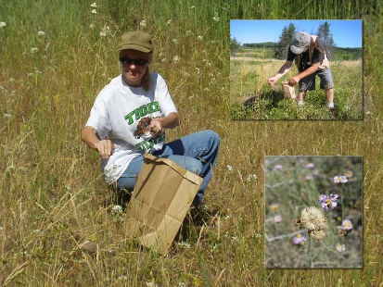
Collecting Native Seed

U. S. Forest Service, US Department of Agriculture

For many native species, collecting wildland seed is the first step in a lengthy process of making plant materials available for restoration projects. Successful seed collection involves planning ahead and monitoring for maturity. Suitable donor populations must be located and seeds must be collected at the appropriate time once they are mature. The window for collection is highly variable among species, ranging from only a few days to several weeks or longer. If the window is missed, collection must wait until the next year or growing season, at a minimum.
Forest Service seed collections are made by volunteers, staff, and professional collectors under contract. Regardless of the method, supervisory controls are in place to ensure that collection sites are not located within off-limit areas, such as in Research Natural Areas, sensitive or federally listed plant sites, or other environmentally sensitive areas. Also avoided are collection sites occupied by invasive plant species.
Although hot and challenging at times, wildland seed collection is rewarding work.
For each target species, collection sites are located using guidelines that ensure a representative sample of genetic variation is obtained. The specific number and distribution of collection sites will vary according to size, density, continuity of populations, and biology of the species sampled, as well as the desired quantity of seed to be obtained. A general rule of thumb is to collect from a minimum of five collection sites at least 0.5-1.0 mile apart.
A larger number of collection sites may be needed for inbreeding plant species to adequately sample genetic variation among populations. Within-population genetic variability is sampled by collecting from a large number of widely spaced or unrelated plant parents (30-50 or more plants is optimal).

Answer these questions about the above article:

Seeds may not be collected from off limit areas such as:
1. ________________________________
2. ________________________________
3. ________________________________
4. ________________________________

The specific number and distribution of collection sites will vary according to 5. _______________, 6. _______________, continuity of 7. ______________ and biology of the 8. __________ sampled, as well as the desired 9. ______________ of seed to be obtained.

Natural Resources Management
Packet # 13

Name: ________________________________ Date: ____________________

1. You planted three different species in peat pots that can then be planted directly into the ground. Compare this with spreading seed of plants for wildlife use. Which method might be more effective and why?

________________________________________________________________________

________________________________________________________________________

________________________________________________________________________

2. Would the best method change if you were planting perennials (which live many years such as trees and shrubs) compared to the annuals (that live only one year) that you planted in your mini greenhouse?

_______________________________________________________________________

_______________________________________________________________________

_______________________________________________________________________

Natural Resources Management
Packet # 14

Name: ________________________________ Date: ____________________

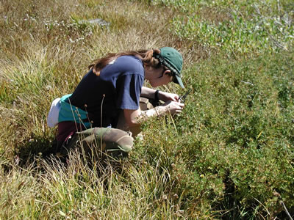
Collecting Native Seed
U. S. Forest Service, US Department of Agriculture

Collection Methods
Seed collection methods will vary depending on the species. Grass seed is harvested by stripping or shaking it off the stem, or by clipping the stem with scissors or small scythes just below the spikelet. Shrub seed is picked or lightly beaten or shaken, using a tarp to catch the falling seed. For species that dehisce explosively, the entire inflorescence may be cut prior to maturity and allowed to dry in mesh or paper bags, or under netting.
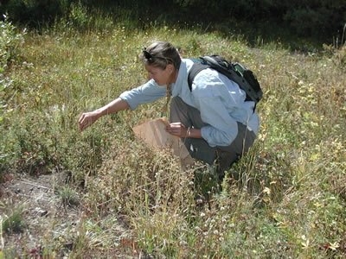
Ladders may be required for collecting seed from taller shrubs, or plants can be lightly pruned with telescoping pole pruners. For large-scale harvesting, specialty equipment and machines may be necessary. Whatever the method, collections should always be conducted in a manner that does not damage existing vegetation or other resources. Ideally, at least 50 percent of the seed crop at a given site is left intact to allow for natural recruitment and regeneration of the native population.
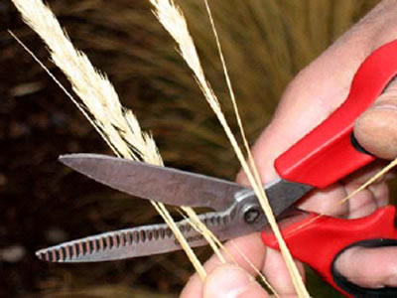
Close monitoring is required to match the timing of seed collection activities to the distribution of seed maturation. Multiple trips to a site may be required for determining when the seed is mature, and also for collecting. Collecting at multiple times throughout the maturation period can help prevent inadvertent selection against either early or late maturing genotypes.

Storage
Seed must be collected and stored in such a way as to ensure its viability. Overheating can kill seeds, and excessive heat and temperature fluctuations should be avoided. High moisture content during storage can also cause seed damage and loss of viability due to molds. A good rule of thumb is the 100 rule of thumb, where the sum of temperature (degrees F) and relative humidity (%) does not exceed 100.

Answer these questions about the above article:

1. Seed must be collected and stored in such a way as to ensure its _______________
2. Seed collection methods vary depending on the ____________
3. Multiple trips to a site may be required for determining when the seed is ____________
Whatever the method, collections should always be conducted in a manner that does not damage existing 4. _________ or other 5. ______________

Natural Resources Management
Packet # 15

Name: ________________________________ Date: ____________________

Weekly Update

Name of the seed: ______________________

Number of seeds planted: _______________

Germination Percentage: ________________

Average height: _______________________

General health/Notes: ________________________________________________________

~~~~~~~~~~~~~~~~~~~~~~~~~~~~~~~~~~~~~~~~~~~~~~

Name of the seed: ______________________

Number of seeds planted: _______________

Germination Percentage: ________________

Average height: _______________________

General health/Notes: ________________________________________________________

~~~~~~~~~~~~~~~~~~~~~~~~~~~~~~~~~~~~~~~~~~~~~~~~

Name of the seed: ______________________

Number of seeds planted: _______________

Germination Percentage: ________________

Average height: _______________________

General health/Notes: ________________________________________________________

