AP Physics Day 1

Slide 1

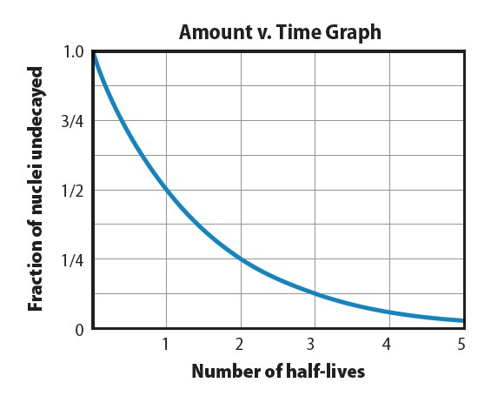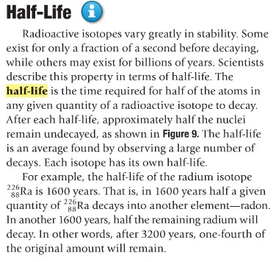
Nuclear Decay and Reactions
Copyright © McGraw
₋
_{Hill Education}
Half
-
Life
•
The time required for half of the
atoms in any given quantity of a
radioactive isotope to decay is
the
half
-
life
of that
element
.
•
If
you know the original amount
of a radioactive substance and
its half
-
life, you can calculate the
amount remaining after a given
number of half
-
lives
.
¹
remaining
original
2
_{t}
 

 
 
Half
-
Life

Slide 2

Half-Life
- Each particular isotope has its own half-life.
- Half-lives of radioactive isotopes are used to date objects.
- The decay rate, or number of decays per second, of a radioactive substance is called its activity.
- Activity is proportional to the number of radioactive atoms present. Therefore, the activity of a particular sample is also reduced by one-half in one half-life.
- The activity of a sample is also related to its half-life. The shorter the half-life, the higher the activity.
- The SI unit for decays per second is a Becquerel (Bq).
Copyright © McGraw_{-Hill Education} Nuclear Decay and Reactions

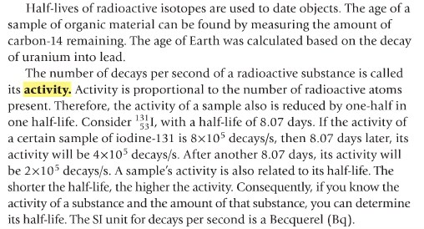

Activity: Solve the following half-life problems.
- Fluorine-21 has a half life of approximately 5 seconds. What fraction of the original nuclei would remain after 1 minute?

- Iodine-131 has a half life of 8 days. What fraction of the original sample would remain at the end of 32 days?

- The half-life of chromium-51 is 28 days. If the sample contained 510 grams, how much chromium would remain after 56 days? How much would remain after 1 year? How much was present 168 days ago?

- If 20.0 g of a radioactive isotope are present at 1:00 PM and 5.0 g remain at 2:00 PM, what is the half life of the isotope?

- The half life of Uranium-238 is 4.5 billion years and the age of earth is 4.5 X 10⁹ years. What fraction of Uranium-238 that was present when Earth was formed still remains?

- Chromium-48 decays. After 6 half-lives, what fraction of the original nuclei would remain?

- The half life of iodine-125 is 60 days. What fraction of iodine-125 nuclides would be left after 360 days?

- Titanium-51 decays with a half life of 6 minutes. What fraction of titanium would remain after one hour?

- A medical institution requests 1 g of bismuth-214, which has a half life of 20 min. How many grams of bismuth-214 must be prepared if the shipping time is 2 h?

- The half life of radium 226 is 1602 years. If you have 500 grams of radium today how many grams would have been present 9612 years ago?

