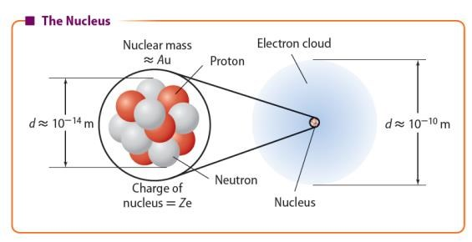
The Nucleus
Copyright © McGraw
-
Hill Education
Description of the Nucleus
•
Atoms consist of a dense, positively charged nucleus that is surrounded by
an electron cloud.
•
The nucleus contains positively charged protons and uncharged neutrons.
Protons and neutrons are collectively referred to as
nucleons.
•
The number of protons is the
atomic number
(
Z
).
•
The number of nucleons is the
mass number
(
A
).
•
The mass of a proton
or
neutron
is about 1 atomic
mass
unit (u). An
atomic
mass
unit
is a unit of
mass
equal to
1.66
×
10
⁻
²⁷
kg.

Review vocabulary:
Nucleus – the tiny, massive, positively charged central core of an atom.
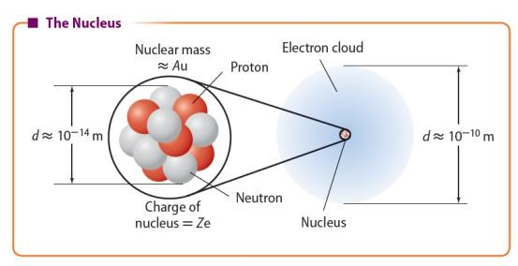
The Nucleus
Copyright © McGraw
-
Hill Education
Description of the Nucleus
•
The total charge on the nucleus is equal to the atomic number times the
fundamental charge.
•
The mass of the nucleus is approximately equal to the mass number times 1
atomic mass unit.
nuclear charge =
Z
e
nuclear mass

A
u

Isotopes
- Recall that an element can have more than one isotope. That is, atoms of an element can have different masses.
- All nuclei of an element have the same number of protons but can have different numbers of neutrons.
- All isotopes of a neutral element have the same number of electrons as protons and behave chemically in the same way.
- A special method of notation is used to describe an isotope.
Mass number A
X Element symbol
Z
Atomic number
Copyright © McGraw-Hill Education The Nucleus

Q: Compare and contrast the isotopes of carbon-12 and carbon-14.

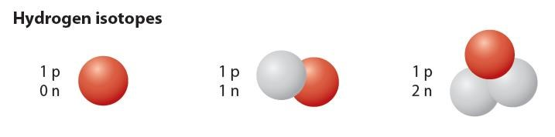
The Nucleus
Copyright © McGraw
-
Hill Education
Isotopes
•
Most elements have several isotopic forms that occur naturally.
•
The atomic mass listed in the periodic table is weighted average mass
of the naturally occurring isotopes of the element.
•
While the mass of an individual atom is close to a whole number of
mass units, the atomic mass determined from an average sample of
atoms does not have to be.
•
The mass of the isotope carbon
-
is now used to define the mass unit.
12
One u is defined to be 1/12 the mass of the carbon
-
isotope
12
.

Q: Identify the mass number and the electric charge of each Hydrogen nucleus in the slide above.

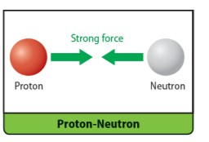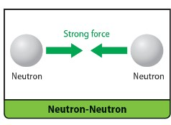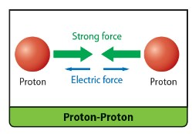
The Nucleus
Copyright © McGraw
-
Hill Education
The Strong Nuclear Force
•
The protons in the nucleus repel each other, but the
nucleus does not fly apart because an even stronger
attractive force exists within the nucleus.
•
The
strong nuclear force
is an attractive force
between nucleons that are close together, as they are
in a nucleus. It is the strongest of the four
fundamental forces.
•
The strong force has a range on the order of 10
⁻¹⁵
m.
Outside this range, the effects of the strong force are
minimal.
•
The strong nuclear force has the same strength
between all nucleon
pairs
but does not
affect
electrons.
•
The strong force is also responsible for holding
together the particles that make up protons and
neutrons.

The strong force is the same between all pairs of nucleons.

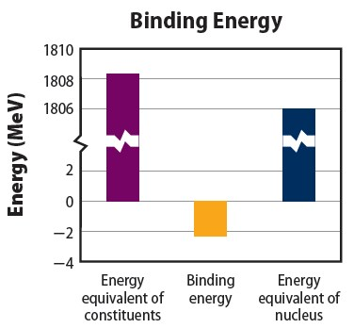
The Nucleus
Copyright © McGraw
-
Hill Education
The Strong Nuclear Force
•
The mass of an assembled nucleus is less
than
the
sum of the masses of the protons
and
neutrons
that compose it.
•
This difference between the sum of the
masses
of
the individual nucleons and the
actual mass
is
called the
mass defect.
•
To
pull a nucleon out of a nucleus, you
have to
do
work to overcome the strong
nuclear force.
•
Doing work adds energy to the
system and
so the system
of separated protons and
neutrons has
more
energy than the
assembled nucleus.
•
This energy difference between separated
nucleons and the assembled nucleus is
the
binding energy
of the nucleus
.

The energy equivalent of the mass of the individual nucleons is equal to the energy equivalent of the mass of the bound nucleus plus the binding energy.

The Nucleus
Copyright © McGraw
-
Hill Education
The Strong Nuclear Force
•
Because the assembled nucleus has less
energy, all binding energies are negative.
•
The binding energy can be expressed in the
form of an equivalent amount of mass,
according to Einstein’s famous equation.
•
At this scale, the most convenient unit of
mass is the atomic mass unit
= 1.6605
(1
u
×
10
⁻²⁷
kg
)
and the most
convenient
of energy is the electron volt

(1
eV
= 1.60218
×
10
⁻¹⁹
J).
•
The
energy equivalent of 1
u is 931.49 MeV.
²
c
E m

Energy Equivalent of Mass

Q: Describe the meaning of the equation E = 931.49 MeV/u, and explain why it is important.

The Strong Nuclear Force  Use with Example Problem 1.  Problem  Use the information in the table below to compare the mass defect and binding energy of deuterium,  ²₁ , with that of helium, ₂ e.  KnownMasses  mhydrogen atom 1.007825 u  mneutron 1.008665 u  mdeuterium atom 2.014102 u  mhelium atom 4.002603 u  Response  SKETCH AND ANALYZE THE PROBLEM  • List the unknowns. The knowns are listed in the table above. | UNKNOWN  mass defect of deuterium = ? binding energy of deuterium = ?  mass defect of helium = ? binding energy helium = ?  SOLVE FOR THE UNKNOWN  - Calculate the mass of the parts of deuterium.  mass of hydrogen: 1.007825 u mass of neutron: 1.008665 u mass of parts of deuterium: 2.016490 u  - Calculate the mass defect of deuterium.  mass of deuterium: 2.014102 u mass of parts of deuterium: 2.016490 u mass defect of deuterium: 0.002388 u
Copyright © McGraw-Hill Education | The Nucleus

The Strong Nuclear Force  Use with Example Problem 1.  Problem  Use the information in the table below to compare the mass defect and binding energy of deuterium,  ²₁ , with that of helium, ₂ e.  KnownMasses  mhydrogen atom 1.007825 u  mneutron 1.008665 u  mdeuterium atom 2.014102 u  mhelium atom 4.002603 u  Response  SKETCH AND ANALYZE THE PROBLEM  • List the unknowns. The knowns are listed in the table above. | UNKNOWN  mass defect of deuterium = −0.002388 u binding energy of deuterium = ? mass defect of helium = ? binding energy helium = ?  SOLVE FOR THE UNKNOWN  - Calculate the mass of the parts of helium.  mass of 2 hydrogen atoms: 2.015650 u mass of 2 neutrons: 2.017330 u mass of parts of helium: 4.032980 u  - Calculate the mass defect of helium.  mass of helium: 4.002603 u mass of parts of helium: 4.032980 u mass defect of helium: 0.030377 u
Copyright © McGraw-Hill Education | The Nucleus

UNKNOWN
The Strong Nuclear Force mass defect of deuterium = −0.002388 u
binding energy of deuterium = ? mass defect of helium = −0.030377 u Use with Example Problem 1.
_{Problem} binding energy helium = ?
Use the information in the table
below to compare the mass defect ^{SOLVE FOR THE UNKNOWN} and binding energy of deuterium, • Calculate the binding energy for deuterium and
KnownMasses
mhydrogen atom | 1.007825 u
mneutron | 1.008665 u
mdeuterium atom | 2.014102 u
mhelium atom | 4.002603 u
21 , with that of helium, 2 e. for helium. binding energy  mass defect 931.49 MeV/u   ^{deuterium}   0.002388 u 931.49 MeV/u
binding energy
 2.2244 MeV
^{helium}   0.030377 u 931.49 MeV/u
binding energy
 28.296 MeV
^{Response} EVALUATE THE ANSWER
SKETCH AND ANALYZE THE PROBLEM • The binding energy and mass defect of helium
• List the unknowns. The knowns are are about 10 time those of deuterium. listed in the table above.
Copyright © McGraw-Hill Education The Nucleus

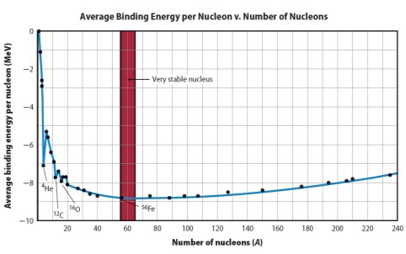
The Nucleus
Copyright © McGraw
-
Hill Education
The Strong Nuclear Force
•
A more negative average binding energy indicates tightly bound nucleons and
a more stable nucleus.
•
The binding energy per nucleon depends on the mass of the nucleus.
The
most stable nucleus is iron
-
56.
•
Large, unstable nuclei will readily decay into smaller, more stable nuclei. For
example, all nuclei with atomic
numbers
greater than 92
decay
readily.
•
Under certain conditions,
such
as
high
temperature,
nuclei
smaller than iron
-
56

can
fuse into larger, more
stable
nuclei.

The binding energy per nucleon changes as the number of nucleons (A) varies. Iron-56 has the most tightly bound nucleus and is the most stable isotope known.

𝟏𝟑𝟏 𝟐𝟑𝟔
Q: Infer which nucleus 𝑰 or Pu, would you expect to have a larger-magnitude average binding 𝟓𝟐 𝟗𝟒
energy per nucleon?

Activity: Complete the following problems.

Use these values to solve the following problems:
Mass of hydrogen = 1.007825 u
Mass of neutron = 1.008665 u
1 u = 931.49MeV

- The carbon isotope ¹²C has a mass of 12.000000 u. 6
  - Calculate its mass defect.
  - Calculate its binding energy.

- Deuterium (²H) has a mass of 2.014102 u. 1
  - Calculate its mass defect.
  - Calculate its binding energy.

- The nitrogen isotope (²H) has a mass defect of -0.113986 u.
1
  - Calculate the mass of this isotope.
  - Calculate the binding energy of the nucleus.

