AP Physics Snow Day 3
Exploring Refraction
You will be exploring the behavior of a ray of light at the boundary, or interface, between two materials.
Activity #1:
Define the following terms:

Reflection:
__________________________________________________________________________________________ __________________________________________________________________________________________
Refraction:
__________________________________________________________________________________________ __________________________________________________________________________________________
Transmission:
__________________________________________________________________________________________ __________________________________________________________________________________________
Angle of Incidence:
__________________________________________________________________________________________ __________________________________________________________________________________________
Angle of Refraction:
__________________________________________________________________________________________ __________________________________________________________________________________________
Index of Refraction:
__________________________________________________________________________________________
__________________________________________________________________________________________

Activity #2:
Go to this website: http://www.physicsclassroom.com/Physics-Interactives/Refraction-and-Lenses/Refraction/RefractionInteractive

Click on the upper left-hand corner of the graphic below to launch the interactive module in full screen.

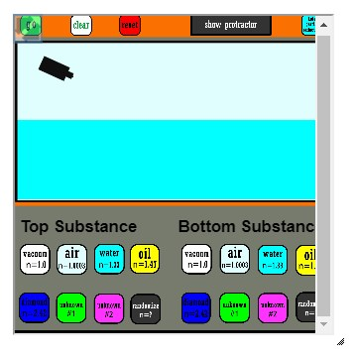
Use this interactive to answer the following questions.

- What affect does an increase in the angle of incidence have upon the angle of reflection?
____________________________________________________________________________________
____________________________________________________________________________________
____________________________________________________________________________________

- What affect does an increase in the angle of incidence have upon the angle of refraction?
____________________________________________________________________________________
____________________________________________________________________________________
____________________________________________________________________________________

- Under what conditions are the angles of incidence greater than the angles of refraction?
____________________________________________________________________________________
____________________________________________________________________________________
____________________________________________________________________________________

- Every substance has its own unique index of refraction (n). For light passing from air to another material, what affect does increasing the angle of incidence have upon the angle of refraction?
____________________________________________________________________________________
____________________________________________________________________________________
____________________________________________________________________________________

- Under what conditions is the angle of incidence greater than the angle of refraction? And under what conditions is the angle of incidence less than the angle of refraction?
____________________________________________________________________________________
____________________________________________________________________________________
____________________________________________________________________________________

Lesson adapted from http://www.physicsclassroom.com

