Tracy Transaction’s Checking Account Transactions
Directions: Record the following transactions on a checking account register. Be sure to record the information carefully. Also be sure to do the arithmetic accurately.
1. Beginning Balance in Tracy’s checking account - $300
2. Tracy paid Sneaker World $63 for new sneakers on Oct. 15 with a debit card
3. Tracy deposited her paycheck on Oct. 21 in the amount of $43.25
4. Tracy wrote check #101 for $17.75 to Randy’s Records on Oct. 25
5. Tracy wrote check #102 for $9.45 to Brandon’s Books on Oct. 25
6. Tracy made a withdrawal of $20.00 using her ATM card at a TD Bank on Oct. 25
7. Tracy deposited her paycheck on Nov. 5 in the amount of $43.25
8. Tracy wrote check #103 for $18.00 to her school to add money to her lunch account
on Nov. 6
9. Tracy made a withdrawal of $20.00 using her ATM card at another bank on Nov. 7 and was charged a fee of $1.50
10. Tracy deposited her birthday money $125.00 on Nov. 12

SAMPLE CHECKING ACCOUNT STATEMENT
Statement Date 11/15/18
Tracy Transaction
555 Deposit Lane 1112223339
Cherry Hill, NJ 08034 Account Number

*** Checking***
Account Number 1112223339
Previous Statement Balance as Of 10/14/18……………………. 300.00
Plus 3 Deposits and Other Credits………………………. 211.50
Less 6 Checks and Other Debits………………………… 149.70
Current Statement Balance as Of 11/15/18……………………. 361.80
Number of Days in This Statement Period 33

***Checking Transactions***
Serial Date Amount
101 10/25 17.75
102 10/25 9.45
103 11/6 18.00

***Checking Account Transactions***
Date Description Debits Credits
10/17 POS Debit 10/15 63.00
Sneaker World
10/21 Deposit 43.25
10/25 Withdrawal 10/25 20.00
TD Bank, N.A.
11/5 Deposit 43.25
11/7 Withdrawal 20.00
Fee Assessed By
Non-TD Bank 1.50
11/12 Deposit 125.00

***Balance by Date***
10/15 300.00 11/6 258.30
10/25 233.05 11/14 361.80
Statement Date 11/15/18

THIS STATEMENT REPRESENTS AN ACCOUNTING BETWEEN THE BANK AND YOU. IF THERE
IS AN ERROR IN IT, CALL IT TO THE BANK’S ATTENTION PROMPTLY IN WRITING. FAILURE TO
DO SO WITHIN 14 DAYS FROM THE DATE OF THIS STATEMENT MAY BAR YOUR RIGHT TO
HAVE THE ERROR CORRECTED. NOTICE MUST BE SENT BY CERTIFIED MAIL TO US AT THE
ADDRESS LISTED ON THE FRONT OF THIS STATEMENT.

Balance Reconciliation
1. Enter Ending Balance ______________
2. Add deposits recorded in your checkbook but not shown
on the reverse side of this statement. Enter the interest
earned deposit in your checkbook. ______________
3. Total (1 and 2 above) ______________
4. Enter Total “Checks Outstanding” (from bottom column) ______________
Balance (3 less 4 should equal your checkbook balance) ______________

Checks Outstanding
(Written by you but not yet indicated as paid on any statement)

Check Number or Date Amount
TOTAL

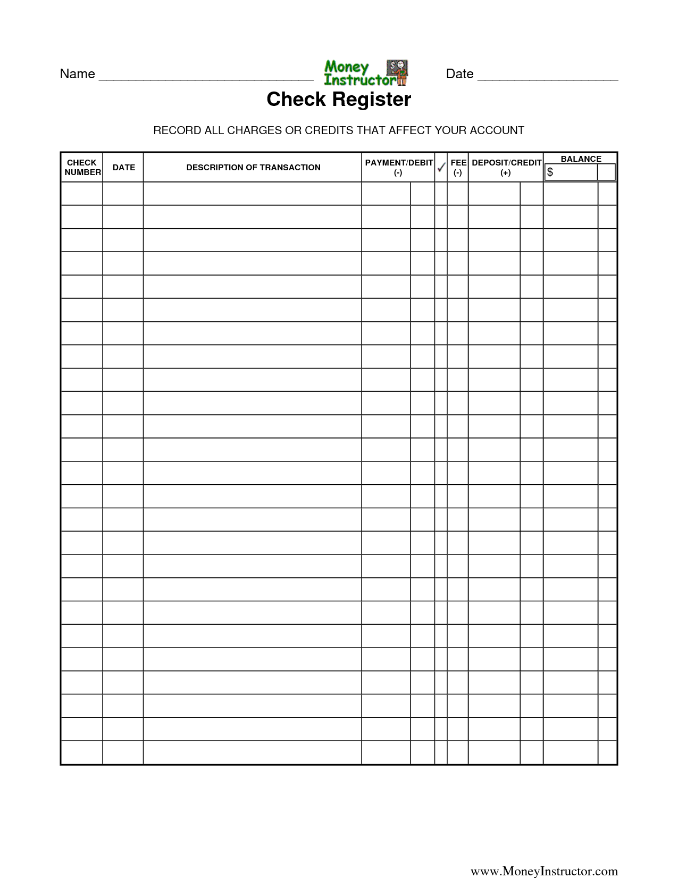
The Best Paying Job……..

Do help wanted ads tell you exactly how much you’ll make when you get a job? This lesson will help you figure out the take-home pay you can expect from the jobs described in the ads.

Quick Reference
These abbreviations and terms are important to know:
Hrs./Day = total number of hours worked in 1 day
Days/Wk. = total number of days worked in 1 week
FWT = Federal Withholding Tax
FICA = Social Security Tax under the Federal Insurance
Contribution Act
Gross pay = hourly rate x total hours worked
Deductions = total taxes and other payments paid
by the employee
Net pay = gross pay – deductions
Taxes withheld usually come from tables provided by
the government to employers. Higher gross pay usually
means higher percentage of tax deducted.
PHOTOGRAPHERS
$10.40/hr.
9:30–3:30 p.m., 5 days a wk. Talented people
needed for on-location assignments. Write to:
Conte’s Photos 1475 Queen St.
West Toronto, Ontario

FAST FOOD CASHIER TRAINEE
$6.50/hr.
5 days, 9–1 p.m. or 1–5 p.m.
Ideal for students and working
parents. Will train.
Call Benny’s Burgers 672-4785.

TRAVEL GUIDE
$8.80/hr.
5 hrs./day, 5 days /wk. Must speak fluent
Japanese. J-Tours, 201 E. 50th St., Fifth Fl.

Fill in the missing amounts on the weekly check stub for each job. Follow the steps used in the example.
1. PHOTOGRAPHER 2. FAST FOOD CASHIER TRAINEE 3. TRAVEL GUIDE
Hrs./Day FWT Hrs./Day FWT Hrs./Day FWT
6 $46.80
Days/Wk. FICA Days/Wk. FICA Days/Wk. FICA
5 $22.50
Total Hrs. State Total Hrs. State Total Hrs. State
30 $16.85
City City City
$10.92
Other Other Other
Rate Rate Rate
$10.40 Total Deduction Tot. Ded. Tot. Ded
Gross Pay B. $97.07 Gross Pay B. Gross Pay B.
A. $312.00 Net Pay A. Net Pay A. Net Pay
C. $214.93 C. C.

