“The time is now for our country to help young farmers”
#4

FoodTank The Think Tank for Food
https://foodtank.com/news/2017/11/2017-national-young-farmer-survey/
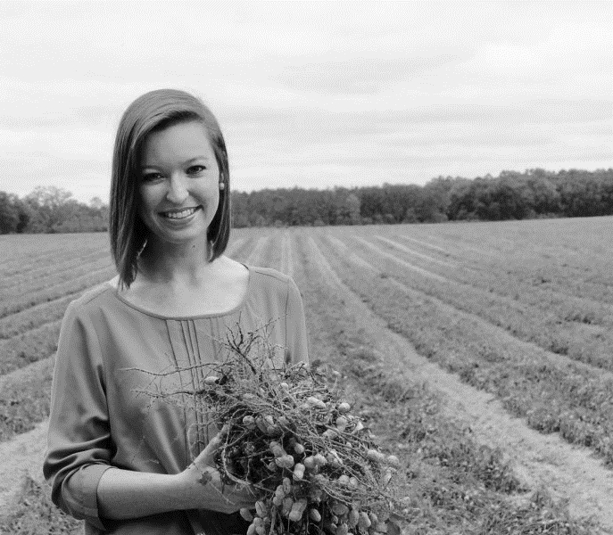
A new report from the National Young Farmers Coalition (NYFC) discusses the results of the 2017 National Young Farmer Survey. The number of American farmers is decreasing and their average age is increasing, as reported by the U.S. Department of Agriculture (USDA). This survey examines the needs and challenges of young farmers to determine how to encourage a new generation of farmers.
“The time is now for our country to help young farmers defy the odds, preserve farming as a livelihood, and revitalize our nation’s rural economy,” says Lindsey Lusher Shute, Executive Director and Co-founder of NYFC. “This report proves that there are thousands of young people ready to build new farms in the United States, but we’ve got to do our part and make sure that they will succeed.”
The survey collected data from over three thousand former, current, and aspiring farmers under 40 years of age in the United States with the help of 94 partner organizations and in partnership with Dr. Kathleen Merrigan, Executive Director of Sustainability at George Washington University and former U.S. Deputy Secretary of Agriculture. The survey found generational differences in farming, including more diversity in demographics and crops.
“Things are changing in American agriculture and our perceptions and policies need to keep pace,” says Dr. Merrigan. “This survey reveals that it’s no longer Old MacDonald of storybook fame. Rather, it’s Ms. MacDonald, a college graduate who didn’t grow up on the farm and considers her farming practices to be sustainable or organic.”
Young farmers are operating smaller farms and are capitalizing on the demand for local food by selling directly to consumers. 75 percent of current young farmers describe their farms as ‘sustainable,’ while 63 percent are ‘organic.’ The average survey participant was more educated than the average American, with 14 percent completing a master’s degree. 60 percent were female and 75 percent were first-generation farmers.
The main concerns for young farmers are access to land, student loan debt, availability of skilled labor, and access to health insurance. Based on the survey results, the NYFC is supporting a series of policy reforms called the Young Farmer Agenda. The agenda addresses the concerns found in the survey as well as finding ways to engage young farmers to invest in on-farm conservation, improving credit and risk management opportunities, and addressing racial inequity among farmers.
“America desperately needs young people to repopulate our farm and ranch lands. This survey reveals the daunting challenges they face. As policymakers sit down to write our next farm bill, I hope they pay attention to these survey findings,” says Dr. Merrigan. “If nothing more is done to help transition young people into American agriculture, we will be importing all our food.”
A. Short Answer

How can we get more young people to become farmers?

___________________________________

___________________________________

___________________________________

~~~~~~~~~~~~~~~~~~~~~~~~~~~~~~~~

B. Word Search

D T R A N S I T I O N C
M E L B A N I A T S U S
D I M D S L N R U F N T
A B P O G U S N A O L U
H L H G G U U M I J F D
M X T Z R R R T L K S E
M R E V I T A L I Z E N
K M E S P R N P L W L T
C Y K Y E J C A H H Y Z
S Z A N Q E E J P I A B
Z D E L O R G A N I C V
U G U I X Q F M J T R S

Survey Generation Revitalize
Demographics Sustainable Organic
Student loans Insurance Risk
Transition

~~~~~~~~~~~~~~~~~~~~~~~~~~~~~~~

C. Fill in the Blank

The average survey participant was:
1. more _______________,
2. _____________ percent female, and
3. ____________ percent first-generation farmers.
4. There are thousands of _______________ people ready to build new farms.

5. If more things are not done to help transition young people into farming, we will be ________________ all our food.

It’s no longer 6. _________ MacDonald of storybook fame, it’s 7. _______ MacDonald.

75 % of current young farmers describe their farms as 8. ______________ while 63 % are 9. _____________

10. This survey examines the needs and challenges of young farmers to determine how to encourage a new ____________ of farmers.

~~~~~~~~~~~~~~~~~~~~~~~~~~~~~~~~

D. Summarize the Assignment

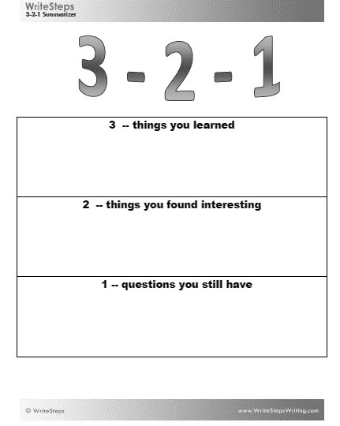

Northeast farmers weigh warming climate, drenched fields
#5

Cornell University
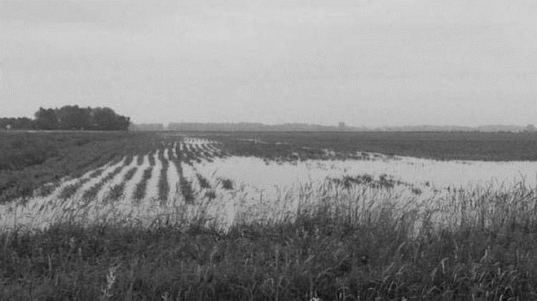
December 14, 2017

Farmers in the Northeast are adapting to longer growing seasons and warming climate conditions -- but they may face spring-planting whiplash as they confront fields increasingly saturated with rain, according to a research paper published in the journal Climatic Change.
"Climate change can easily intensify agricultural susceptibility, but also presents fresh, surprising opportunities," said David Wolfe, professor of plant and soil ecology at Cornell University and senior author of the paper.
For the past two decades, the Northeast has been getting warmer for longer periods of time. It also has seen a 71 percent increase in the frequency of extreme precipitation events -- more than any other region in the United States, according to the paper. Heavy rainfall, for example, increases the likelihood of diseases such as potato and tomato late blight, along with plant-root fungal problems that stress carrots and other root vegetables.
"Heavy rains not only cause disease problems, but can prevent farmers from having access to the fields to plant in spring or to harvest in fall," Wolfe said.
While warmer temperatures expand the agricultural production season, climate change warms oceans and creates a more energetic atmosphere. This, in turn, brings more rainfall, said Art DeGaetano, professor of climatology and director of the Northeast Regional Climate Center at Cornell. Such rainfall extremes are projected to continue through the current century, according to the paper.
For several years, the researchers examined the rainfall three weeks prior to the last frost. "The date of the last frost in the spring gets earlier and earlier. But that pushes you against the time when rainfall increases the most," said DeGaetano.
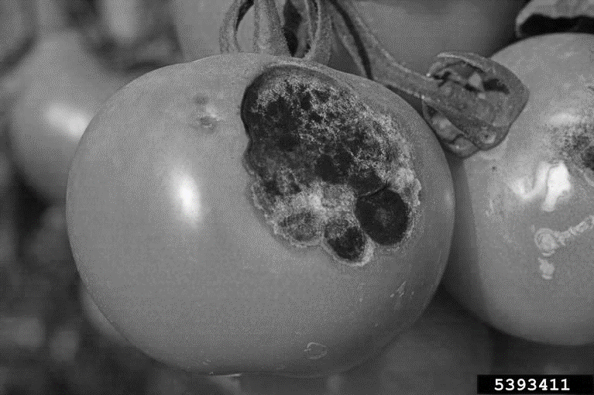
Fresh market vegetable grower profit is based on reaching markets early, when the crop's value is greatest. Delayed planting due to wet spring soils can have negative financial effects. Farmers can try planting a field even when it is wet, but using heavy farm equipment compacts soil and decreases its ability to hold water, diminishing yield potential.

~~~~~~~~~~~~~~~~~~~~~~~~~~~~~~~~
A. Short Answer

Does global warming have enough of an effect on agriculture to warrant concern? Why or why not?

___________________________________

___________________________________

___________________________________
B. Word Search

Z L D K Y H C G J F
T P L E T W Z C Y U
W H S A L P I H W N
N A G T F A A O J G
O Q R I C N Y D F A
L K G M L A I E A L
K D W N E B P A D V
G S T E K R A M R H
B A N I K R Q W O Q
X M V J D X Q Z N C
Adapt Whiplash Climate
Rainfall Blight Fungal
Warmer Markets Delayed
Compacts

~~~~~~~~~~~~~~~~~~~~~~~~~~~~~~~

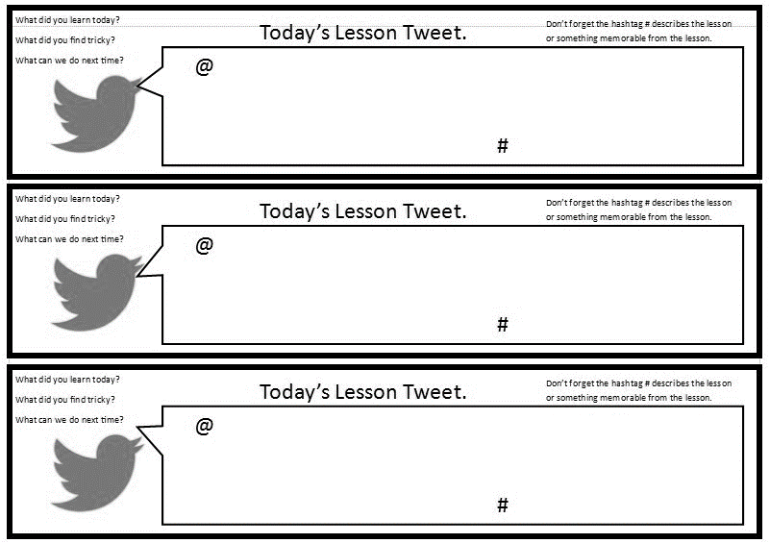
C. Fill in the Blank

Using heavy equipment on a wet field compacts 1. ___________ and decreases its ability to hold 2. ___________

The date of the last frost in the spring is getting 3. ______________

Climate change warms oceans and creates a more 4. ________________ atmosphere
Twitter about this
assignment; 240
characters

Heavy rains can prevent farmers from having 5. ___________ to fields in the spring and fall

Farmers are adapting to longer
6. _____________ seasons and
7. _________________ climate conditions.

Farmers have to confront increasingly
8. ____________ fields.

The Northeast has seen a
9. __________ present increase in the frequency of extreme
10. ___________________ events.

~~~~~~~~~~~~~~~~~~~~~~~~~~~~~~~

D. Create Tweets

Twitter about this
assignment; 240
characters

Exploring a world without
#1

food animals

USDA/Agricultural Research Service
December 6, 2017
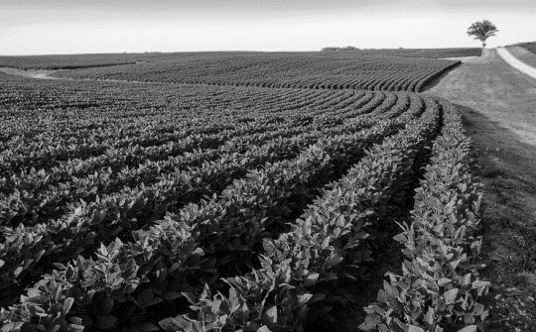
What would happen if U.S. farmers stopped producing animals for food and Americans went vegan? Some have called for a move in that direction to address increasing concerns about U.S. health, eating habits, and climate change. Researchers at USDA's Agricultural Research Service (ARS) and Virginia Tech recently explored those questions and found surprising results.
Mary Beth Hall, an ARS animal scientist at the U.S. Dairy Forage Research Center in Madison, Wisconsin, and Robin R. White, a professor of Animal and Poultry Science at Virginia Tech in Blacksburg, VA, found that shifting land usage from food animal production to food crop production would increase the total U.S. food supply by 23 percent. Because much of that land is unsuitable for high value crops, most of the additional food produced would include high-calorie crops like corn and soybeans.
A complete shift away from food animal production would present major challenges to meeting America's nutritional needs. With no meat, milk, eggs, fish, or cheese in our diets, the U.S. population would not receive enough of several different essential dietary nutrients from the foods they eat, according to the study results. The findings are based on information compiled in the USDA dietary guidelines.
"Different types of carefully balanced diets -- vegan, vegetarian, omnivore -- can meet a person's needs and keep them healthy, but this study examined balancing the needs of the entire nation with the foods we could produce from plants alone. There's a difference between what's possible when feeding one person versus feeding everyone in the U.S.," says Hall.
Eliminating food animals would increase deficiencies in calcium, vitamins A and B12 and some important fatty acids. The last are important as they help to reduce cardiovascular disease and improve cognitive function and vision in infants. Animal food products are the only available, non-supplemental sources of some fatty acids and vitamin B12.
A plant-only diet also would require individuals to eat more food and more daily calories to meet their nutritional needs from the foods they eat because the available foods from plants are not as nutrient dense as foods from animals.
Agriculture in the U.S. contributed to approximately 9 percent of the nation's total greenhouse gas emissions in 2015, with nearly half of that total coming from animal production, according to Environmental Protection Agency (EPA) reports. The scientists determined that eliminating food animals from U.S. production would reduce greenhouse gas emissions, but not by the full 49 percent of agricultural emissions that animals currently contribute. Rather, greenhouse gas emissions from agriculture would drop by 28 percent without farmed animals because of increases associated with producing additional food crops and the use of more synthetic fertilizer to replace manure. That would represent a drop of only about 2.6 percent of total U.S. emissions.
"A take-home message from the study was that we need to expand the way we think about food production to account for the complex consequences of changing any individual piece within the wider food system," says White.

~~~~~~~~~~~~~~~~~~~~~~~~~~~~~~~~
A. Short Answer

Can food animals be done away with globally? Why or why not?

___________________________________

___________________________________

___________________________________

~~~~~~~~~~~~~~~~~~~~~~~~~~~~~~~
B. Word Search

S I N E M O R W C N P S
V N J U M U E N A E O D
I A O J T Y I I L M F I
T G C I H R R C N A T C
A E C O S A I I L C I A
M V H E T S V E H A X Y
I M G E M O I H N Q C T
N C G A R P G M Z T M T
A E E E A H A M E N S A
V G R E E N H O U S E F
B N I M A T I V X E A B
U C Q Z Q H J G O I B G

CALCIUM FATTYACIDS
GAS EMISSIONS GREENHOUSE
NUTRIENTS OMNIVORE
VEGAN VEGETARIAN
VITAMIN A VITAMIN B
C. Fill in the Blank

1. Not producing food animals would represent a drop of only about __________ percent of total U.S. greenhouse gas emissions

2. The available foods from plants are not as nutrient __________ as foods from animals.

Some think that if we stop producing food animals that would address concerns about
3. __________,
eating 4. _____________,
and climate 5. _________________

~~~~~~~~~~~~~~~~~~~~~~~~~~~~~~~

D. Snapchat Story

Make your own Snapchat story about this assignement. Make two drawings and
use the texts boxes to write your message/description.

The Environmental Cost of a Loaf of Bread Will Give You
#2

Double Carb Regret

By Anne Tong in NEWS › FOOD, Feb 27, 2017

https://studentedge.org/article/the-environmental-cost-of-a-loaf-of-bread
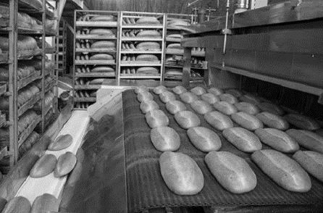

Scientists have launched an in-depth analysis into the environmental impact of a single loaf of bread, from the farm to the shop shelf.

What they found won’t be the best news for environmentally conscious carb lovers.
According to the BBC, the use of fertilizer to grow wheat accounts for 43 per cent of greenhouse gas emissions.
Researchers at the University of Sheffield wanted to assess the environmental impact of a common, daily staple. (Something you’d likely have for breakfast, like, every morning).
The team gathered data for emissions involved at every stage of the process; from growing the wheat, to fertilization and then harvesting. Not stopping there, they also analyzed data from transporting the grains to the mill, grinding the grains into flour, transporting the flour to a bakery, and then baking and packaging the loaf.
Lead researcher Dr. Liam Goucher argues every single loaf of bread embodies global warming because of the gargantuan amount of fertilizers used by farmers to increase their wheat harvest.
“People are well aware of where bread comes from but there’s a lack of understanding about perhaps the environmental impact of that bread or the emissions contained by that bread,” Goucher said.
Ammonium nitrate based fertilizers are being used “at unsustainable rates,” say researchers. “With over 100 million tons of fertilizer used globally each year to support agricultural production this is a massive problem,” warned Professor Peter Horton, a co-researcher on the study.
The team hope analysis of this sort will be used to create a market for foods with lower emissions in the future. Think, going into a supermarket or bakery and asking for “climate-smart bread”.
Exciting things to come for bread, apparently.

~~~~~~~~~~~~~~~~~~~~~~~~~~~~~~~~

A. Short Answer

Does this article make you rethink eating bread? Why or why not?

___________________________________

___________________________________

___________________________________

___________________________________
B. Word Search

Y F Z J K T M Q E A E X
R V M M A R J D V H M Z
E M F E Z E N A K D I B
K C H V F Z D X D C S N
A W A Y Q I W O Z G S Y
B Y N R E L P A T S I Y
L W N V B I C E Y Q O T
C V J Q M T S I Z Q N G
K X V P F R E A L V S I
T R A M S E T A M I L C
P C S A V F L O U R C M
T R A N S P O R T G W F

Carb Wheat Impact
Staple Transport Flour
Bakery Fertilizer Emissions
Climatesmart
~~~~~~~~~~~~~~~~~~~~~~~~~~~~~~~~

C. Fill in the Blank

1. The team hopes analysis of this sort will encourage people to ask for “___________ - ______________ ___________”

2. They studied data that involved __________________ the flour to bakery.

3. Dr. Goucher said farmers increase their harvest by using ______________ amounts of fertilizers.

4. Researchers wanted to assess the environmental impact of a common ___________ ______________

5. Goucher said there is a lack of understanding about the _______________ impact contained by bread.

6. The use of fertilizer to grow wheat accounts for _________ percent of greenhouse emissions.

7. __________________ ________________ based fertilizers are bring used at unsustainable rates, according to Goucher.

8. There is over ___________ million tons of fertilizer used globally each year.

9. The team studied an item you would have for ________________ every morning.

10. The team hopes to create a market for foods causing lower ______________ in the future.

~~~~~~~~~~~~~~~~~~~~~~~~~~~~~~~~~
D. Make a facebook post, including two pictures or drawings, about the assignment.

Full Harvest raises $2 million to stop farmers from tossing ‘ugly’ fruit and veggies
#3

Posted Apr 12, 2017 on TechCrunch, by Lora Kolodny (@lorakolodny)

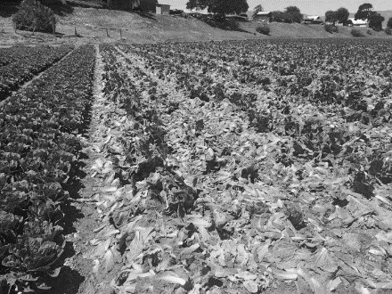
Full Harvest, a San Francisco-based startup, has raised $2 million in seed funding to reduce food waste at the farm level. Founded by Christine Moseley, formerly the head of business development for cold-pressed juice makers Organic Avenue, Full Harvest connects farmers with food makers who want to buy the fruit and veggies that grocers deem too ugly to sell in stores.
While she was helping grow Organic Avenue’s retail business, Moseley wanted to figure out how to secure lower-priced organic produce. It felt strange that her company was buying picture perfect fruits and vegetables knowing they’d soon be cold-pressed into juices. Organic Avenue also paid a high price for that pretty produce, driving the cost of its healthful juices above $10.
But Moseley’s true a-ha moment came when she was visiting an organic, romaine lettuce farm, she said: “I was standing with beautiful green romaine leaves up to my calves. The farmers were throwing out all these crunchy, green leaves because they were looking for just the perfect heads of lettuce for the stores.”
World awareness of food waste has increased in recent years, partly owing to better tools to study the phenomenon. In 2014, the UN Food and Agriculture Organization released startling research that found at least one-third of food produced each year is wasted, and saving just one-quarter of it could feed the world’s starving people. That same report pointed out food wasted on the farm level in industrialized nations was a major culprit. That’s when Moseley started Full Harvest.
Startups and reports like this are making a cultural impact. By now, groceries including Sainsbury’s and Tesco in the UK, and some Whole Foods Markets in the US, are starting to sell a limited amount of twisted carrots, twinned strawberries and lumpy potatoes, for example. But farms still waste 20% to 40% of produce that they grow because it does not fit grocers’ cosmetic standards.
Greater and immediate demand for “ugly” fruit can be unlocked by tapping into other markets, Moseley believes, like companies that make juice, soups and sauces, baby food, frozen foods and even pet foods. Full Harvest is not alone in its mission. Its competition includes regional food nonprofits like Borderlands Food Bank that divert produce before it goes to a landfill, and other tech startups, most directly Boston-based Spoiler Alert. Spoiler Alert helps large food makers sell, or donate, what would be wasted.
Full Harvest’s seed investors included: Wireframe Ventures. BBG Ventures, Early Impact Ventures, Impact Engine, Radicle, Astia and Joanne Wilson. The deal represents a first from Radicle’s new agriculture-focused fund. Radicle’s CEO and Managing Partner Kirk Haney said, “Now, it’s all about market adoption for Full Harvest. As they get more farmers and growers on the sell side, and buyers on the marketplace, they will start to have a bigger impact, and experience the ‘network effect’ we see in other marketplaces whether that’s Alibaba, Amazon Prime or Rent the Runway.”
Moseley said her company will use its funding to add new features and functionality to its platform, to expand their team from 10 to about 20 employees over the next year and to let food industry players know they now have a means to curb food waste at the farm level.

~~~~~~~~~~~~~~~~~~~~~~~~~~~~~~~~

A. Short Answer

What do you think should happen to “ugly food” and how would YOU make it happen?
___________________________________

___________________________________

___________________________________

~~~~~~~~~~~~~~~~~~~~~~~~~~~~~~~

B. Fill in the Blank

In 2014, the UN Food and Agriculture Organization released startling research that found at least 1. __________________ of food produced each year is
2. __________________, and saving just
3. __________________ of it could feed the world’s starving people.

4. Greater and immediate demand for _________________ fruit can be unlocked by tapping into other markets.

Spoiler Alert helps large food makers sell, or donate, what would be
5. ______________.
C. Word Search

H N P S Z E D W P M
L Q T W I N N E D U
E L W W X O V Y L D
P T I S D R I H T D
F W S F U G L Y L R
R Q T A D A D P Y J
M D E M W N E M C M
H P D G V I A U X U
P E R F E C T L W M
G N I V R A T S M R

Waste Ugly Organic
One third Starving Landfill
Twisted Twinned Lumpy
Perfect
~~~~~~~~~~~~~~~~~~~~~~~~~~~~~~~
D. Instagram Post

Draw a picture and write a caption about the topic

Draw a picture and write a caption about one point

