**Five Weird Jobs With Animals That You’ll Absolutely Love**

**#1**

<https://theleap.co.uk/jobs-with-animals/>

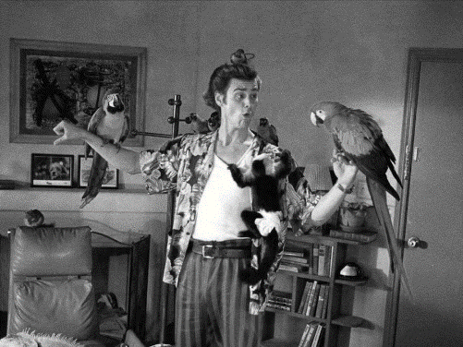 As a nation of animal lovers, it’s surprise that jobs with animals are amongst the most popular careers in the UK. If you have your heart set on working with animals then you’re going to love these weird and wonderful options… Be warned, though – for a truly amazing career you’re going to have to think outside the box!

**1. Ace Ventura, Pet Detective**

More of a Jim Carey than a Steve Erwin? We’re pleased to report that **the job of pet detective really does exist**, and does exactly what it says on the tin! These courageous and determined sleuths locate lost and stolen animals and return them to their very grateful (and often wealthy) owners.

**2. Snake Milking: Not for Wimps**

Beware this job is not for the faint hearted… or any [ophdiophobics](http://en.wikipedia.org/wiki/Ophidiophobia" \t "_blank" \o "Ophidiophobia on Wikipedia) for that matter! Become a snake milker and you will be part of an elite group of professionals/crazies that extract venom (not actually milk!) from slippery serpents.

You may ask *‘why would anyone want to do that?!’* Well, here’s your answer: snake venom is highly dangerous, generally lowering blood pressure, stopping the heart, paralyzing muscles and causing internal bleeding. If you were to get bitten, I think it’s safe to say you’re going to want an antidote.

And what are antidotes made of? You guessed it: **venom**. Because antidotes are made from venom themselves, there’s an essential need for brave souls willing to extract it. Cue the snake milkers.

**34. You Could Be an Ostrich Babysitter!**

And it gets weirder. This (highly niche) job with animals basically involves sitting in a field full of ostrich, making sure that their territorial nature doesn’t cause them to peck each other to death.

If that’s not enough, you also need to ensure these cuties aren’t ostrich-napped… we all know how cute baby birds are. Now this might sound like a very easy job, but with one of the strongest beaks in the bird world you might want to think twice before putting yourself in the pecking/firing line!

**4. Animal Colourists Make Animals Look Pretty**

Love art and animals? Want to combine your furry and fashion passions? Well then this could be the job with animals for you. Providing make up treatments for animals on screen and stage, animal colourists are hired by film makers to make their cast look picture perfect.

**5. If All Else Fails, Become a Big Cat Dentist**

Just how brave are you? Could you… perform a [root canal on a tiger](http://bigcatrescue.org/today-at-big-cat-rescue-dec-9-2012-tiger-dental/)? Extraction on an ocelot? Believe it or not, there are big cats out there with dental problems to be seen to (it’s all that red meat if you ask me).

If 7-8 years of veterinary school doesn’t make you flinch, and you’ve got nerves of steel, perhaps you’re made for this ultimate job working with animals.

**Still Looking for Ideas on How to Work With Animals?**

Of course the jobs listed above are not for everyone. But if you still want to get a job with animals in future there are worse ways to start than by gaining work experience in the field first.

There are volunteer opportunities all over the world where you can join expert vets and conservationists working to protect animals in the wild or captivity. These not only give you insight into the practicalities of a possible career working with animals but may also open doors to a dream career through connections and CV boosting experiences.

~~~~~~~~~~~~~~~~~~~~~~~~~~~~~~~~

**A. Short Answer**

If you had to choose, which job would you do ***and why?***

\_\_\_\_\_\_\_\_\_\_\_\_\_\_\_\_\_\_\_\_\_\_\_\_\_\_\_\_\_\_\_\_\_\_\_

\_\_\_\_\_\_\_\_\_\_\_\_\_\_\_\_\_\_\_\_\_\_\_\_\_\_\_\_\_\_\_\_\_\_\_

\_\_\_\_\_\_\_\_\_\_\_\_\_\_\_\_\_\_\_\_\_\_\_\_\_\_\_\_\_\_\_\_\_\_\_

~~~~~~~~~~~~~~~~~~~~~~~~~~~~~~~~

**B. Fill in the Blank**

1. To be a big cat dentist you must complete \_\_\_\_\_\_\_\_\_\_\_\_\_\_ years of veterinary school.

2. Ostrich babysitters must make sure they do not \_\_\_\_\_\_\_\_\_ each other to death.

Snake venom can 3. \_\_\_\_\_\_\_\_\_\_\_\_\_\_\_ blood pressure, 4. \_\_\_\_\_\_\_\_\_\_\_\_\_\_ the heart and cause internal bleeding.

5. Animal Colorists provide \_\_\_\_\_\_\_\_\_\_\_\_ \_\_\_\_\_\_ treatment for animals on stage and screen.

**C. Word Search**

**R E E R A C J R M A**

**D E T E C T I V E N**

**O L T E K K Z X Y T**

**C A P T I V I T Y I**

**M T Y N I W W Q A D**

**E N N U B S U Z B O**

**R E K L I M Y S E T**

**L D M O N E V B K E**

**K T Y V B F W J A R**

**W M C D W R B R M B**

Babysitter Detective Make up

Venom Dental Antidote

Volunteer Captivity Career

Milker

~~~~~~~~~~~~~~~~~~~~~~~~~~~~~~~~

**D. Snapchat Story**

Make your own Snapchat story about this assignement. Make two drawings and

use the texts boxes to write your message/description.

 

**Perks and Downfalls of Rabbits as Pets**

**#2**

**PetPonder**

<https://petponder.com/rabbits-as-pets-pros-cons>

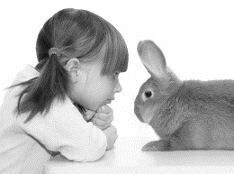

Rabbits are cute―that's a given, and that is the main reason why many want to adopt them as pets. But is it really feasible to have them as pets? The following article gets into a little more detail about the pros and cons of owning rabbits as pets. So if you're planning on adopting rabbits, you should have a read through the article and then decide whether you want to take that responsibility or not.  
  
 **The Pros**  
 So why is keeping rabbits a good thing? What is tipping the scale in their favor? Here are a few points:

* Rabbits are quiet, tame creatures and are not prone to any sort of destructive behavior.
* Rabbits are extremely social and playful. Once initiated into a family, they form very close bonds with their owners.
* Depending on the types of rabbits, the care that you administer for them will vary, however, it is not a very daunting task that demands a lot from the owners.
* Rabbits are rather entertaining when in groups or even alone.
* If you have a child in the family, then having a pet rabbit is the perfect way to initiate him/her into caring for a pet. Most rabbit breeds are absolutely tame and interacting with them teaches us special traits of caring and forming bonds.
* It is possible to train certain rabbit breeds to follow instructions, and therefore, toilet training them is possible.
* Rabbits live longer than most other smaller pets like rodents and hamsters. This ensures that they will be around for a long time.

**The Cons**  
 If you have a pet rabbit, or any pet for that matter, there is bound to be some fraction of caring for them. Though I will not term these following pointers as cons per se`, they are definitely things that you might want to keep in mind before getting a pet rabbit for yourself or your kid.

* A rabbit's maintenance costs a little. Rabbits require a cage (if that's what you're planning to provide for as their house) and it needs to be a huge one with separate sections for the number of rabbits that there are.
* The natural rabbit habitat is out in the open, so keeping rabbits in the garden is actually a good choice. But make sure that you do not leave them anywhere near the vegetable section as they might get into it and destroy it.
* There have been cases of rabbits having chewed on wires and other such items when kept indoors. This is because they have teeth that need to be constantly trimmed which they do by biting and chewing on things and objects.
* Many people may not know this but a rabbit will dirty a place (and make it stink really bad) if left in the house. Thus, it is necessary to either train the rabbit to use the litter box, or make sure that you allow him access to the yard.
* Spaying and neutering your pet rabbits is a must if you're planning to keep them.
* Make sure that you trim their nails often. If you do not, they will set about trimming them on their own on some form of furniture or the other.

Having given you the information on the negative and positive aspects of owning rabbits as pets, and having told you about some factors that you will have to look into in order to decide whether or not you want a pet rabbit or not, it will become easier to take a final decision hereon.

~~~~~~~~~~~~~~~~~~~~~~~~~~~~~~~~

**A. Short Answer**

Would a rabbit make a good pet for you? ***Why or why not?***

\_\_\_\_\_\_\_\_\_\_\_\_\_\_\_\_\_\_\_\_\_\_\_\_\_\_\_\_\_\_\_\_\_\_\_\_

\_\_\_\_\_\_\_\_\_\_\_\_\_\_\_\_\_\_\_\_\_\_\_\_\_\_\_\_\_\_\_\_\_\_\_\_

\_\_\_\_\_\_\_\_\_\_\_\_\_\_\_\_\_\_\_\_\_\_\_\_\_\_\_\_\_\_\_\_\_\_\_\_

~~~~~~~~~~~~~~~~~~~~~~~~~~~~~~~~

**B. Word Search**

**M F E I I V T R E H M**

**J A N A I N C T D E U**

**X W I X B Z A N P D K**

**H J A N Z I R I P U T**

**J G R E T U E N L V B**

**P L T I X E T D L S Y**

**N H N G W B N D P W P**

**G I K S O C I A L E X**

**D I B N I Y Y X N H T**

**J T D Y O P I L M C V**

**Y C O U W D D E P M E**

Social Chew Nails

Interact Initiate Spay

Neuter Bond Train Maintenance

**C. Fill in the Blank**

1. Rabbits can be trained to follow instructions so they can be \_\_\_\_\_\_\_\_\_\_\_\_\_\_\_ trained

2. Rabbits chew on \_\_\_\_\_\_\_\_\_\_\_\_\_\_ and other such items when kept indoors

Rabbits are 3. \_\_\_\_\_\_\_\_\_\_\_\_\_, tame creatures, not prone to 4. \_\_\_\_\_\_\_\_\_\_\_\_\_\_ behaviors

5. \_\_\_\_\_\_\_\_\_\_\_\_\_\_\_ with rabbits may teach children about caring and forming bonds

~~~~~~~~~~~~~~~~~~~~~~~~~~~~~~~~

**D. Make Tweets about this assignemnt**

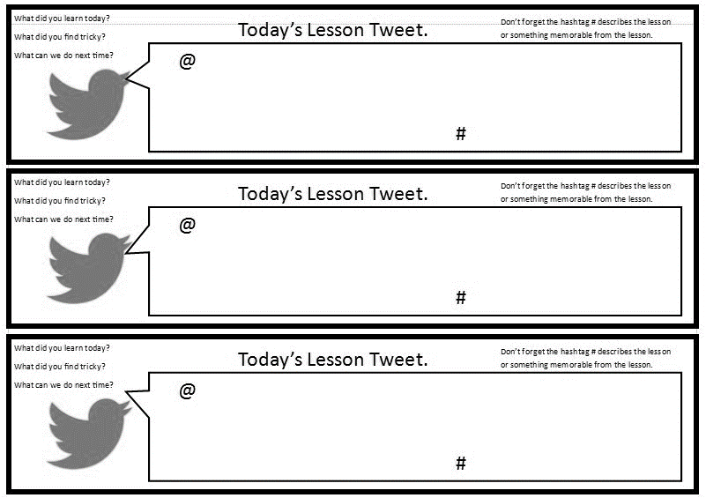

Twitter about this

assignment; 240

characters

Twitter about this

assignment; 240

characters

**5 Ways Pets Can Improve Your Health**

**#3**

By [Jeanie Lerche Davis](https://www.webmd.com/jeanie-lerche-davis)

WEBMD archives

A pet is certainly a great friend. After a difficult day, pet owners quite literally feel the love.

In fact, for nearly 25 years, research has shown that living with pets provides certain health benefits. Pets help lower [blood pressure](https://www.webmd.com/hypertension-high-blood-pressure/guide/diastolic-and-systolic-blood-pressure-know-your-numbers) and lessen [anxiety](https://www.webmd.com/anxiety-panic/default.htm). They boost our immunity. They can even help you get dates.

**Allergy Fighters**

"The old thinking was that if your family had a pet, the children were more likely to become allergic to the pet. And if you came from an [allergy](https://www.webmd.com/allergies/default.htm)-prone family, pets should be avoided," says researcher James E. Gern, MD, a pediatrician at the University of Wisconsin-Madison, in the *Journal of*[*Allergy*](https://www.webmd.com/allergies/allergy-relief-10/slideshow-allergy-myths-facts)*and Clinical Immunology*.

However, a growing number of studies have suggested that kids growing up in a home with "furred animals" -- whether it's a pet cat or dog, or on a farm and exposed to large animals -- will have less risk of [allergies and asthma](https://www.webmd.com/asthma/guide/allergies-asthma), he tells WebMD.

In his recent study, Gern analyzed the [blood](https://www.webmd.com/heart/anatomy-picture-of-blood) of babies immediately after birth and one year later.

If a dog lived in the home, infants were less likely to show evidence of [pet allergies](https://www.webmd.com/allergies/features/how-pets-allergies-can-go-hand-in-paw) -- 19% vs. 33%. They also were less likely to have [eczema](https://www.webmd.com/skin-problems-and-treatments/eczema/default.htm), a common [allergy](https://www.webmd.com/allergies/allergies-assessment/default.htm) [skin](https://www.webmd.com/skin-problems-and-treatments/picture-of-the-skin) condition that causes red patches and [itching](https://www.webmd.com/skin-problems-and-treatments/guide/skin-conditions-pruritus). In addition, they had higher levels of some immune system chemicals -- a sign of stronger immune system activation.

**Date Magnets**

Dogs are great for making love connections. Forget Internet matchmaking -- a dog is a natural conversation starter.

This especially helps ease people out of social isolation or shyness, Nadine Kaslow, PhD, professor of [psychiatry](https://www.webmd.com/mental-health/guide-to-psychiatry-and-counseling) and behavioral sciences at Emory University in Atlanta, tells WebMD.

"People ask about breed, they watch the dog's tricks," Kaslow says. "Sometimes the conversation stays at the 'dog level,' sometimes it becomes a real social interchange."

**Dogs for the Aged**

"Studies have shown that [Alzheimer's](https://www.webmd.com/alzheimers/default.htm) patients have fewer anxious outbursts if there is an animal in the home," says Lynette Hart, PhD, associate professor at the University of California at Davis School of Veterinary Medicine.

"Their caregivers also feel less burdened when there is a pet, particularly if it is a cat, which generally requires less care than a dog," says Hart.

Walking a dog or just caring for a pet -- for elderly people who are able -- can provide [exercise](https://www.webmd.com/fitness-exercise/default.htm) and companionship. One [insurance](https://www.webmd.com/health-insurance/default.htm) company, Midland Life [Insurance](https://www.webmd.com/a-to-z-guides/condition-15/insurance/rm-quiz-insurance-basics) Company of Columbus, Ohio, asks clients over age 75 if they have a pet as part of their medical screening -- which often helps tip the scales in their favor.

**Good for Mind and Soul**

Pet owners with AIDS are far less likely to suffer from [depression](https://www.webmd.com/depression/default.htm) than those without pets. "The benefit is especially pronounced when people are strongly attached to their pets," says researcher Judith Siegel, PhD.

People in stress mode get into a "state of dis-ease," in which harmful chemicals like cortisol and norepinephrine can negatively affect the immune system, says Blair Justice, PhD, a psychology professor at the University of Texas School of Public Health and author of *Who Gets Sick: How Beliefs, Moods, and Thoughts Affect Your Health*.

Studies show a link between these chemicals and plaque buildup in [arteries](https://www.webmd.com/heart/picture-of-the-arteries), the red flag for [heart disease](https://www.webmd.com/heart-disease/default.htm), says Justice.

Like any enjoyable activity, playing with a dog can elevate levels of serotonin and dopamine -- nerve transmitters that are known to have pleasurable and calming properties, he tells WebMD.

"People take drugs like [heroin](https://www.webmd.com/mental-health/addiction/heroin-use) and [cocaine](https://www.webmd.com/drugs/2/drug-1383/cocaine+topical/details) to raise serotonin and dopamine, but the healthy way to do it is to pet your dog, or hug your spouse, watch sunsets, or get around something beautiful in nature," says Justice, who recently hiked the Colorado Rockies with his wife and two dogs.

**Good for the Heart**

[Heart attack](https://www.webmd.com/heart-disease/guide/heart-disease-heart-attacks) patients who have pets survive longer than those without, according to several studies. Male pet owners have less sign of [heart disease](https://www.webmd.com/heart-disease/ss/slideshow-visual-guide-to-heart-disease) – lower [triglyceride](https://www.webmd.com/cholesterol-management/lowering-triglyceride-levels) and [cholesterol levels](https://www.webmd.com/cholesterol-management/guide/understanding-numbers) -- than non-owners, researchers say.

~~~~~~~~~~~~~~~~~~~~~~~~~~~~~~

**A. Short Answer**

Should people with pets be given a health insurance break? ***Why or why not?***

\_\_\_\_\_\_\_\_\_\_\_\_\_\_\_\_\_\_\_\_\_\_\_\_\_\_\_\_\_\_\_\_\_\_\_

\_\_\_\_\_\_\_\_\_\_\_\_\_\_\_\_\_\_\_\_\_\_\_\_\_\_\_\_\_\_\_\_\_\_\_

\_\_\_\_\_\_\_\_\_\_\_\_\_\_\_\_\_\_\_\_\_\_\_\_\_\_\_\_\_\_\_\_\_\_\_

~~~~~~~~~~~~~~~~~~~~~~~~~~~~~~~~

**B. Fill in the Blank**

Kids growing up in a home with furred animals will have less risks of

1. \_\_\_\_\_\_\_\_\_\_\_\_ and 2. \_\_\_\_\_\_\_\_\_\_\_\_\_\_

The benefit is more pronounced when the person is strongly 3. \_\_\_\_\_\_\_\_\_\_ to the pet.

3. \_\_\_\_\_\_\_\_\_\_\_\_\_\_\_\_\_\_\_\_ patients have fewer 4. \_\_\_\_\_\_\_\_\_\_ outbursts if there is an animal in the home

~~~~~~~~~~~~~~~~~~~~~~~~~~~~~~~

**C. Word Search**

**E Y B J I A D Q M C**

**U T V K D C E T N O**

**Q E N I M A P O D R**

**A I A L L E R G Y T**

**L X O Y K S E L K I**

**P N X E T E S N C S**

**I A W R C L S F P O**

**Y B E A U T I F U L**

**D S E R O T O N I N**

**S R I M M U N I T Y**

Immunity Anxiety Allergy

Beautiful Stress Depression

Plaque Serotonin Dopamine

Cortisol

~~~~~~~~~~~~~~~~~~~~~~~~~~~~~~~~~



**Tobacco, Secondhand Smoke, and Pets**

**#4**

***ANRF, 12/21/2017***

http://www.no-smoke.org/learnmore.php?id=623

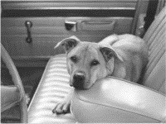

In recent years, studies have concluded that tobacco and secondhand smoke are not only dangerous to people, but also to pets. Specifically, with respect to secondhand smoke, researchers have found that exposure to tobacco smoke has been associated with certain cancers in dogs and cats; allergies in dogs; and eye and skin diseases and respiratory problems in birds, according to the researchers.

As stated by Dr. Carolynn MacAllister, Oklahoma State University Cooperative Extension Service veterinarian, "If smoking is that harmful to human beings, it would make sense that secondhand smoke would have an adverse effect on pets that live in the homes of smokers. There have been a number of scientific papers recently that have reported the significant health threat secondhand smoke poses to pets. Secondhand smoke has been associated with oral cancer and lymphoma in cats, lung and nasal cancer in dogs, as well as lung cancer in birds."

"One reason cats are so susceptible to secondhand smoke is because of their grooming habits. Cats constantly lick themselves while grooming, therefore they lick up the cancer-causing carcinogens that accumulate on their fur," MacAllister said. "This grooming behavior exposes the mucous membrane of their mouth to the cancer-causing carcinogens."

"A recent study conducted at Colorado State University shows that there is a higher incidence of nasal tumors in dogs living in a home with secondhand smoke compared to dogs living in a smoke free environment," she said. "The increased incidence was specifically found among the long nosed breed of dogs. Shorter or medium nosed dogs showed higher rates for lung cancer." According to MacAllister, the longer nosed breeds of dogs have a great surface area in their noses that is exposed to the carcinogens. This also provides more area in which the carcinogens can accumulate. The carcinogens tend to build up on the mucous membranes of long nosed dogs so not as much reaches the lungs.

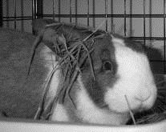 Pet birds also are victims of secondhand smoke. A bird's respiratory system is hypersensitive to any type of pollutant in the air. MacAllister said the most serious consequences of secondhand smoke exposure in birds are pneumonia or lung cancer. Other health risks include eye, skin, heart, and fertility problems.

The good news is that many smokers are becoming aware of this problem and are being motivated to quit smoking. In a [study published in ***Tobacco Control***](http://tobaccocontrol.bmj.com/cgi/content/abstract/tc.2008.028282v1?maxtoshow=&HITS=10&hits=10&RESULTFORMAT=&fulltext=Milberger&searchid=1&FIRSTINDEX=0&sortspec=relevance&resourcetype=HWCIT), researchers led by Sharon M. Milberger, ScD, of the Henry Ford Health System in Detroit, found that 28.4% of smokers who participated in an online survey said learning that secondhand smoke was bad for their pet's health would motivate them to quit. And 8.7% said knowing the potential adverse health effects of secondhand smoke would spur them to ask their partners to quit.

**A. Short Answer**

Should pet owners smoke inside? ***Why or why not?***

\_\_\_\_\_\_\_\_\_\_\_\_\_\_\_\_\_\_\_\_\_\_\_\_\_\_\_\_\_\_\_\_\_\_\_

\_\_\_\_\_\_\_\_\_\_\_\_\_\_\_\_\_\_\_\_\_\_\_\_\_\_\_\_\_\_\_\_\_\_\_

\_\_\_\_\_\_\_\_\_\_\_\_\_\_\_\_\_\_\_\_\_\_\_\_\_\_\_\_\_\_\_\_\_\_\_

\_\_\_\_\_\_\_\_\_\_\_\_\_\_\_\_\_\_\_\_\_\_\_\_\_\_\_\_\_\_\_\_\_\_\_

~~~~~~~~~~~~~~~~~~~~~~~~~~~~~~~~

**B. Word Search**

**R E C N A C H U W D I**

**S E C O N D H A N D F**

**A O S E I G R E L L A**

**L Y M P H O M A Q T E**

**C A R C I N O G E N S**

**L P R L C R Q L C Y R**

**L A N T O B A C C O E**

**A R P N K S O T Y X V**

**I Y M E A R L N O M D**

**U I L N J M N K F R A**

**E T A L U M U C C A Y**

Secondhand Tobacco Cancer

Allergies Adverse Respiratory

Lymphoma Nasal Accumulate

Carcinogens

~~~~~~~~~~~~~~~~~~~~~~~~~~~~~~~~

**C. Fill in the Blank**

1. Cats are susceptible to secondhand smoke because of their \_\_\_\_\_\_\_\_\_\_\_\_\_\_\_\_\_\_\_ habits.

The most serious consequences of smoke for birds are 2. \_\_\_\_\_\_\_\_\_\_\_\_\_\_\_ or lung 3. \_\_\_\_\_\_\_\_\_\_\_\_\_\_

4. There is sometimes a higher rate of \_\_\_\_\_\_\_ \_\_\_\_\_\_\_\_\_\_\_\_\_ in dogs living in smoker’s homes.

5. After learning that second hand smoke was bad for their pet’s health \_\_\_\_\_\_\_\_\_\_\_\_ percent of smokers said they were motivated to quit.

Researchers have found that exposure to second hand smoke is associated with:

6. \_\_\_\_\_\_\_\_\_\_\_\_\_\_\_\_\_\_\_ in dogs and cats;

7. \_\_\_\_\_\_\_\_\_\_\_\_\_\_\_\_\_\_\_ in dogs;

8. \_\_\_\_\_\_\_\_\_\_\_\_\_\_\_\_\_\_ diseases in birds; and 9. \_\_\_\_\_\_\_\_\_\_\_\_\_\_\_ problems in birds.

10. There has been an increased incidence of nasal tumors specifically among the \_\_\_\_\_\_\_\_\_\_ nosed dogs.

~~~~~~~~~~~~~~~~~~~~~~~~~~~~~~~~~

**D. Make a facebook post, including two pictures or drawings, about this assignment**.



**DIFFERENT KINDS OF RODENTS**

**#5**

By Keri Gardner

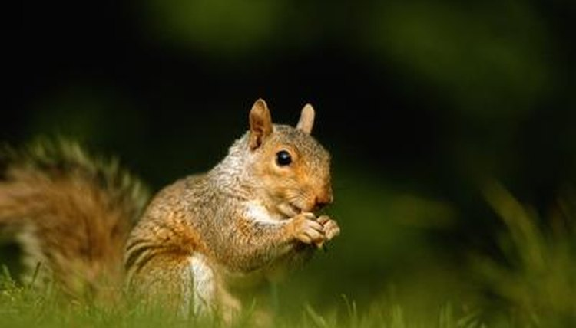There are over 2,000 species of rodents in the world, so it's not surprising that some of them have become pets. They are small and require minimal care, making them a good choice as a family pet. Common types of pet rodents include gerbils, mice, rats, guinea pigs and hamsters, while chinchillas and degus are less conventional. Rabbits are not considered to be rodents.

**Hamsters**

The most common pet hamster is the Syrian hamster, which is about 6 inches long. Syrians live 2 to 3 years, while dwarf hamsters such as Siberian, Roborovsky's Djungarian and Chinese are smaller, living only 1 to 2 years. Hamsters are nocturnal and may be quite noisy at night. Since hamsters sleep during the day, they may nip when awakened during the day. Children under six should not handle these fragile animals.

**Rats and Mice**

Mice and rats are in the same rodent family, Muridae. Mice typically live 18 to 24 months, while rats live a bit longer, up to 36 months. Proper nutrition will increase the lifespan of rats and mice as they are prone to obesity. Mice are slightly more nervous than rats, though both can be enjoyable pets. Rats rarely bite and may bond closely to the owner.

**Gerbils**

The typical pet gerbil originated from Mongolia. These very busy little rodents grow to about 4 inches, with a tail the same length. They enjoy the company of other gerbils, so it's a good idea to purchase them in pairs or groups. Gerbils love to play in their cage during the day and seldom bite when handled. These pets are recommended for older children who know how to handle small rodents carefully.

**Guinea Pigs**

Guinea pigs are the largest common rodent kept as pets. They are social and do well in same-sex pairs. These rodents are good pets for all ages of children and can be easily handled due to their bigger size. They live 5 to 10 years and can be quite vocal. Guinea pigs need larger cages than other rodents with a minimum of four square feet per animal. Additionally, guinea pigs should get fresh fruits, vegetables and grass hay daily in addition to their commercial guinea pig food.

**Chinchillas**

Chinchillas are very active and acrobatic animals. Since they are nocturnal, most activity occurs at night. They should have a large cage with at least 4 by 4 by 3 feet of space. Chinchillas will climb and dart quickly, both horizontally and vertically. These soft little rodents will also need to have dust baths with 2 to 4 inches of commercial chinchilla dust. Most chinchillas love to cuddle and rarely bite.

**Exotic Rodents**

A variety of unusual pet rodents exists. Degus look like a large gerbils and need branches or rocks for climbing. Other exotic pet rodents include prairie dogs, flying squirrels, spiny mice and capybara. A capybara can grow as big as a large dog. Another exotic pet, the sugar glider, appears to be a rodent but is not a rodent at all. It is a marsupial in the opossum family.

~~~~~~~~~~~~~~~~~~~~~~~~~~~~~~~~

**A. Short Answer**

Which of these animals do you think would make the best pet, ***and why?***

\_\_\_\_\_\_\_\_\_\_\_\_\_\_\_\_\_\_\_\_\_\_\_\_\_\_\_\_\_\_\_\_\_\_\_\_

\_\_\_\_\_\_\_\_\_\_\_\_\_\_\_\_\_\_\_\_\_\_\_\_\_\_\_\_\_\_\_\_\_\_\_\_

\_\_\_\_\_\_\_\_\_\_\_\_\_\_\_\_\_\_\_\_\_\_\_\_\_\_\_\_\_\_\_\_\_\_\_\_

~~~~~~~~~~~~~~~~~~~~~~~~~~~~~~~~

**B. Fill in the Blank**

1. Rats and mice are in the same \_\_\_\_\_\_\_\_\_\_\_\_\_\_ family

2. There are \_\_\_\_\_\_\_\_\_\_\_\_\_\_\_\_ species of rodents in the world

3. \_\_\_\_\_\_\_\_\_\_\_\_\_\_ are very active and acrobatic animals

4. The most common hamster is the \_\_\_\_\_\_\_\_\_\_\_\_\_\_\_

5. The typical pet gerbil originated from \_\_\_\_\_\_\_\_\_\_\_\_\_\_\_

Degus look like a large 6. \_\_\_\_\_\_\_\_\_\_\_\_\_ and need 7. \_\_\_\_\_\_\_\_\_\_\_\_\_\_\_ or rocks for 8. \_\_\_\_\_\_\_\_\_\_\_\_\_\_\_

Gerbils live 9. \_\_\_\_\_\_\_\_\_\_\_\_\_ years and can be quite 10. \_\_\_\_\_\_\_\_\_\_\_\_\_\_.

**C. Word Search**

**V X D K I H L O D A**

**Z G E L N P S E L J**

**D E C R C I G L W L**

**C R R O G U I N E A**

**Z B D D S H P V D M**

**B I T E C Q T D I I**

**D L A N R U T C O N**

**G S I T A D E R U I**

**T H K S T N H I U M**

**C H A M S T E R M H**

Rodents Minimal Gerbils

Rats Mice Guinea pigs

Hamster Chinchilla Degus

Nocturnal

~~~~~~~~~~~~~~~~~~~~~~~~~~~~~~~~

**D. Instagram Post**



Draw a picture and write a caption about one point

Draw a picture and write a caption about the topic