Packs 11-20 for Chinese 1
Pack 11
一、Introduce 56 ethnic groups in China
China is a large country noted for its dense population and vast territory. There are altogether 56 ethnic groups in China. The defining elements of an ethnic group are language, homeland, and social values. 53 ethnic groups use spoken languages of their own, and 23 ethnic groups have their own written languages.
According to the fifth national census taken in 2001, the Han people made up 91.59 percent of the country's total population, totaling 1159.4 million; and the other 55 ethnic groups, 8.41 percent, totaling 106.43 million. As the majority of the population is of the Han ethnic group, the other 55 ethnic groups are customarily referred to as the national minorities.
The Han people can be found throughout the country, though mainly on the middle and lower reaches of the Yellow River, the Yangtze River and the Pearl River valleys, and the Northeast Plain. The national minorities, though fewer in number, are also scattered over a vast area, mainly distributed in the border regions from northeast China to north, northwest and southwest China. The largest is the 12 million-strong Zhuang ethnic group in southwestern China. And Yunnan Province, home to more than 20 ethnic groups, has the greatest diversity of minority people in China.
Equality, unity and common prosperity are the fundamental objectives of the government in handling the relations between ethnic groups. China exercises a policy of regional autonomy for various ethnic groups, allowing ethnic groups living in compact communities to establish self-government and direct their own affairs.
In most of China's cities and county town, two or more ethnic groups live together. Taking shape over China's long history, this circumstance of different ethnic groups living together in one area while still living in individual compact communities in special areas continues to provide the practical basis for political, economic and cultural intercourse between the Han and the various minority peoples, and for the functioning of the autonomous national minority areas system.
Read article and answer questions.
- What’s 56 ethnic groups in China? Where they live?

- Do they have their own language and religion?

- Why we need respect and protect their culture?

- Should people respect different culture in the world? What’s your opinions and why?

Write simple Characters: Every characters 10 time ,Pinyin and Characters.
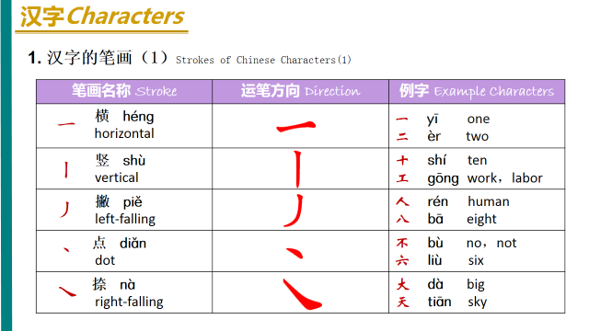
- 工人gōng rén worker labor：
＿＿＿＿＿＿＿＿＿＿＿＿＿＿＿＿＿＿＿＿＿＿＿＿＿＿＿＿______________________
- 人rén people
＿＿＿＿＿＿＿＿＿＿＿＿＿＿＿＿＿＿＿＿＿＿＿＿＿＿＿＿＿＿＿＿＿____________
- 不bù no,not
＿＿＿＿＿＿＿＿＿＿＿＿＿＿＿＿＿＿＿＿＿＿＿＿＿＿＿＿＿＿＿＿＿＿__________
- 大dà large big
＿＿＿＿＿＿＿＿＿＿＿＿＿＿＿＿＿＿＿＿＿＿＿＿＿＿＿＿＿＿＿＿＿___________
- 天tiān sky day
＿＿＿＿＿＿＿＿＿＿＿＿＿＿＿＿＿＿＿＿＿＿＿＿＿＿＿＿＿＿＿＿＿＿＿＿＿＿
- 木mù tree, wood
＿＿＿＿＿＿＿＿＿＿＿＿＿＿＿＿＿＿＿＿＿＿＿＿＿＿＿＿＿＿＿＿＿＿＿＿＿＿
- 林lín a small forest
＿＿＿＿＿＿＿＿＿＿＿＿＿＿＿＿＿＿＿＿＿＿＿＿＿＿＿＿＿＿＿＿＿＿＿＿＿＿
- 森sēn large forest
＿＿＿＿＿＿＿＿＿＿＿＿＿＿＿＿＿＿＿＿＿＿＿＿＿＿＿＿＿＿＿＿＿＿＿＿＿＿

Pack 12
一、Introduce Chinese culture elements
Chinese Dragon
Dragon totem worship in China has been around for the last 8,000 years. The ancients in China considered the dragon (or long) a fetish that combines animals including the fish, snake, horse and ox with cloud, thunder, lightning and other natural celestial phenomena. The Chinese dragon was formed in accordance with the multicultural fusion process of the Chinese nation. To the Chinese, the dragon signifies innovation and cohesion.
Question 1 ： what’s the Chinese name for dragon? Do you know how to write Pinyin and Characters?

2. What Chinese dragon looks like? What’s the different from western dragon? (Appearance, meaning and so on)

3. What’s Chinese dragon represent for?

Dumplings
Dumplings are one of the Chinese people’s favorite traditional dishes. According to an ancient Chinese legend, dumplings were first made by the medical saint---Zhang Zhongjing. There are three steps involved in making dumplings: 1) make dumpling wrappers out of dumpling flour; 2) prepare the dumpling stuffing; 3) make dumplings and boil them. With thin and elastic dough skin, fresh and tender stuffing, delicious taste, and unique shapes, dumplings are worth eating hundreds of times. There’s an old saying that claims, “Nothing could be more delicious than dumplings”. During the Spring Festival and other holidays, or when treating relatives and friends, Chinese people like to follow the auspicious custom of eating dumplings. To Chinese people who show high reverence for family love, having dumplings at the moment the old year is replaced by the new is an essential part of bidding farewell to the old and ushering in the new year.
- Why people like to eat dumpling? (At least 4 reasons)

- How to make dumpling?

Acupuncture
Acupuncture is an important part of traditional Chinese medicine (TCM). In accordance with the “main and collateral channels” theory in TCM, the purpose of acupuncture is to dredge the channel and regulate qi and blood, so as to keep the body’s yin and yang balanced and achieve reconciliation between the internal organs. It features in traditional Chinese medicine that “internal diseases are to be treated with external therapy”. The main therapy of acupuncture involves using needles to pierce certain acupoints of the patient’s body, or adopting moxibustion to stimulate the patient’s acupoints so as to stimulate the channels and relieve pain. With its unique advantages, acupuncture has been handed down generation after generation and has now spread all over the world. Nowadays, acupuncture, along with Chinese food, kung fu (otherwise known as Chinese martial arts), and traditional Chinese medicine, has been internationally hailed as one of the “four new national treasures.”
- How Acupuncture works?

- What’s the four new national treasures? Do you know what’s the four old national treasures ?

Chinese Kung Fu
Chinese kung fu, or Chinese martial arts, carries traditional Chinese culture in abundance. It is a traditional Chinese sport which applies the art of attack and defence in combat and the motions engaged with a series of skill and tricks. The core idea of Chinese king fu is derived from the Confucian theory of both “the mean and harmony” and “cultivating qi” (otherwise known as nourishing one’s spirit). Meanwhile, it also includes thoughts of Taoism and Buddhism. Chinese kung fu has a long history, with multi-various sects and many different boxing styles, and emphasizes coupling hardness with softness and internal and external training. It contains the ancient great thinkers’ pondering of life and the universe. The skills in wielding the 18 kinds of weapons named by the later generations mainly involve the skills of bare-handed boxing, such as shadow boxing (Taijiquan), form and will boxing (Xingyiquan), eight trigram palm (Baguazhang), and the skills of kung fu weaponry, such as the skill of using swords, spears, two-edged swords and halberds, axes, tomahawks, kooks, prongs and so on.
- What’s the core idea of Chinese Kongfu?

2 what’s he skills in wielding the 18 kinds of weapons?

Chinese Characters
Chinese characters were initially meant to be simple pictures used to help people remember things. After a long period of development, it finally became a unique character system that embodies phonetic sound, image, idea, and rhyme at the same time. The writing system, which was extremely advanced in ancient times, began with inscriptions on bones and tortoise shells, and these are regarded as the original forms of Chinese characters. Afterwards, Chinese characters went through numerous calligraphic styles: bronze inscriptions, official script, regular script, cursive script, running script, etc. Chinese characters are usually round outside and square inside, which is rooted in ancient Chinese beliefs of an orbicular sky and a rectangular Earth. The five basic strokes of Chinese characters are “---“ (the horizontal stroke) “│” (the vertical stroke), “／”( the left-falling stroke), “＼” (the right-falling stroke), and “乙” (the turning stroke).
- what’ s 5 basic character strokes?

- Does Chinese character from pictures?

Chinese Chopsticks
The Chinese way of eating with chopsticks is unique in the world. The recorded history of chopsticks started more than three thousand years ago. Chopsticks were named zhu in ancient Chinese. They look deceptively simple to use, but possess multi-various functions, such as clamping, turning over, lifting up, raking, stirring, scooping, poking, tearing, and so on. Chopsticks were taken as an auspicious mascot by ordinary people in ancient China. For example, the partial tone of chopsticks is often used by people as a metaphor at weddings to indicate a blessing or benediction for the couple to have a baby soon. Unlike using a knife and fork or one’s own hands, a pair of chopsticks also implies the meaning of “Harmony is what matters”. Chopsticks are highly praised by Westerners as a hallmark of ancient oriental civilization.
Chinese Seal
A seal can also be defined as a stamp. Both the Chinese official and private seal of various dynasties have different titles, such as stamp, zhu note, contract, fu, lease and others. The seals used by the emperors of ancient China were called xi, yin, bao, etc. According to historical records, seals were widely used during the Warring States Period (475BC-221BC). The making of a seal is to engrave fonts, such as seal characters and official script and so on; or images in the form of intaglio and embossment into the seal, basically shaped as round or square. Covered with a vermilion overlay, the Chinese seal is not only used in daily life, but it is also used to represent signatures on paintings and calligraphies. It is gradually becoming one of China’s unique artworks.
- what’ s another name for seal?

Chinese Era
The Chinese era is the symbol that the Chinese calendar uses for recording and naming years. The ten Heavenly Stems are: jia, yi, bing, ding, wu, ji, geng, xin, ren, gui. The twelve Earthly Branches are: zi.chou, yin, mou, chen, si, wu, wei, shen, you, xu, hai. After observing the lunar month, the ancients found that the moon always wazes and wanes roughly 12 times a year, and two lunar months account for about 60 days, so the order of the ten Heavenly Stems and the order of the twelve Earthly Branches are properly matched in turn. In terms of recording date, 60 years is considered to be a full time cycle. The Chinese era chronology was first invented in ancient times and is still in use now. according to the chronology of the “ten Heavenly Stems,” 2011 is the year of “the seventh of the ten Heavenly Stems” and “ the fifth of the twelve Earthly Branches”
二、Write simple Characters: Every characters 10 time ,Pinyin and Characters.
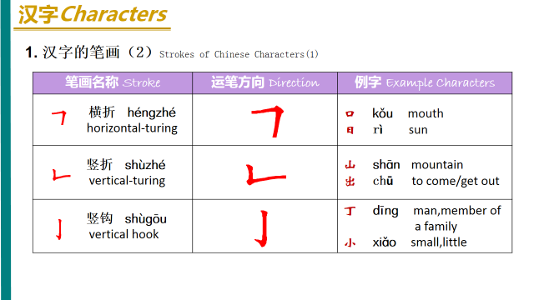
1.口kǒu mouth
＿＿＿＿＿＿＿＿＿＿＿＿＿＿＿＿＿＿＿＿＿＿＿＿＿＿＿＿＿＿＿＿＿＿＿＿＿＿
２.日rì sun, day
＿＿＿＿＿＿＿＿＿＿＿＿＿＿＿＿＿＿＿＿＿＿＿＿＿＿＿＿＿＿＿＿＿＿＿＿＿＿
３.山shān mountain
＿＿＿＿＿＿＿＿＿＿＿＿＿＿＿＿＿＿＿＿＿＿＿＿＿＿＿＿＿＿＿＿＿＿＿＿＿＿
４.出chū go out
＿＿＿＿＿＿＿＿＿＿＿＿＿＿＿＿＿＿＿＿＿＿＿＿＿＿＿＿＿＿＿＿＿＿＿＿＿＿
５.丁dīng a surname someone’s surname is ding
＿＿＿＿＿＿＿＿＿＿＿＿＿＿＿＿＿＿＿＿＿＿＿＿＿＿＿＿＿＿＿＿＿＿＿＿＿＿
６小xiǎo small
＿＿＿＿＿＿＿＿＿＿＿＿＿＿＿＿＿＿＿＿＿＿＿＿＿＿＿＿＿＿＿＿＿＿＿＿＿＿
７.见jiàn to see
＿＿＿＿＿＿＿＿＿＿＿＿＿＿＿＿＿＿＿＿＿＿＿＿＿＿＿＿＿＿＿＿＿＿＿＿＿＿

Pack 13
一、Confucius
Confucius named Qiu styled Zhongni, a great thinker and educator in the late Spring and Autumn Period, and the founder of Confucianism. Confucius instructed more than 3000 disciples and some were from poor families. Confucius gradually changed the tradition that only nobilities had the right to receive education. In his later years, Confucius compiled many literary works of ancient times, including The Book of Songs, The Book of Documents, and The Books of Changes. His saying and behaviors were compiled in The Analects of Confucius by his disciples. His ideology has been absorbed and carried composing the essential part of Chinese traditional ideology. It was also spread into the border regions and areas building up a circle of Confucianism. UNESCO labeled him one of the“ Ten Culture Celebrities ”.
- What‘s the opinions of Confucius?

Paper-Cuts
Chinese paper-cuts are pretty and exquisite with a unique oriental style. They make viewers to feel the real daily life and a festive atmosphere. The making of paper-cuts is a popular folk art of more than 2000 years in China. They are mostly created by women in rural areas. The designs are fowls domestic animals crops, episodes from operas auspicious symbols and so on. Used on the Chinese lunar New Year or other festivals, they add delight and festivity to the life of the ordinary people. Paper-cuts fall into two categories, simple and natural single-colored ones, and gorgeous and colorful ones. The famous ones are window-panes from Shanxi, figurines of local operas from Weixian Hebei, and embroidery copies in ethnic minorities in southern China. Chinese paper-cut has been listed as one of the world’s cultural heritages by UNESCO.
- Why Chinese paper-cutting been listed a one of the world’s cultural heritages?

Cheong-sam Long Gown and Mandarin Jacket
Originated in Manchu female?s dress in the Qing Dynasty, Cheong-sam is regarded as the model of Chinese traditional dressing culture. It accords with the harmony of Chinese culture in style and shows rich oriental feature in techniques. It gives prominence to a lady?s slender figure and heightens the gravity center of human body together with high-heel shoes. Civility elegance and dignity can be fully displayed. It has developed its own long-lasting trend.
As for the traditional clothes of Chinese men, the long gown and mandarin jacket are typical. As the dress of Manchu men both have round-necks and narrow sleeves. The mandarin jacket has buttons down the front ,mostly with sleeves like a horse,s hoof. The front of long gowns is basically large .The long gown and mandarin jacket give the impression of comfortableness and ease as well as sobriety.
Chinese Tea
Chinese people like to drink tea, they often entertain friends and guests with it. Tealeaf is a necessity in the life of Chinese people. Concerning the production method Chinese tea can be classified into green tea, black tea, oolong tea scented tea and so on. Green tea is not fermented and is brilliant green. The most famous is the Longjing tea from the region the West Lake in Hangzhou. Black tea is fermented. Famous ones are the keemun tea of Anhui and the Dian black tea of Yunnan. Oolong tea is half fermented. The best one is Wuyiyan tea of Fujian. Scented tea is made by smoking tea leaves with fragrant flowers. The most famous is jasmine tea produced in Fujian. Drinking tea can quench one?s thirst dispel fatigue. The constant drinking tea is beneficial for people?s health.
- Does Chinese tea hot, sweet or cold?

- How many different kinds of Chinese tea?

Traditional Chinese Painting
It is the art of painting on a piece of Xuan paper or silk with a Chinese brush soaked with black ink or colored pigments. By subject, it can be classified into figure painting landscape painting and flowers and birds painting. Figure painting came into maturity in the warring States and reached its peak during the Tang Dynasty. Famous artists include GuKaizhi and Wudaozi .Landscape painting delineates the outside scenery. It appeared in the Qin Dynasty and reached high level by the Song Dynasty. Famous artists are Li sixun,Fan kuan,and Tang yin. Flowers and birds painting focuses on flowers birds animals fishes and insects. It appeared in the Northern and Southern dynasties and matured during the Song Dynasty. Celebrated artists include Zhu da in flowers and birds, Zheng xie in bamboo and Qi baishi in fish and shrimp. It can not only make life beautiful but brings decorous sentiment and artistic enjoyment.
1, What’s the classification of Chinese traditional painting?

Embroidery
Embroidery is a renowned traditional Chinese handicraft of more than 3000 years. On a piece of silk or cloth, people embroider all kinds of beautiful pictures, and patterns with threads of silk ,wool or cotton. Suzhou Embroidery in Jiangsu, Hunan Embroidery, Guangdong Embroidery, and Sichuan Embroidery, are famous ones in China. Suzhou Embroidery has a history of 2000 years. The artists can make flowers, birds, animals, and even gardens. It is refined and exquisite. The best known work is an embroidered cat with bright eyes and fluffy hair, looking vivid and lifelike. Hunan Embroidery appeared 2000 years ago. Artists of traditional Chinese painting were involved, the embroidery has an air of traditional Chinese painting. Typical embroidery shows images of lions and tigers, that are so vivid that one can feel their ferocity.
- Do you know what Chinese Embroidery looks like?
Write simple Characters: Every characters 10 time ,Pinyin and Characters.
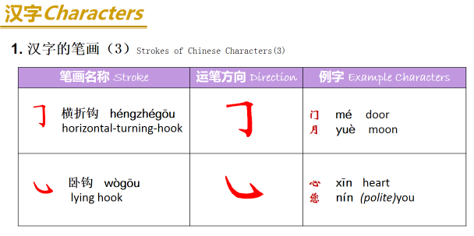
１.门mén door＿＿＿＿＿＿＿＿＿＿＿＿＿＿＿＿＿＿＿＿＿＿＿＿＿＿＿＿＿＿＿＿＿＿＿＿
们men ＿＿＿＿＿＿＿＿＿＿＿＿＿＿＿＿＿＿＿＿＿＿＿＿＿＿＿＿＿＿＿＿＿＿＿＿＿＿
２.月yuè moon, month ＿＿＿＿＿＿＿＿＿＿＿＿＿＿＿＿＿＿＿＿＿＿＿＿＿＿＿＿＿＿＿＿
３.心x īn heart＿＿＿＿＿＿＿＿＿＿＿＿＿＿＿＿＿＿＿＿＿＿＿＿＿＿＿＿＿＿＿＿＿＿＿＿
４.您nín ＿＿＿＿＿＿＿＿＿＿＿＿＿＿＿＿＿＿＿＿＿＿＿＿＿＿＿＿＿＿＿＿＿＿＿＿＿＿
５.中zhōng ＿＿＿＿＿＿＿＿＿＿＿＿＿＿＿＿＿＿＿＿＿＿＿＿＿＿＿＿＿＿＿＿＿＿＿＿

Pack 14
一．Introduce 4 traditional Chinese festival
The Spring Festival
The first day of the first lunar month is the New Year’s Day in the Chinese lunar calendar. The Chinese have many traditional customs relating to the festival, families undertake a thorough cleaning, do the Spring Festival shopping, create paper-cuts for window decoration, put up New Year pictures, write Spring Festival couplets and make New Year cakes, to bid farewell to the old and usher in the new. The night before the festival is the New Year?s Eve. It is the time for a happy family reunion to have a sumptuous New Year?s Eve dinner. People talk and laugh until daybreak, which is called “ staying up to see the year out ”When. the bell tolls midnight, people eat dumplings. From the first day of the lunar year, people visit relatives and friends to greet each other. Setting off firecrackers is a favorite activity of children in the festival. The sound of firecrackers can be heard everywhere, adding to the rejoicing atmosphere. From the Chinese all over the world, the Spring Festival is the most important day.
- What’s the customs in spring festival?

The Lantern Festival
The 15th day of the first lunar month is the traditional Lantern Festival of China. The Chinese people have the custom of enjoying lanterns and eating glutinous rice dumplings. There is a common saying that“ Playing on the Lantern Festival” . The custom started the in Han Dynasty with a history of more than 2000 years. On the night, everyplace is decorated with lanterns to form a bustling atmosphere. People go in crowds to enjoy themselves and some lanterns there are riddles, which encourage people to strive to be the first to find the answer. Another custom is to eat glutinous rice dumplings. It is a round ball made of glutinous rice flour with a filling of sugar and kernels. When boiled it is very savory and tasty. The Chinese people hope that everything is satisfactory .To eat them on the first full moon night of a year is to wish that family members will remain united and happy.
1, What’s the traditional food in Lantern Festival?

2.What people do in the festival?

The Pure Brightness Day
The Pure Brightness Day in the third lunar month one of the 24 Seasonal Division Points is also an ancient traditional festival in China. People have the custom of sweeping graves, take an outing and wear a willow twig. Every family goes to the countryside for a memorial ceremony at their ancestors? tombs. People remove weeds around the tomb, add new earth burn incense and offer food and paper coins to show remembrance and respect for ancestors. This is called grave“ or“ sweeping a grave ” . At this time,the grass is burgeoning willows along rivers have put“ visiting a forth new buds, it is fresh green everywhere and a good time for an outing. In ancient times people used to have a walk in the outside, and wear a willow twig in their hair, to pray for safety and happiness. It was supposed to be able to drive away ghosts and disasters.
- What people will do during this day?

2. Why people wear a willow twig in their hair?

The Mid-Autumn Festival
The 15th day of the eighth lunar is China’s traditional Mid -Autumn Festival. They have the custom of admiring the moon and eating moon cakes. Since people can consider the full moon as the symbol of reunion and satisfaction, the festival is also called the Festival for Reunion. According to traditional custom, the Chinese people enjoy fruits and moon cakes, while admiring the moon.
As the moon cake is round, symbolizing reunion. It is sometimes called “ reunion cake ”The. Chinese moon cake has many varieties. There are sweet,salty, meat and vegetable fillings. It is carved with various decorative patterns and words. Good looking and delicious. On the night, the whole family will sit together to admire the moon and eat moon cakes filled with happiness for harvest and family reunion. At that time, people far away will look up at the moon and miss their hometown and family.
- Why the festival is also called the Festival for Reunion?

- What people do in the festival?

- What’s the 4 traditional festival in China?

Write simple Characters: Every characters 10 time ,Pinyin and Characters.
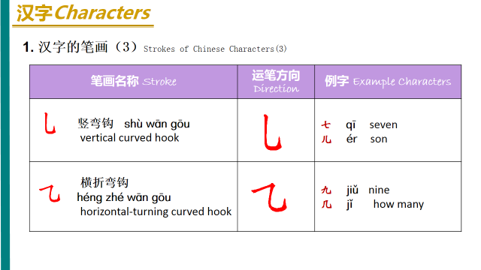
- 儿子ér zi son
＿＿＿＿＿＿＿＿＿＿＿＿＿＿＿＿＿＿＿＿＿＿＿＿＿＿＿＿＿＿＿＿＿＿＿＿＿
女儿nǚ ér: daughter
＿＿＿＿＿＿＿＿＿＿＿＿＿＿＿＿＿＿＿＿＿＿＿＿＿＿＿＿＿＿＿＿＿＿＿＿
- 几jǐ how many
＿＿＿＿＿＿＿＿＿＿＿＿＿＿＿＿＿＿＿＿＿＿＿＿＿＿＿＿＿＿＿＿＿＿＿＿＿＿
- 夕xī sunset
＿＿＿＿＿＿＿＿＿＿＿＿＿＿＿＿＿＿＿＿＿＿＿＿＿＿＿＿＿＿＿＿＿＿＿＿＿＿
- 岁suì years old
＿＿＿＿＿＿＿＿＿＿＿＿＿＿＿＿＿＿＿＿＿＿＿＿＿＿＿＿＿＿＿＿＿＿＿＿＿＿
Pack 15
一、The Great Wall
The Great Wall, like the Pyramids of Egypt, the Taj Mahal (1) in India and the Hanging Garden of Babylon (2), is one of the great wonders of the world. Starting out in the east on the banks of the Yalu River in Liaoning Province, the Wall stretches westwards for 12,700 kilometers to Jiayuguan in the Gobi desert, thus known as the Ten Thousand Li Wall in China. The Wall climbs up and down, twists and turns along the ridges of the Yanshan and Yinshan Mountain Chains through five provinces——Liaoning, Hebei, Shanxi, Shaanxi, and Gansu and two autonomous regions——Ningxia and Inner Mongolia, binding the northern China together. Historical records trace the construction of the origin of the Wall to defensive fortification back to the year 656 B.C. during the reign of King Cheng of the States of Chu. Its construction continued throughout the Warring States period in the fifth Century B.C. when ducal states Yan, Zhao, Wei, and Qin were frequently plundered by the nomadic peoples living north of the Yinshan and Yanshan mountain ranges. Walls, then, were built separately by these ducal states to ward off such harassments. Later in 221 B.C., when Qin conquered the other states and unified China, Emperor Qinshihuang ordered the connection of these individual walls and further extensions to form the basis of the present great wall. As a matter of fact, a separate outer wall was constructed north of the Yinshan range in the Han Dynasty(206 BC——1644 BC.), which went to ruin through years of neglect. In the many intervening centuries, succeeding dynasties rebuilt parts of the Wall. The most extensive reinforcements and renovations were carried out in the Ming Dynasty (1368——1644) when altogether 18 lengthy stretches were reinforced with bricks and rocks. it is mostly the Ming Dynasty Wall that visitors see today.
The Great Wall is divided into two sections, the east and west, with Shanxi Province as the dividing line. The west part is a rammed earth construction, about 5.3 meters high on average. In the eastern part, the core of the Wall is rammed earth as well, but the outer shell is reinforced with bricks and rocks. The most imposing and best preserved sections of the Great Wall are at Badaling and Mutianyu, not far from Beijing and both are open to visitors.
The Wall of those sections is 7.8 meters high and 6.5 meters wide at its base, narrowing to 5.8 meters on the ramparts, wide enough for five horses to gallop abreast. There are ramparts, embrasures, peep-holes and apertures for archers on the top, besides gutters with gargoyles to drain rain-water off the parapet walk. Two-storied watch-towers are built at approximately 400-meters internals. The top stories of the watch-tower were designed for observing enemy movements, while the first was used for storing grain, fodder, military equipment and gunpowder as well as for quartering garrison soldiers. The highest watch-tower at Badaling standing on a hill-top, is reached only after a steep climb, like "climbing a ladder to heaven". The view from the top is rewarding, hoverer. The Wall follows the contour of mountains that rise one behind the other until they finally fade and merge with distant haze.
A signal system formerly existed that served to communicate military information to the dynastic capital. This consisted of beacon towers on the Wall itself and on mountain tops within sight of the Wall. At the approach of enemy troops, smoke signals gave the alarm from the beacon towers in the daytime and bonfire did this at night. Emergency signals could be relayed to the capital from distant places within a few hour long before the invention of anything like modern communications.
There stand 14 major passes (Guan, in Chinese) at places of strategic importance along the Great Wall, the most important being Shanghaiguan and Jiayuguan. Yet the most impressive one is Juyongguan, about 50 kilometers northwest of Beijing.
Known as "Tian Xia Di YI Guan" (The First Pass Under Heaven), Shanghaiguan Pass is situated between two sheer cliffs forming a neck connecting north China with the northeast. It had been, therefore, a key junction contested by all strategists and many famous battles were fought here. It was the gate of Shanghaiguan that the Ming general Wu Sangui opened to the Manchu army to suppress the peasant rebellion led by Li Zicheng and so surrendered the whole Ming empire to the Manchus, leading to the foundation of the Qing Dynasty. (1644-1911)
Jiayuguan Pass was not so much as the "Strategic pass Under the Heaven" as an important communication center in Chinese history. Cleft between the snow-capped Qilian Mountains and the rolling Mazong Mountains, it was on the ancient Silk Road. Zhang Qian, the first envoy of Emperor Wu Di of the Western Han dynasty (206 B.C-24 A.D), crossed it on his journey to the western regions. Later, silk flowed to the west through this pass too. The gate-tower of Jiayuguan is an attractive building of excellent workmanship. It has an inner city and an outer city, the former square in shape and surrounded by a wall 11.7 meters high and 730 meters in circumference. It has two gates, an eastern one and a western one. On each gate sits a tower facing each other. the four corners of the wall are occupied by four watch towers, one for each.
Juyongguan, a gateway to ancient Beijing from Inner Mongolia, was built in a 15-kilometer long ravine flanked by mountains. The cavalrymen of Genghis Khan swept through it in the 13th century. At the center of the pass is a white marble platform named the Cloud terrace, which was called the Crossing-Street Dagoba, since its narrow arch spanned the main street of the pass and on the top of the terrace there used to be three stone dagobas, built in the Yuan Dynasty (1206-1368). At the bottom of the terrace is a half-octagonal arch gateway, interesting for its wealth of detail: it is decorated with splendid images of Buddha and four celestial guardians carved on the walls. The vividness of their expressions is matched by the exquisite workmanship. such grandiose relics works, with several stones pieced together, are rarely seen in ancient Chinese carving. The gate jambs bear a multi-lingual Buddhist sutra, carved some 600 years ago in Sanskrit(3), Tibetan, Mongolian, Uigur(4), Han Chinese and the language of Western Xia. Undoubtedly, they are valuable to the study of Buddhism and ancient languages.
As a cultural heritage, the Wall belongs not only to China but to the world. The Venice charter says: "Historical and cultural architecture not only includes the individual architectural works, but also the urban or rural environment that witnessed certain civilizations, significant social developments or historical events." The Great Wall is the largest of such historical and cultural architecture, and that is why it continues to be so attractive to people all over the world. In 1987, the Wall was listed by UNESCO as a world cultural heritage site.
- What the history of the Great Wall?

- Where is Great wall?

- Why it is so famous over the word?

- What’s the Great Wall culture?

Write simple Characters: Every characters 10 time ,Pinyin and Characters.
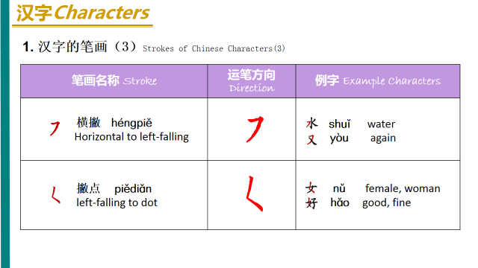
1.水shuǐ water
＿＿＿＿＿＿＿＿＿＿＿＿＿＿＿＿＿＿＿＿＿＿＿＿＿＿＿＿＿＿＿＿＿＿＿＿＿＿
２.又yòu again
＿＿＿＿＿＿＿＿＿＿＿＿＿＿＿＿＿＿＿＿＿＿＿＿＿＿＿＿＿＿＿＿＿＿＿＿＿＿
３.女nǔ girl 男 nán boy
＿＿＿＿＿＿＿＿＿＿＿＿＿＿＿＿＿＿＿＿＿＿＿＿＿＿＿＿＿＿＿＿＿＿＿＿＿＿
4.好 hǎo good
＿＿＿＿＿＿＿＿＿＿＿＿＿＿＿＿＿＿＿＿＿＿＿＿＿＿＿＿＿＿＿＿＿＿＿＿＿＿
5.大dà large
＿＿＿＿＿＿＿＿＿＿＿＿＿＿＿＿＿＿＿＿＿＿＿＿＿＿＿＿＿＿＿＿＿＿＿＿＿＿
6.了le past time, end of sentences.
＿＿＿＿＿＿＿＿＿＿＿＿＿＿＿＿＿＿＿＿＿＿＿＿＿＿＿＿＿＿＿＿＿＿＿＿＿＿
Pack 16
一Countries and Statesssic Anecdotes of Traditional Chinese Culture
- King Yu Tamed the Flood
Long time ago, it was said that a deluge engulfed a huge area of land claimed many lives, so King Shun sent Yu to control the flood.
Talking with seniors, Yu drew lessons from the past water-control experience. After the field survey, he made up a feasible plan. Then he led people to divert he floods, and during this time, though he actually passed by the door of his own home for three times, he didn’t go in. With 13-year persistent efforts under his leadership, 9 large rivers were finally dredged leading floods into the sea.
While harnessing the floods, Yu, along with others, helped people rebuild their homes, fallowed lands and resumed production. In this way, he gave the common people a peaceful and contented life and achieved an immortal feat. At that time, to commemorate Yu the Great, the whole country was called “the City of Yu”; and for his feat, a mausoleum called “Yu Ling” was built in his honor by the later generations.
- What king Yu did?

- Why people respect him?
2. Reign of Zhenguan
Reign of Zhenguan (627-649 AD) was the golden and prosperous age of early Tang Dynasty under the reign of Emperor Taizong, Li Shimin. He is typically considered one of the greatest emperors in the whole Chinese history. Emperor Taizong’s reign was regaded ad the exemplary model against whicj the emperors of later generations were measured, and was considered required study for future crown princes. During his 23-year reign, the nation enjoyed stability and prosperity with the fourishing economy and powerful troops, and the people lived in peace.
The emperor put people in the first place. He saw people as water and emperor as boat, and believed that the water could bear the coat and swallow it as well (民，水也；君，舟也。水能载舟，亦能覆舟。) Taking the downfall of Sui Dynasty as a negative example, Emperor Taizong appointed people on their merits and put them in the most suitable place, besides, he encouraged the free airing of views, accepted criticism with modesty and gave important position to the capable chancellors such as 房玄龄、杜如晦和魏征 and so on. He made a peaceful society by takibg a series of policies, such as putting great emphasis on agriculture, cutting taxes upon farmers, taking the policy of recuperation and strictly enforcing thrift.
Because his era name was Zhenguan, the grand times under his rule was generally recognized as Reign of Zhenguan, which laid a solid foundation for the peace and prosperity of later Tang Dynasty.
After a long time deposition, feudal china ushered on the age of integration in such fields as politics, economy and culture during the 60-year reign of Emperor Qianlong.
1.Why people like good emperor in ancient China?

- Do you think why Chinese people follow their government when some disaster happened? ( we just talk about different cultures, so please not be so sensitive, thank you )

3.What’s the different between American government and Chinese government? What do you like? Why?

3. Sleeping on Brushwood and Tasting Gall
In the Spring and Autumn Period, the State of Wu defeated the State of Yue, and took the King Gou Jian and his wife prisoner. For several years, Gou Jian laboured as salve in Wu. When he was released and returned to Yue, Gou Jian was determined to take revenge for losing his state. In order that he would nec\ver forget his humiliation, Gou Jian slept on a pie of brushwood and tasted gall before every meal in order to remind him of the shame and revenge. After ten years of careful preparations, he attacked and finally conquered the State of Wu.
This idiom is used to describe inspiring oneself to accomplish an ambition.
4.Jing Ke Assassinated the King of Qin 荆轲刺秦
During the warring States Periods, the Prince of Yan sent a famous assassinator Jing Ke to kill the King of Qin. Jing Ke, together with another warrior,left for Qin with the head of 樊於期，a defector of Qin and the map of 督康，the most fertile land of Yan. Approaching the River Yi, Jing Ke sung a heartbroken song impassionedly, “ the River Yi is cold as the wind blows , the hero will never return after this departure.”
Knowing that the envoy from yan brought both the head of 樊於期 and the map of督康 ， the King of Qin felt very happy and ordered to meet Jing Ke at Xianyang Palace right away. Seeing the king, Jing Ke talked with ease. He handed the map to the king. No sooner had the king fully unrolled the map than Jing Ke took out the dagger hidden in the map and grabbed the king’s sleeve trying to stab him. The king tore the sleeve and jumped by the nearby screen heading out. Nobody could do anything to help. The king managed to pull out his long sword and chopped off the left leg of Jing Ke who finally died at Qin’s palace.
Though the assassination failed, Jing Ke took his place in the history book forever due to his bravery.
- Why people think JinKe is a brave hero? Do you think he is or not?

Write simple Characters: Every characters 10 time ,Pinyin and Characters.

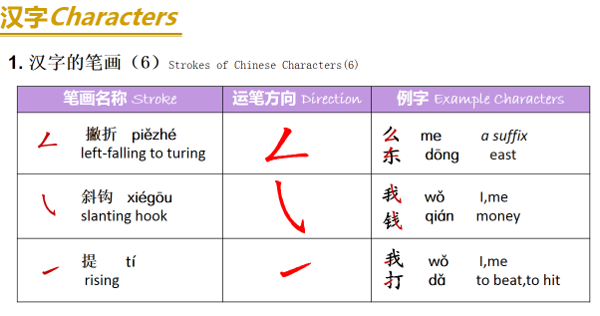
1,什么shénme what
＿＿＿＿＿＿＿＿＿＿＿＿＿＿＿＿＿＿＿＿＿＿＿＿＿＿＿＿＿＿＿＿＿＿＿＿
2.东dōng east
＿＿＿＿＿＿＿＿＿＿＿＿＿＿＿＿＿＿＿＿＿＿＿＿＿＿＿＿＿＿＿＿＿＿＿＿＿＿
3,我wǒ I me
＿＿＿＿＿＿＿＿＿＿＿＿＿＿＿＿＿＿＿＿＿＿＿＿＿＿＿＿＿＿＿＿＿＿＿＿＿＿
4.钱qián money
＿＿＿＿＿＿＿＿＿＿＿＿＿＿＿＿＿＿＿＿＿＿＿＿＿＿＿＿＿＿＿＿＿＿＿＿＿＿
5打dǎ hit or play a ball
＿＿＿＿＿＿＿＿＿＿＿＿＿＿＿＿＿＿＿＿＿＿＿＿＿＿＿＿＿＿＿＿＿＿＿＿＿＿
6.西xī west
＿＿＿＿＿＿＿＿＿＿＿＿＿＿＿＿＿＿＿＿＿＿＿＿＿＿＿＿＿＿＿＿＿＿＿＿＿＿

Pack 17
China Ancient Four Inventions
1. Compass, gunpowder, papermaking skill and typography, is China ancient four inventions, it is one of the signs that China become to the ancient civilized country, occupy the important position in the history of human civilization.
1. Compass
The invention of the compass is the result of China ancient working people know to the object magnetism in the long-term practice. Because of productive labor, people have found the characteristic of the magnet pointing to direction. Through experiment and research in many ways, invented the Compass at last. The Compass give play to important function in the navigation after introducing to Europe.
2. Gunpowder
The gunpowder is made of niter, sulfur and charcoal three kinds of materials mixing. In the Tang Dynasty, the gunpowder begins to be applied to the military affairs. People utilize the throwing stone machine, light the gunpowder bag and throw out, burn the enemy, this is the most primitive cannon.
3. Papermaking skill
The invention of papermaking skill is China’s contribution to the civilization of the world. In the Eastern Han Dynasty (A.D. 105), the papermaking skill inventor Cai lun is on the basis of that forefathers weave silks experience, Have made into the vegetable fiber paper with bark, broken fishing network, rag, etc. raw materials. From then on, paper become to the material that generally write.
4. Typography
The typography is one of the most important four inventions in ancient China. The woodblock printing appear in Sui dynasty, it is that carve protruding Backward Chinese character on woodblock with knife, then brush Chinese ink-liquid, print on the paper. In Sung Dynasty, word worker Bi Sheng (A.D. 1004 —— 1048), Use the clay with viscidity, make into the rectangle cube, carve the single Chinese characters on it, burn it with the fire, form the font. The printing skill is named the typography.
In a word, China ancient four inventions, has left behind a magnificent chapter in the history of human science and culture. These great inventions once influenced and benefited the whole world, had promoted the advancing of human history
- What’s the four China ancient inventions ?

- Which one you are interested in? Why?

- What do you think of Gunpowder? Do you think it bring fortune or disaster to the world ?Do you like gun ?Why? (culture discuss ,no sensitive please)

Know about Chinese characters structure.
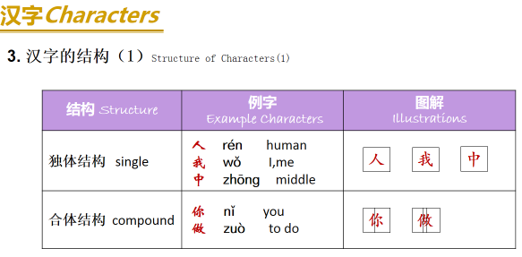
- 我w ǒ________________________
- 你n ǐ ________________________
- 做zu ò to do _____________________________
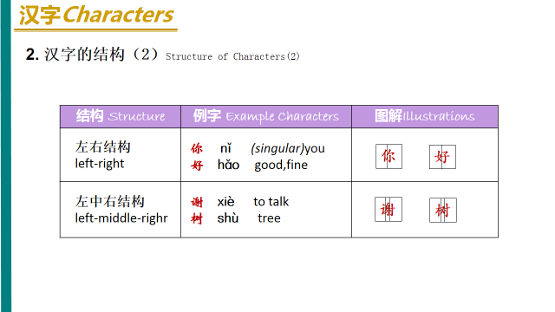
- 好h ǎo_________________________
- 谢xi è _________________________
- 树sh ù _________________________
Pack 18
一、China classical music
China classical music is the traditional art or court music of China. It has a long history stretching for more than three thousand years. It has its own unique systems of musical notation, as well as musical tuning and pitch, musical instruments and styles or musical genres. Chinese music instruments can be categorized into eight classes by the materials they are made from. There are eight kinds of materials：metal , stone, clay, leather, silk, wood, bottle-gourd and bamboo. There is reed and gourd to make Sheng , bamboo to make Xiao(panpipes), wood to make Chu, silk to make Guzheng, clay to make Xun, metal to make Bell, stone to make Sonorous stone, and skin to make Drum .
Guzheng – Made by silk,a traditional Chinese musical instrument. It belongs to the zither family of string instruments. The pipa - is a plucked Chinese string instrument. The instrument has a pear-shaped wooden body. It has been played for nearly two thousand years of history in China. Sheng ：made by reed and gourd. Xiao ：made by bamboo. Chu-made by wood . Xun -made by clay. Bell -made by metal. Sonorous stone –made by stone. Drum –made by skin.
Chinese top ten classical songs: 夕阳箫鼓Flute And Drum At Sunset
十面埋伏House of Flying Daggers 阳春白雪White Snow In Sunny Spring
汉宫秋月Autumn Moon Over Han Palace平沙落雁Wild Geese over the Clam Sands 梅花三弄Three Stanzas of Plum-blossoms 渔樵问答Dialog Between Fisherman And Woodcutter
高山流水High Mountains And Flowing Water 胡笳十八拍The Eighteen Beat of Wu Gier 广陵散 A Music From Guangling
High Mountains and Flowing Streams: It is a gem in the treasure trove of Chinese music. From this name ,you can imagine a harmonious picture with green mountains surrounding you and clear streams quietly passing by your feet. The music is played by Chinese zither. It is slow and quiet, sometimes with rhythm and beats like the flowing water. It is a song in praise of the life-long friendship between Yu Boya, a zither master ,and Zhong Ziqi a woodcutter . The message is that it is not easy for one to find a true friend who can share everything and understand every feeling of the other.
- What do you know about Chinese music?

- What’s the instruments of Chinese classic music?

- Do you like China songs or American songs? What musical style do you like? Why?

- Do you play any musical instrument? Why you like it? What it made with?

- What materials made for Chinese instruments?

Read books and tell me what’s meaning in English.
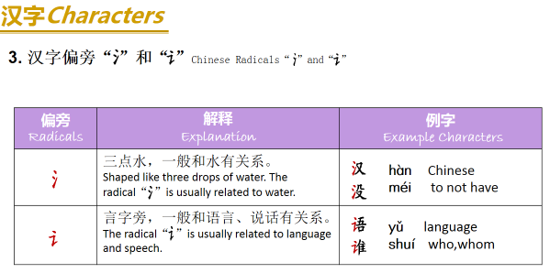
１.汉语hànyǚ Chinese＿＿＿＿＿＿＿＿＿＿＿＿＿＿＿＿＿＿＿＿＿＿＿＿＿＿＿＿＿＿＿＿＿＿＿＿＿＿＿＿＿＿＿＿＿＿＿＿
２.没有méiyǒu not have＿＿＿＿＿＿＿＿＿＿＿＿＿＿＿＿＿＿＿＿＿＿＿＿＿＿＿＿＿＿＿＿＿＿＿＿＿＿＿＿＿＿＿＿＿＿＿
３.语文yǚwén Chinese＿＿＿＿＿＿＿＿＿＿＿＿＿＿＿＿＿＿＿＿＿＿＿＿＿＿＿＿＿＿＿＿＿＿＿＿＿＿＿＿＿＿＿＿＿＿＿＿
４.谁？shéi who＿＿＿＿＿＿＿＿＿＿＿＿＿＿＿＿＿＿＿＿＿＿
５.书包shūbāo book pack＿＿＿＿＿＿＿＿＿＿＿＿＿＿＿＿＿＿＿＿＿＿＿＿＿＿＿＿＿＿＿＿＿＿＿＿＿＿＿＿＿＿＿＿＿＿＿
- 是shì to be
＿＿＿＿＿＿＿＿＿＿＿＿＿＿＿＿＿＿＿＿＿＿＿＿＿＿＿＿＿＿＿＿＿＿＿＿
- 爸bà dad
＿＿＿＿＿＿＿＿＿＿＿＿＿＿＿＿＿＿＿＿＿＿＿＿＿＿＿＿＿＿＿＿＿＿＿＿
- 茶chá tea
＿＿＿＿＿＿＿＿＿＿＿＿＿＿＿＿＿＿＿＿＿＿＿＿＿＿＿＿＿＿＿＿＿＿＿＿
- 高gāo tall high
＿＿＿＿＿＿＿＿＿＿＿＿＿＿＿＿＿＿＿＿＿＿＿＿＿＿＿＿＿＿＿＿＿＿＿＿
- 低d ī short low
＿＿＿＿＿＿＿＿＿＿＿＿＿＿＿＿＿＿＿＿＿＿＿＿＿＿＿＿＿＿＿＿＿＿＿＿
- 个gè common measure word
＿＿＿＿＿＿＿＿＿＿＿＿＿＿＿＿＿＿＿＿＿＿＿＿＿＿＿＿＿＿＿＿＿＿＿＿
- 多少duōshǎo how many
＿＿＿＿＿＿＿＿＿＿＿＿＿＿＿＿＿＿＿＿＿＿＿＿＿＿＿＿＿＿＿＿＿＿＿＿
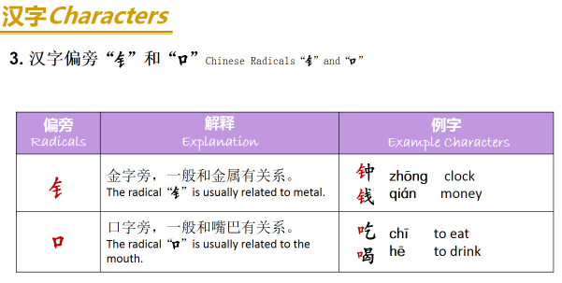1.钟zhōng clock＿＿＿＿＿＿＿＿＿＿＿＿＿＿＿＿＿＿＿＿＿＿＿＿＿＿＿＿＿＿＿＿＿＿＿＿＿＿
2.钱qián money＿＿＿＿＿＿＿＿＿＿＿＿＿＿＿＿＿＿＿＿＿＿＿＿＿＿＿＿＿＿＿＿＿＿＿＿＿＿
3, 吃chī eat＿＿＿＿＿＿＿＿＿＿＿＿＿＿＿＿＿＿＿＿＿＿＿＿＿＿＿＿＿＿＿＿＿＿＿＿＿＿
4, 喝hē drink＿＿＿＿＿＿＿＿＿＿＿＿＿＿＿＿＿＿＿＿＿＿＿＿＿＿＿＿＿＿＿＿＿＿＿＿＿＿
Pack 19
China （porcelain）
China is the hometown of china.The invention of china is a great contribution to world civilization.In English, china means porcelain。
Primitive-celadon appeared in the Shang Dynasty, then from the Western Zhou Dynasty, the Warring States to the Eastern Han Dynasty, through the 1600 years’ change and development, porcelain firing technology had been improved gradually. Around the 16th century BC in Shang Dynasty, the early Chinese porcelain appeared. As it was still rough on the firing process, it can be only called proto-porcelain(原始瓷). After long-term improvements, in 2 century the end of the Han Dynasty, the mature celadon was created, in the history of our country's pottery it was an important milestone. To Jin, original porcelain had been eliminated ,at the same time color porcelain appeared. The period also appeared black porcelain . To the Song Dynasty, porcelain kilns have been over half of Chinese, is the most prosperous period for porcelain. Then Jun kiln, Ge kiln,Ru kiln,Guan kiln and the Ding kiln and known as the five famous kilns. Song Dynasty is the highest aesthetic（美学的） era of porcelain。Yuan Dynasty is Chinese porcelain production turning period, innovation and development in many ways. The blue and white porcelain became the mainstream of Jingdezhen porcelain production. Successfully firing the exquisite（精致的） white glaze porcelain and the single-glaze porcelain with copper（铜） as the coloring agent（色剂）, made the Ming Dynasty porcelain colorful. The porcelain technology continued to improve. Qing Dynasty is the most prosperous period China porcelain production, the quantity and quality of porcelain production reached a peak. A new kind of porcelain had appeared, which called enamel (珐琅器).
Four traditional porcelain ：1.Blue and white porcelain（青花瓷）2.Color glaze porcelain（颜色釉瓷）3、Faille Rose Porcelain（粉彩瓷）4、Glowing porcelain（玲珑瓷）
Blue and white porcelain is elegant, noble, and pure, such as the Millennium basket, with its strong vitality and ceramic art, become the perfect combination of modern and traditional. Blue and white porcelain was first appeared in the Yuan Dynasty. It was formed by using pigment to depict patterns on the green body and firing at high temperature after glazing. The glazing color is glittering and elegant. The green pigment dissolve in green body, showing a verdant color. Although it has single hue, it still gives people rich feeling. Blue and white porcelain is durable。it will not fade until broken。In July 12, 2005, Christie's auction in London, the Yuan Dynasty "Guiguzi" blue and white porcelain pot make 14000000 pounds, equivalent to about 230000000 yuan, it is the highest record in the world of Chinese art auction record. Ancient Chinese craftsmen adding different metal oxides in the glaze, at different temperatures and flame, glaze will show different color, to form the rich and colorful color glaze。Famille Rose Porcelain also called soft porcelain, the famille rose as the main decoration of Famille rose porcelain .
Chinese ceramics of the Song Dynasty constitute the foremost expression of ceramic art. During the Song period, a unity of the essential components fundamental to the art: vessel shape, potting techniques, glaze, decoration, firing processes, and aesthetic theory were all combined in a high standard of excellence. which led to a variety of classic wares, usually associated with a specific region of China. These included the court-patronized five famous kilns: Ru (汝), Guan (官), Ge (哥), Jun (钧), Ding (定) wares;
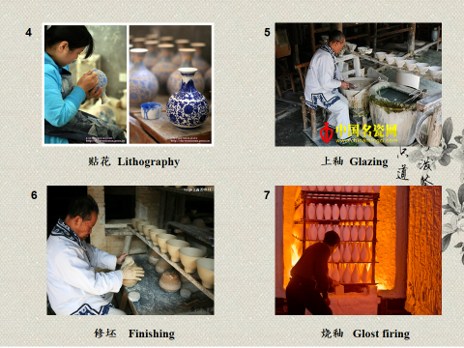
Jingdezhen is a prefecture-level city in Jiangxi Province of China, with a total population of 1,587,477(2010).It is known as the "Porcelain Capital" because it has been producing quality pottery for 1700 years. The city has a well-documented history that stretches back over 2000 years. Jingdezhen is one of Chinese Historical and Cultural Cities, and was named outstanding civilization & health city of Jiangxi Province.
"Ceramic Road" began in the late Tang Dynasty, it is the main artery of the sea between exchanges of Chinese and foreign Medieval. The reason of the name "Ceramic Road", mainly due to the porcelain trade-based nature, some people named this sea trade route as the "Marine Silk Road.“ China's china scattered along this trade route like the shining pearl and lighted the whole of Southeast Asia, Africa and the Arab . "Ceramic Road" brought to China a great commercial wealth.
- What’s china (porcelain)?

- What’s four traditional porcelains?

- How to make a china (porcelain)?

- Do you like porcelains? Why?

- How do you understand "Ceramic Road"?

- 饭店fandian restaurant
＿＿＿＿＿＿＿＿＿＿＿＿＿＿＿＿＿＿＿＿＿＿＿＿＿＿＿＿＿＿＿＿＿＿＿______________
- 学习xué xí to learn ,to study
＿＿＿＿＿＿＿＿＿＿＿＿＿＿＿＿＿＿＿＿＿＿＿＿＿＿＿＿＿＿＿＿＿＿＿＿＿__________
- 这zhè this 、那nà that 、哪nǎ which where 国 guó country
＿＿＿＿＿＿＿＿＿＿＿＿＿＿＿＿＿＿＿＿＿＿＿＿＿＿＿＿＿＿＿＿＿＿
___________________________________________________________________________________
４.同学们tóngxuémen classmates＿＿＿＿＿＿＿＿＿＿＿＿＿＿＿＿＿＿＿＿＿＿＿＿＿＿＿＿
５.凶xiōng fierce＿＿＿＿＿＿＿＿＿＿＿＿＿＿＿＿＿＿＿＿＿＿＿＿＿＿＿＿＿＿＿＿＿＿＿
６.医生yī shēng doctor＿＿＿＿＿＿＿＿＿＿＿＿＿＿＿＿＿＿＿＿＿＿＿＿＿＿＿＿＿＿＿＿
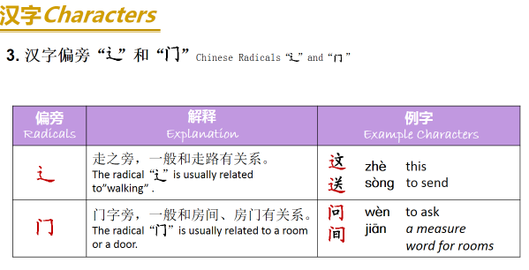
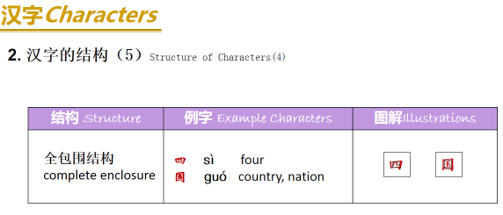
- 这zhè this
＿＿＿＿＿＿＿＿＿＿＿＿＿＿＿＿＿＿＿＿＿＿＿＿＿＿＿＿＿＿＿＿＿＿＿＿＿＿
- 送给sòng gěi give
＿＿＿＿＿＿＿＿＿＿＿＿＿＿＿＿＿＿＿＿＿＿＿＿＿＿＿＿＿＿＿＿＿＿＿＿＿＿
- 请问qǐng wèn please ask

＿＿＿＿＿＿＿＿＿＿＿＿＿＿＿＿＿＿＿＿＿＿＿＿＿＿＿＿＿＿＿＿＿＿＿＿＿＿
- 中间zhōng jiān in the middle of

＿＿＿＿＿＿＿＿＿＿＿＿＿＿＿＿＿＿＿＿＿＿＿＿＿＿＿＿＿＿＿＿＿＿＿＿＿＿
- 左zuǒleft 右yòu right 前qián in front of ,or before 后hòu behind of or after

______________________________________________________________________________

______________________________________________________________________________

Pack 20
一．Second part of culture
Chinese Beijing Opera
Praised as “Oriental Opera”, Beijing Opera is a genuine national quintessence of China. It originated from many kinds of ancient local operas, especially huiban in southern China. At the end of the 19th Century, Beijing Opera evolved and took shape, becoming the greatest kind of opera in China. Beijing Opera is a blend of performing arts---song, speech, performance, acrobatix fighting and dance. Beijing Opera portrays and narrates the plot and characters through stylized acting. The main types of roles in Beijing Opera are sheng(male), dan (young female), jing (painted face, male), and chou( clown, male or female). Beijing Opera is the most popular and influential opera in China with a history of almost 200 years. In development Beijing Opera has formed a number of fictitious props. For instance a pedal means a boat. Without any physical props involved , an actor may perform going upstairs or downstairs opening or closing a door by mere gestures. Though exaggerated those actions would give audience an impression with graceful movements.
- What four basic role in Beijing opera?

- What’s different with Beijing opera and western Opera?

Chinese Taoism
Taoism first originated in China. The founder of Taoism is Laozi, a philosopher and thinker who lived in the late Spring and Autumn Period (770BC-476BC). Tao Te Ching whose authorship has been attributed to Laozi, is considered to be the main Taoist classic. Taoism advocates the value of a human being’s life, recommends the discarding of all desires and worries from one’s mind, and encourages the cultivation of moral character and the nourishment of human nature. The following is an example of Laozi’s golden saying:
The way that can be told of is not an unvarying way;
The names that can be named are not unvarying names.
It was from the nameless that Heaven and Earth sprang;
The named is but the mother that rears the ten thousand creatures, each after its kind.
Truly, only he that rids himself forever of desire can see the secret essences;
He that has never rid himself of desire can see only the outcomes.
- Who created Taoism? What’s the main Taoist classic?

- What’s the philosophy of Taoism?

Chinese Idioms
Chinese idioms refer to comprehensive and integrated fixed phrases and expressions. Idioms are established and accepted by constant usage and common practice. An idiom is a language unit that is larger than a word, but has the same grammatical function as a word. Most Chinese idioms consist of four characters. For example, ziqiangbuxi ( make unremitting efforts to improve oneself), qingchuyulan(bluer than indigo), and houjibofa (success comes with time and effort). Idioms are extrated from folk proverbs, ancient works of literature, poems, fables, allusions, and well-known sayings. Idioms are a part of the Chinese language that are concise and have great vitality.
Chinese silk
China is the home of silk. Mulberry planting, sericulture, silk reeling and thickening are all great inventions of the ancient Chinese. As early as the Shang and Zhou Dynasties (1600BC-256BC), the Chinese people’s silk-weaving techniques had reached an extremely high level. During the Western Han Dynasty (206BC-25AD), Zhang Qian, an outstanding diplomat, travelled around central Asia and connected China with the Persian Gulf and the Mediterranean, opening up a new era of Sino-foreign trade, exchange and communication. From then on, China’s silk became well known for its extraordinary quality, exquisite design and color, and abundant culture connotations. Hitherto, Chinese silk has been accepted as a symbol of Chinese culture and the emissary of oriental civilization.
Chinese Classical Garden
The Chinese classical garden is a precious treasure of our ancient Chinese architecture. It is a kind of environment art, which systematically combines artificial mountains and rivers, plants and buildings with the natural landscape. The construction standard of a Chinese classical garden is “artificial as it is, the garden must look ingenious and natural.” When you go sightseeing in a Chinese classical garden, you should be able to appreciate its artistic concept which “makes use of the natural landscape to create the real fun of mountains and rivers for viewers.” Of the world’s three major garden systems, the Chinese classical garden is hailed as one of the origins of the world’s garden due to its long history and abundant connotations.
- What’s the construction standard of a Chinese classical garden?

The Four Treasures of the Study
The writing brush, ink stick, ink stone, and paper were requisite treasures in the study of the scholars of ancient China, and they are often referred to as the “Four Treasures of the Study.” The writing brush and ink stick have been used by the Chinese to write and paint since 5,000 years ago. In the Qin Dynasty (221BC---206BC), people already used feathers of different hardness and bamboo trunks to make brushes. During the Han Dynasty (206BC-220AD), man-made ink was used instead of natural ink. After paper was invented by the Chinese, bamboo slips, wooden tablets, brocade and silk, which originally functioned as writing surfaces, gradually faded out. The ink stone was first developed with the use of writing brushes and ink. After the Song Dynasty (960AD---1279AD), the “Four Treasure of the Study” particularly referred to hubi, the writing brush produced in Huzhou, Zhejiang province; huimo, the ink stick produced in Huizhou, Anhui province; xuan paper, a kind of paper produced in Xuanzhou, Anhui province; and duanyan, the ink stone made in Zhaoqing, Guangdong province (Zhaoqing was earlier called Duanzhou). Indeed, the Four Treasures of the Study” have writtin the whole Chinese civilization, as it is.
- What’s China’s Four Treasures of the Study in ancient ?

It is said Buddha (the ultimate Emperor for the whole universe in Chinese legend) once called together all the animals on the earth for an important meeting. Only twelve animals turned up: the rat, the ox, the tiger, the rabbit, the dragon, the snake, the horse, the sheep, the monkey, the rooster, the dog and the pig. The rat, being the smartest, jumped on top of the ox to be the first one to arrive. As a reward, the Buddha gave each animal a year in the cycle and declared that anyone born in that year would resemble the animal in some way. In addition, each two hours of the day is also governed by one animal. The hours of 11pm to 1:00 am is by Rat, from 1 am to 3 am by Ox and so on. Six elements of the planet: wood, fire, air, water, gold and earth are also integrated into the animal Zodiac signs.
- Check what’s your animal zodiac? Write it in Chinese Pinyin and characters.

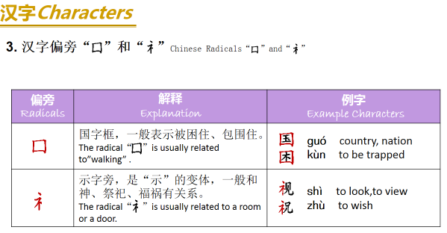
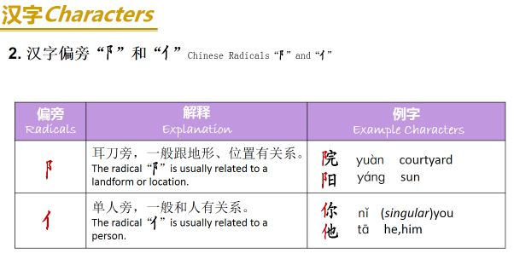
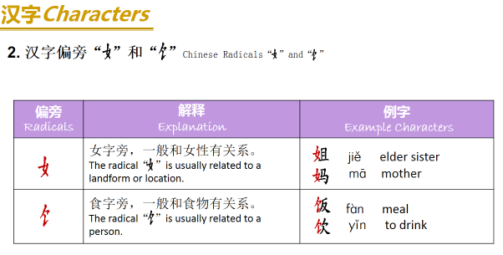
- 困kùn to be trapped ＿＿＿＿＿＿＿＿＿＿＿＿＿＿＿＿
- 看电视kàn diànshì watch TV
＿＿＿＿＿＿＿＿＿＿＿＿＿＿＿＿＿＿＿＿＿＿＿＿＿＿＿＿
- 祝你生日快乐zhùnǐ shēngrì kuài lè.
＿＿＿＿＿＿＿＿＿＿＿＿＿＿＿＿＿＿＿＿＿＿＿＿＿＿＿＿
＿＿＿＿＿＿＿＿＿＿＿＿＿＿＿＿＿＿＿＿＿＿＿＿＿＿＿＿
＿＿＿＿＿＿＿＿＿＿＿＿
- 课本kè běn textbook＿＿＿＿＿＿＿＿＿＿＿＿＿＿＿＿＿＿＿＿＿＿＿＿＿＿＿＿＿＿＿＿＿＿＿
- 周末zhōu mò weekend＿＿＿＿＿＿＿＿＿＿＿＿＿＿＿＿＿＿＿＿＿＿＿＿＿＿＿＿＿＿＿＿＿＿＿＿＿＿＿＿＿
8.她she、他he 、它it .tā＿＿＿＿＿＿＿＿＿＿＿＿＿＿＿＿＿＿＿＿＿＿＿＿
9.院yuàn yard 阳yáng sunshine＿＿＿＿＿＿＿＿＿＿＿＿＿＿＿＿＿＿＿＿＿＿＿＿＿＿＿＿＿＿＿＿＿＿＿＿＿＿＿＿＿＿＿＿＿＿＿
10.下午xià wǔ afternoon电diàn话huà telephone＿＿＿＿＿＿＿＿＿＿＿＿＿＿＿＿＿＿＿＿＿＿＿＿＿＿＿＿＿＿＿＿＿＿＿＿＿＿＿＿＿＿＿＿＿＿＿
1.天气tiānqì weather＿＿＿＿＿＿＿＿＿＿＿＿＿＿＿＿＿＿＿＿＿＿＿＿＿＿＿＿＿＿＿＿＿＿＿＿＿＿＿＿＿＿＿＿
2.雨yǚ rain 雪xuě snow 风fēng wind＿＿＿＿＿＿＿＿＿＿＿＿＿＿＿＿＿＿＿＿＿＿＿＿＿＿＿＿＿＿＿＿＿＿＿＿＿
3.吃饭chī fàn＿＿＿＿＿＿＿＿＿＿＿＿＿＿＿＿＿＿＿＿＿＿＿＿＿＿＿＿＿＿＿＿＿＿＿＿＿＿＿＿＿＿＿＿＿
4.饮料yǐnliào＿＿＿＿＿＿＿＿＿＿＿＿＿＿＿＿＿＿＿＿＿＿＿＿＿＿＿＿＿＿＿＿＿＿＿＿＿＿＿＿＿＿＿＿＿
5.妈妈 māma mom、姐姐jiějie old sister、妹妹mèimei younger sister、哥哥gēge ols brother、弟弟dìdi younger brother、爷爷yéye father’s father。奶奶nǎi nai father’s mother。外公wàigōng mother’s father、外婆wàipó mother’s mother＿＿＿＿＿＿＿＿＿＿＿＿＿

＿＿＿＿＿＿＿＿＿＿＿＿＿＿＿＿＿＿＿＿＿＿＿＿＿

__________________________________________________________

__________________________________________________________

______________________________＿＿＿＿＿＿＿＿＿＿＿

