Packs 17-21
Pack 17
- Read Chinese culture and answer questions
China Ancient Four Inventions
1. Compass, gunpowder, papermaking skill and typography, is China ancient four inventions, it is one of the signs that China become to the ancient civilized country, occupy the important position in the history of human civilization.
1. Compass
The invention of the compass is the result of China ancient working people know to the object magnetism in the long-term practice. Because of productive labor, people have found the characteristic of the magnet pointing to direction. Through experiment and research in many ways, invented the Compass at last. The Compass give play to important function in the navigation after introducing to Europe.
2. Gunpowder
The gunpowder is made of niter, sulfur and charcoal three kinds of materials mixing. In the Tang Dynasty, the gunpowder begins to be applied to the military affairs. People utilize the throwing stone machine, light the gunpowder bag and throw out, burn the enemy, this is the most primitive cannon.
3. Papermaking skill
The invention of papermaking skill is China’s contribution to the civilization of the world. In the Eastern Han Dynasty (A.D. 105), the papermaking skill inventor Cai lun is on the basis of that forefathers weave silks experience, Have made into the vegetable fiber paper with bark, broken fishing network, rag, etc. raw materials. From then on, paper become to the material that generally write.
4. Typography
The typography is one of the most important four inventions in ancient China. The woodblock printing appear in Sui dynasty, it is that carve protruding Backward Chinese character on woodblock with knife, then brush Chinese ink-liquid, print on the paper. In Sung Dynasty, word worker Bi Sheng (A.D. 1004 —— 1048), Use the clay with viscidity, make into the rectangle cube, carve the single Chinese characters on it, burn it with the fire, form the font. The printing skill is named the typography.
In a word, China ancient four inventions, has left behind a magnificent chapter in the history of human science and culture. These great inventions once influenced and benefited the whole world, had promoted the advancing of human history
- What’s the four China ancient inventions ?

- Which one you are interested in? Why?

- What do you think of Gunpowder? Do you think it bring fortune or disaster to the world ?Do you like gun ?Why? (culture discuss ,no sensitive please)

二．Know about Chinese characters structure and write down characters for 6 times.
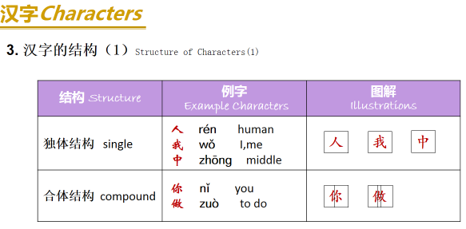
- 我w ǒ________________________________
- 你n ǐ ________________________________
- 做zu ò to do __________________________
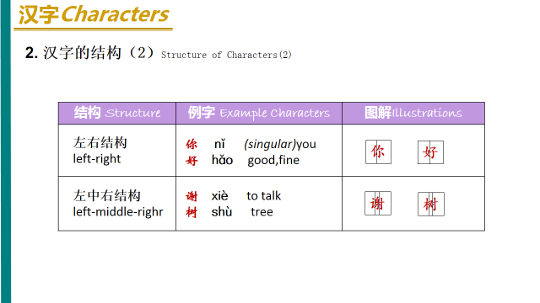
- 好h ǎo________________________________________
- 谢xi è ________________________________________
- 木mù wood,森林sēn lín forest ________________________________________________
- 树sh ù __________________________________________
Pack 18
一、China classical music
China classical music is the traditional art or court music of China. It has a long history stretching for more than three thousand years. It has its own unique systems of musical notation, as well as musical tuning and pitch, musical instruments and styles or musical genres. Chinese music instruments can be categorized into eight classes by the materials they are made from. There are eight kinds of materials：metal , stone, clay, leather, silk, wood, bottle-gourd and bamboo. There is reed and gourd to make Sheng , bamboo to make Xiao(panpipes), wood to make Chu, silk to make Guzheng, clay to make Xun, metal to make Bell, stone to make Sonorous stone, and skin to make Drum .
Guzheng – Made by silk,a traditional Chinese musical instrument. It belongs to the zither family of string instruments. The pipa - is a plucked Chinese string instrument. The instrument has a pear-shaped wooden body. It has been played for nearly two thousand years of history in China. Sheng ：made by reed and gourd. Xiao ：made by bamboo. Chu-made by wood . Xun -made by clay. Bell -made by metal. Sonorous stone –made by stone. Drum –made by skin.
Chinese top ten classical songs: 夕阳箫鼓Flute And Drum At Sunset
十面埋伏House of Flying Daggers 阳春白雪White Snow In Sunny Spring
汉宫秋月Autumn Moon Over Han Palace平沙落雁Wild Geese over the Clam Sands 梅花三弄Three Stanzas of Plum-blossoms 渔樵问答Dialog Between Fisherman And Woodcutter
高山流水High Mountains And Flowing Water 胡笳十八拍The Eighteen Beat of Wu Gier 广陵散 A Music From Guangling
High Mountains and Flowing Streams: It is a gem in the treasure trove of Chinese music. From this name ,you can imagine a harmonious picture with green mountains surrounding you and clear streams quietly passing by your feet. The music is played by Chinese zither. It is slow and quiet, sometimes with rhythm and beats like the flowing water. It is a song in praise of the life-long friendship between Yu Boya, a zither master ,and Zhong Ziqi a woodcutter . The message is that it is not easy for one to find a true friend who can share everything and understand every feeling of the other.
- What do you know about Chinese music?

- What’s the instruments of Chinese classic music?

- Do you like China songs or American songs? What musical style do you like? Why?

- Do you play any musical instrument? Why you like it? What it made with?

- What materials made for Chinese instruments?

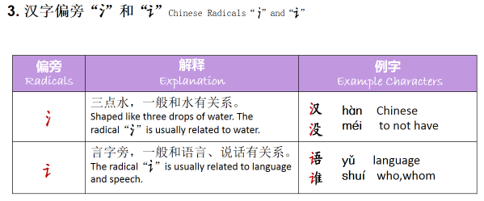
１.汉语hànyǚ Chinese＿＿＿＿＿＿＿＿＿＿＿＿＿＿＿＿＿＿＿＿＿＿＿＿＿＿＿＿＿＿＿＿＿＿＿＿＿＿＿＿＿＿＿＿＿＿＿＿
２.没有méiyǒu not have＿＿＿＿＿＿＿＿＿＿＿＿＿＿＿＿＿＿＿＿＿＿＿＿＿＿＿＿＿＿＿＿＿＿＿＿＿＿＿＿＿＿＿＿＿＿＿
３.语文yǚwén Chinese＿＿＿＿＿＿＿＿＿＿＿＿＿＿＿＿＿＿＿＿＿＿＿＿＿＿＿＿＿＿＿＿＿＿＿＿＿＿＿＿＿＿＿＿＿＿＿＿
４.谁？shéi who＿＿＿＿＿＿＿＿＿＿＿＿＿＿＿＿＿＿＿＿＿＿
- 是shì to be
＿＿＿＿＿＿＿＿＿＿＿＿＿＿＿＿＿＿＿＿＿＿＿＿＿＿＿＿＿＿＿＿＿＿＿＿
- 爸bà dad
＿＿＿＿＿＿＿＿＿＿＿＿＿＿＿＿＿＿＿＿＿＿＿＿＿＿＿＿＿＿＿＿＿＿＿＿
- 茶chá tea
＿＿＿＿＿＿＿＿＿＿＿＿＿＿＿＿＿＿＿＿＿＿＿＿＿＿＿＿＿＿＿＿＿＿＿＿
- 高gāo tall high
＿＿＿＿＿＿＿＿＿＿＿＿＿＿＿＿＿＿＿＿＿＿＿＿＿＿＿＿＿＿＿＿＿＿＿＿
- 低d ī short low
＿＿＿＿＿＿＿＿＿＿＿＿＿＿＿＿＿＿＿＿＿＿＿＿＿＿＿＿＿＿＿＿＿＿＿＿
- 个gè common measure word
＿＿＿＿＿＿＿＿＿＿＿＿＿＿＿＿＿＿＿＿＿＿＿＿＿＿＿＿＿＿＿＿＿＿＿＿
- 多少duōshǎo how many
＿＿＿＿＿＿＿＿＿＿＿＿＿＿＿＿＿＿＿＿＿＿＿＿＿＿＿＿＿＿＿＿＿＿＿＿
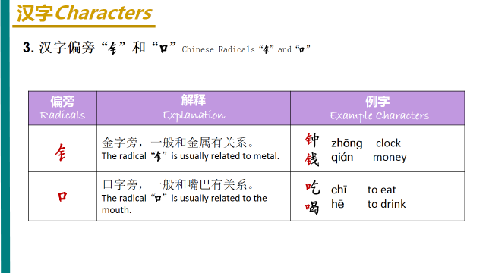
Pack 19
China （porcelain）
China is the hometown of china.The invention of china is a great contribution to world civilization.In English, china means porcelain。
Primitive-celadon appeared in the Shang Dynasty, then from the Western Zhou Dynasty, the Warring States to the Eastern Han Dynasty, through the 1600 years’ change and development, porcelain firing technology had been improved gradually. Around the 16th century BC in Shang Dynasty, the early Chinese porcelain appeared. As it was still rough on the firing process, it can be only called proto-porcelain(原始瓷). After long-term improvements, in 2 century the end of the Han Dynasty, the mature celadon was created, in the history of our country's pottery it was an important milestone. To Jin, original porcelain had been eliminated ,at the same time color porcelain appeared. The period also appeared black porcelain . To the Song Dynasty, porcelain kilns have been over half of Chinese, is the most prosperous period for porcelain. Then Jun kiln, Ge kiln,Ru kiln,Guan kiln and the Ding kiln and known as the five famous kilns. Song Dynasty is the highest aesthetic（美学的） era of porcelain。Yuan Dynasty is Chinese porcelain production turning period, innovation and development in many ways. The blue and white porcelain became the mainstream of Jingdezhen porcelain production. Successfully firing the exquisite（精致的） white glaze porcelain and the single-glaze porcelain with copper（铜） as the coloring agent（色剂）, made the Ming Dynasty porcelain colorful. The porcelain technology continued to improve. Qing Dynasty is the most prosperous period China porcelain production, the quantity and quality of porcelain production reached a peak. A new kind of porcelain had appeared, which called enamel (珐琅器).
Four traditional porcelain ：1.Blue and white porcelain（青花瓷）2.Color glaze porcelain（颜色釉瓷）3、Faille Rose Porcelain（粉彩瓷）4、Glowing porcelain（玲珑瓷）
Blue and white porcelain is elegant, noble, and pure, such as the Millennium basket, with its strong vitality and ceramic art, become the perfect combination of modern and traditional. Blue and white porcelain was first appeared in the Yuan Dynasty. It was formed by using pigment to depict patterns on the green body and firing at high temperature after glazing. The glazing color is glittering and elegant. The green pigment dissolve in green body, showing a verdant color. Although it has single hue, it still gives people rich feeling. Blue and white porcelain is durable。it will not fade until broken。In July 12, 2005, Christie's auction in London, the Yuan Dynasty "Guiguzi" blue and white porcelain pot make 14000000 pounds, equivalent to about 230000000 yuan, it is the highest record in the world of Chinese art auction record. Ancient Chinese craftsmen adding different metal oxides in the glaze, at different temperatures and flame, glaze will show different color, to form the rich and colorful color glaze。Famille Rose Porcelain also called soft porcelain, the famille rose as the main decoration of Famille rose porcelain .
Chinese ceramics of the Song Dynasty constitute the foremost expression of ceramic art. During the Song period, a unity of the essential components fundamental to the art: vessel shape, potting techniques, glaze, decoration, firing processes, and aesthetic theory were all combined in a high standard of excellence. which led to a variety of classic wares, usually associated with a specific region of China. These included the court-patronized five famous kilns: Ru (汝), Guan (官), Ge (哥), Jun (钧), Ding (定) wares;
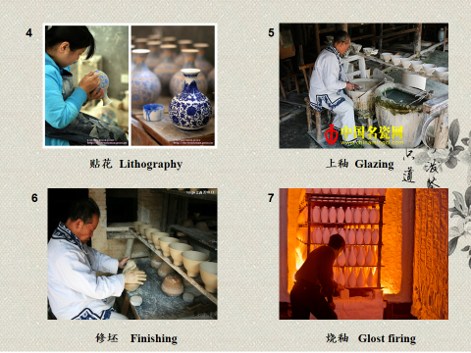
Jingdezhen is a prefecture-level city in Jiangxi Province of China, with a total population of 1,587,477(2010).It is known as the "Porcelain Capital" because it has been producing quality pottery for 1700 years. The city has a well-documented history that stretches back over 2000 years. Jingdezhen is one of Chinese Historical and Cultural Cities, and was named outstanding civilization & health city of Jiangxi Province.
"Ceramic Road" began in the late Tang Dynasty, it is the main artery of the sea between exchanges of Chinese and foreign Medieval. The reason of the name "Ceramic Road", mainly due to the porcelain trade-based nature, some people named this sea trade route as the "Marine Silk Road.“ China's china scattered along this trade route like the shining pearl and lighted the whole of Southeast Asia, Africa and the Arab . "Ceramic Road" brought to China a great commercial wealth.
- What’s china (porcelain)?What’s four traditional porcelains?

- How to make a china (porcelain)?

- Do you like porcelains? Why?
- How do you understand "Ceramic Road"?

- 饭店fandian restaurant
＿＿＿＿＿＿＿＿＿＿＿＿＿＿＿＿＿＿＿＿＿＿＿＿＿＿＿＿＿＿＿＿＿＿＿_______
- 学习xué xí to learn ,to study
＿＿＿＿＿＿＿＿＿＿＿＿＿＿＿＿＿＿＿＿＿＿＿＿＿＿＿＿＿＿＿＿＿＿＿＿＿____
__________________________________________________________________________
- 这zhè this 、那nà that 、哪nǎ which where 国 guó country
＿＿＿＿＿＿＿＿＿＿＿＿＿＿＿＿＿＿＿＿＿＿＿＿＿＿＿＿＿＿＿＿＿＿__________
______________________________________________________________________________
４.同学们tóngxuémen classmates＿＿＿＿＿＿＿＿＿＿＿＿＿＿＿＿＿＿＿＿＿＿＿＿
＿＿＿＿_____________________________________________________________________
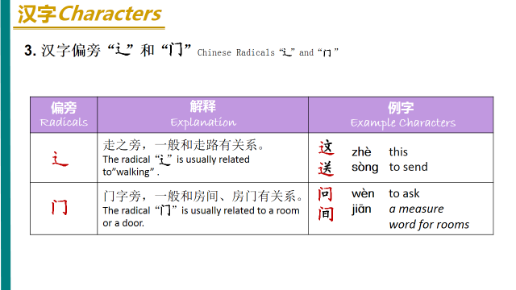
- 这zhè this＿＿＿＿＿＿＿＿＿＿＿＿＿＿＿＿＿＿＿＿＿＿＿＿＿＿＿＿
- 问wèn ask＿＿＿＿＿＿＿＿＿＿＿＿＿＿＿＿＿＿＿＿＿＿＿＿＿＿＿
- 中zhōng in the middle of ＿＿＿＿＿＿＿＿＿＿＿＿＿＿＿＿＿＿＿＿
- 左zuǒleft 右yòu right 前qián in front of ,or before 后hòu behind of or after

______________________________________________________________________________

______________________________________________________________________________
Pack 20
一．Second part of culture
Chinese Beijing Opera
Praised as “Oriental Opera”, Beijing Opera is a genuine national quintessence of China. It originated from many kinds of ancient local operas, especially huiban in southern China. At the end of the 19th Century, Beijing Opera evolved and took shape, becoming the greatest kind of opera in China. Beijing Opera is a blend of performing arts---song, speech, performance, acrobatix fighting and dance. Beijing Opera portrays and narrates the plot and characters through stylized acting. The main types of roles in Beijing Opera are sheng(male), dan (young female), jing (painted face, male), and chou( clown, male or female). Beijing Opera is the most popular and influential opera in China with a history of almost 200 years. In development Beijing Opera has formed a number of fictitious props. For instance a pedal means a boat. Without any physical props involved , an actor may perform going upstairs or downstairs opening or closing a door by mere gestures. Though exaggerated those actions would give audience an impression with graceful movements.
- What four basic role in Beijing opera?

- What’s different with Beijing opera and western Opera?

Chinese Taoism
Taoism first originated in China. The founder of Taoism is Laozi, a philosopher and thinker who lived in the late Spring and Autumn Period (770BC-476BC). Tao Te Ching whose authorship has been attributed to Laozi, is considered to be the main Taoist classic. Taoism advocates the value of a human being’s life, recommends the discarding of all desires and worries from one’s mind, and encourages the cultivation of moral character and the nourishment of human nature. The following is an example of Laozi’s golden saying:
The way that can be told of is not an unvarying way;
The names that can be named are not unvarying names.
It was from the nameless that Heaven and Earth sprang;
The named is but the mother that rears the ten thousand creatures, each after its kind.
Truly, only he that rids himself forever of desire can see the secret essences;
He that has never rid himself of desire can see only the outcomes.
- Who created Taoism? What’s the main Taoist classic?

- What’s the philosophy of Taoism?

Chinese Idioms
Chinese idioms refer to comprehensive and integrated fixed phrases and expressions. Idioms are established and accepted by constant usage and common practice. An idiom is a language unit that is larger than a word, but has the same grammatical function as a word. Most Chinese idioms consist of four characters. For example, ziqiangbuxi ( make unremitting efforts to improve oneself), qingchuyulan(bluer than indigo), and houjibofa (success comes with time and effort). Idioms are extrated from folk proverbs, ancient works of literature, poems, fables, allusions, and well-known sayings. Idioms are a part of the Chinese language that are concise and have great vitality.
Chinese silk
China is the home of silk. Mulberry planting, sericulture, silk reeling and thickening are all great inventions of the ancient Chinese. As early as the Shang and Zhou Dynasties (1600BC-256BC), the Chinese people’s silk-weaving techniques had reached an extremely high level. During the Western Han Dynasty (206BC-25AD), Zhang Qian, an outstanding diplomat, travelled around central Asia and connected China with the Persian Gulf and the Mediterranean, opening up a new era of Sino-foreign trade, exchange and communication. From then on, China’s silk became well known for its extraordinary quality, exquisite design and color, and abundant culture connotations. Hitherto, Chinese silk has been accepted as a symbol of Chinese culture and the emissary of oriental civilization.
Chinese Classical Garden
The Chinese classical garden is a precious treasure of our ancient Chinese architecture. It is a kind of environment art, which systematically combines artificial mountains and rivers, plants and buildings with the natural landscape. The construction standard of a Chinese classical garden is “artificial as it is, the garden must look ingenious and natural.” When you go sightseeing in a Chinese classical garden, you should be able to appreciate its artistic concept which “makes use of the natural landscape to create the real fun of mountains and rivers for viewers.” Of the world’s three major garden systems, the Chinese classical garden is hailed as one of the origins of the world’s garden due to its long history and abundant connotations.
- What’s the construction standard of a Chinese classical garden?

The Four Treasures of the Study
The writing brush, ink stick, ink stone, and paper were requisite treasures in the study of the scholars of ancient China, and they are often referred to as the “Four Treasures of the Study.” The writing brush and ink stick have been used by the Chinese to write and paint since 5,000 years ago. In the Qin Dynasty (221BC---206BC), people already used feathers of different hardness and bamboo trunks to make brushes. During the Han Dynasty (206BC-220AD), man-made ink was used instead of natural ink. After paper was invented by the Chinese, bamboo slips, wooden tablets, brocade and silk, which originally functioned as writing surfaces, gradually faded out. The ink stone was first developed with the use of writing brushes and ink. After the Song Dynasty (960AD---1279AD), the “Four Treasure of the Study” particularly referred to hubi, the writing brush produced in Huzhou, Zhejiang province; huimo, the ink stick produced in Huizhou, Anhui province; xuan paper, a kind of paper produced in Xuanzhou, Anhui province; and duanyan, the ink stone made in Zhaoqing, Guangdong province (Zhaoqing was earlier called Duanzhou). Indeed, the Four Treasures of the Study” have writtin the whole Chinese civilization, as it is.
- What’s China’s Four Treasures of the Study in ancient ?

It is said Buddha (the ultimate Emperor for the whole universe in Chinese legend) once called together all the animals on the earth for an important meeting. Only twelve animals turned up: the rat, the ox, the tiger, the rabbit, the dragon, the snake, the horse, the sheep, the monkey, the rooster, the dog and the pig. The rat, being the smartest, jumped on top of the ox to be the first one to arrive. As a reward, the Buddha gave each animal a year in the cycle and declared that anyone born in that year would resemble the animal in some way. In addition, each two hours of the day is also governed by one animal. The hours of 11pm to 1:00 am is by Rat, from 1 am to 3 am by Ox and so on. Six elements of the planet: wood, fire, air, water, gold and earth are also integrated into the animal Zodiac signs.
- Check what’s your animal zodiac? Write it in Chinese Pinyin and characters.
二、Know about Chinese characters structure and write down characters and Pinyin 6 times.
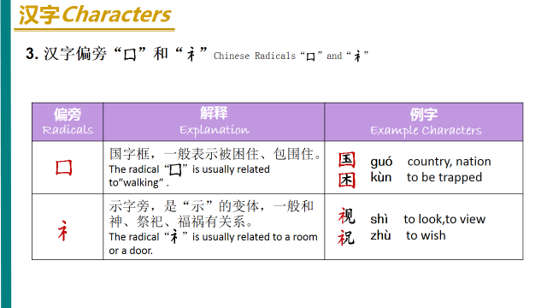
- 困kùn to be trapped ＿＿＿＿＿＿＿＿＿＿＿＿＿＿
- 视shì TV＿＿＿＿＿＿＿＿＿＿＿＿＿＿＿＿＿＿＿＿
- 祝你生日快乐zhùnǐ shēngrì kuài lè.
＿＿＿＿＿＿＿＿＿＿＿＿＿＿＿＿＿＿＿＿＿＿＿＿＿＿＿＿____________________________________＿＿＿＿＿＿＿＿＿＿＿＿＿＿＿＿＿＿＿＿＿____
4.周末zhōu mò weekend＿＿＿＿＿＿＿＿＿＿＿＿_＿＿＿＿＿＿＿＿＿＿＿＿＿＿＿＿＿＿＿＿＿＿＿＿＿＿＿＿＿__________________________________
5.她she、他he 、它it .tā＿＿＿＿＿＿＿＿＿＿＿＿＿＿＿＿＿＿＿＿＿＿＿＿______________________
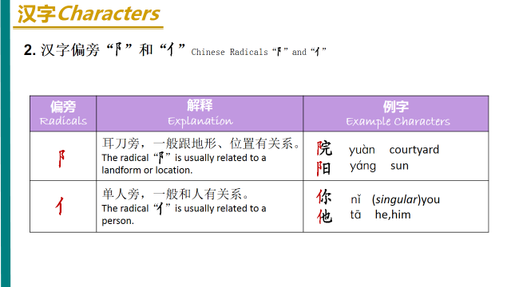
6.阳yáng sunshine＿＿＿＿＿＿＿＿＿＿＿＿＿＿＿＿＿＿＿

＿＿＿＿＿＿＿＿＿＿＿＿＿＿＿＿＿＿＿＿＿＿＿＿＿＿＿__________________________
7.天气tiānqì weather＿＿＿＿＿＿＿＿＿＿＿＿＿＿＿＿＿＿＿＿＿＿＿＿＿＿＿＿＿＿＿＿＿＿＿＿＿＿＿＿＿＿__________
8.雨yǚ rain 雪xuě snow 风fēng wind＿＿＿＿＿＿＿＿＿＿＿＿＿＿＿＿＿＿＿＿＿＿＿＿＿＿＿＿＿＿＿＿＿＿＿＿＿________

Pack 21
一、Know about Chinese characters structure and write down characters and Pinyin 6 times.
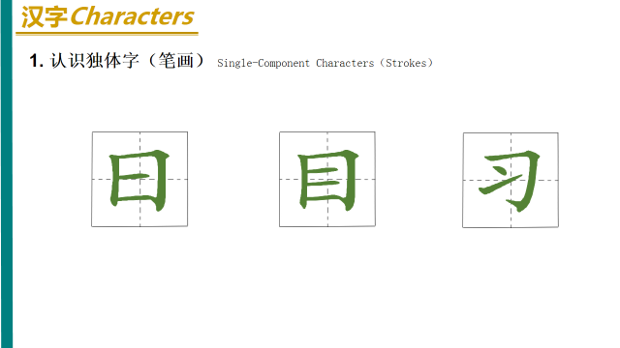
1.日rì sun _________________________________________________
__________________________________________________________
3.目mù eyes_______________________________________________
4.学习xué xí to learn, to study_________________________________
__________________________________________________________
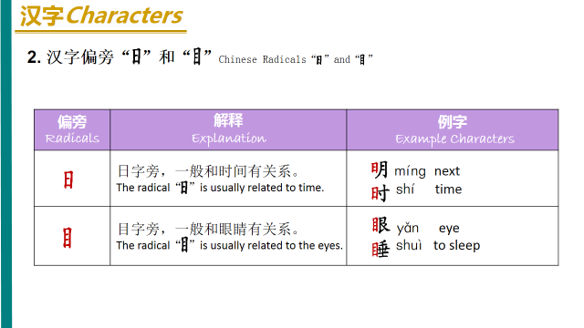
4.明天míngtiān tomorrow___________________________________
5.时shí time __________________________________________________________
7.眼y ǎn eyes_______________________________________________

8.睡shuì to sleep ___________________________________________
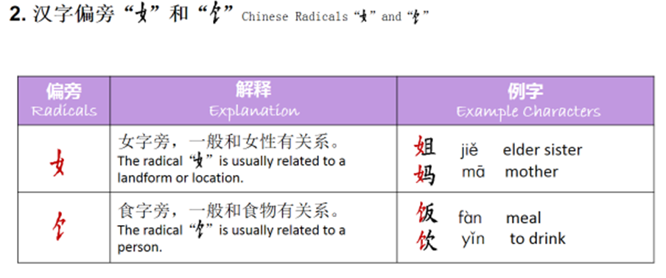
9.吃饭chī fàn＿＿＿＿＿＿＿＿＿＿＿＿＿＿＿＿＿＿＿＿＿＿＿＿＿＿＿＿＿＿＿＿＿＿＿＿＿＿＿＿＿＿＿＿＿____________
10.饮料yǐnliào＿＿＿＿＿＿＿＿＿＿＿＿＿＿＿＿＿＿＿＿＿＿＿＿＿＿＿＿＿＿＿＿＿＿＿＿＿＿＿＿＿＿＿＿＿
11.妈妈 māma mom、姐姐jiějie old sister、妹妹mèimei younger sister、哥哥gēge ols brother、弟弟dìdi younger brother、爷爷yéye father’s father。奶奶nǎi nai father’s mother。外公wàigōng mother’s father、外婆wàipó mother’s mother
12．开车kāi chē drive a car __________________________________________________

