**Day 22 C.P. Worksheet 1- Linear Motion** Name_______________ Per.___

1. If you earn $10 per hour and you work for six hours, how much money do you have?
2. If you drive in a car that travels at 10 meters per second for ten seconds, how far have you traveled?
3. If a ball that is dropped gains speed at 10m/s per second, how fast is it going after six seconds?
4. If you threw the previous ball down and gave the ball an initial speed of 15 m/s, how fast would the ball be going after 6 seconds?
5. If you made $60 but had to pay to get physics tutoring at $10 per hour, how many hours of physics tutoring could you get?
6. If you threw a ball up at 60 m/s and gravity pulls it down at 10 m/s per second, how many seconds will it take for the ball’s speed to be zero?
7. What will the balls speed be after 2 seconds? After 12 seconds?
8. If the ball you threw into the air stopped and started to come back down after 6 seconds, how high did the ball go?



1. Calculate the position of the ball for each time between 0-12 seconds.

|  |  |  |  |  |  |  |  |  |  |  |  |  |
| --- | --- | --- | --- | --- | --- | --- | --- | --- | --- | --- | --- | --- |
| Time (s) | 1 | 2 | 3 | 4 | 5 | 6 | 7 | 8 | 9 | 10 | 11 | 12 |
| Distance (m) |  |  |  |  |  |  |  |  |  |  |  |  |

1. Graph this data

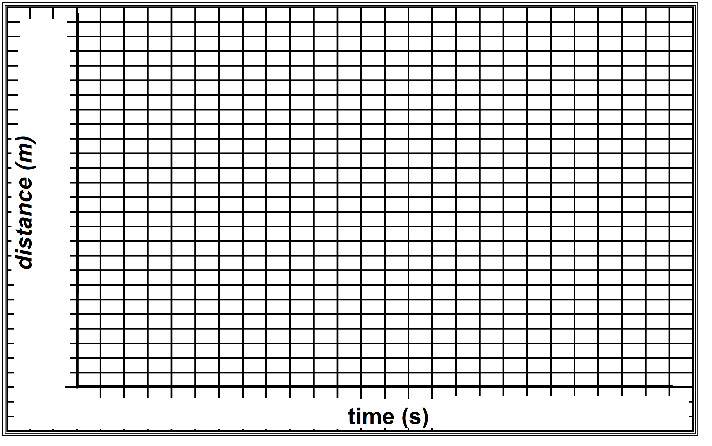

1. What is the average speed of the ball in this case (don’t forget trip up and trip back)?
2. What is the average velocity of the ball in this case?
3. Explain the difference between distance and displacement and relate it to the previous two questions.

**Answers: 1) $60 2) 60 m 3) 60 m/s 4) 75 m/s 5) 6 hours 6) 6 seconds**

**7) 40 m/s, -60 m/s 8) 180m 11) 30m/s 12) 0 m/s**

Day 23 AP Physics Problems Name ______________________________

Normal Force

1) A 6.00 kg box is resting on a table. You push down on the box with a force of 8.00N. What is the magnitude of the normal force of the table on the box?

b) What would be the normal force on the box if you pulled up on the box with a force of 8.00N?

c) What would be the normal force on the box if you pulled up on the box with a force of 25.0N at an angle of 40º from vertical?

2) A 22.0 kg child slides down a slide that makes a 37º angle with the horizontal.

a) What is the magnitude of the normal force that the slide exerts on the child?

b) At what angle from the horizontal is this force directed?

**Day 24** AP Physics Problems Name ______________________________

Normal Force

1) A 6.00 kg box is resting on a table. You push down on the box with a force of 8.00N. What is the magnitude of the normal force of the table on the box?

b) What would be the normal force on the box if you pulled up on the box with a force of 8.00N?

c) What would be the normal force on the box if you pulled up on the box with a force of 25.0N at an angle of 40º from vertical?

2) A 22.0 kg child slides down a slide that makes a 37º angle with the horizontal.

a) What is the magnitude of the normal force that the slide exerts on the child?

b) At what angle from the horizontal is this force directed?

Day 25 Name_________________________

Period_________________________

**HARMONIC MOTION**

**WORKSHEET**

**1.** A simple harmonic motion has a frequency equal to 4 cycles per second and amplitude of 3. Write a formula for such a sinusoidal function.

1___________________________

**2.** Determine the period, frequency, and amplitude of a harmonic motion given by .

**2per___________ freq__________ amp_________**

**3.** A weight suspended from a spring is set into oscillating motion by compressing it to a point 5 cm above its rest position and releasing it. It takes 2.5 s for the weight to complete one cycle. Determine an equation and graph to describe the position of the weight at time t seconds.

_________________________

**3___________________________**

**4.** A person is seated on a Ferris wheel of radius 80 ft that makes one rotation every 25 s. The center of the wheel is 85 ft above the ground. Determine an equation and graph to represent the person’s height above the ground at any time. Assume the ride begins in the middle and rotates down first.

_________________________

**4___________________________**

**5.** A 6-lb weight hanging from the end of a spring is pulled 10 cm below its resting position and released; it takes 0.9 s to complete a cycle. Determine an equation and graph for the motion of the weight.

_________________________

**5___________________________**

**6.** High tide in a bay is 2.6 m above sea level, and low tide is 2.6 m below sea level. The time between high tides is 12.25 hours. Use a sinusoidal function and graph to describe the motion of the tides, assuming that it is low tide at t = 0 hours.

_________________________

**6___________________________**

WRITE AN EQUATION OF THE MOTION FOR THE TIP OF A PENDULUM SATISFYING THE GIVEN CONDITIONS.

**7.** Maximum displacement 12 cm; one cycle in 2 s.

**7___________________________**

**8.** Maximum displacement 7.5 cm; one cycle in 3.1 s.

**8___________________________**

**9.** Maximum displacement 6 cm; one cycle in 0.25 s.

**9___________________________**

**10.** Maximum displacement 5 cm; one cycle in 1.5 s.

**10__________________________**

REWRITE EACH OF THE FOLLLOWING AS AN ALGEBRAIC EXPRESSION:

**11.  12. **

**11___________________________ 12________________________________**

Day 26 Advanced Placement Physics Waves and Optics

Energy:  Waves transport energy.

Vibration / oscillation: Something must be vibrating / oscillating in order to create a wave.

Medium: Waves must travel in a medium with one important exception.

Electromagnetic waves are the only type of wave that do not require a medium at all.

Frequency:  Number of vibrations, oscillations, cycles, revolutions, etc. that take place each second.

Period:  Time for one complete vibration / oscillation.

Wavelength:  The length on a single wave. Measure to the same point on the next wave.

Velocity:  Wave velocity depends on the elasticity of the medium. Sound travels faster in metal than in water and faster in water than in air. Light, however, is unusual. It is fastest in a vacuum and slows slightly in air, and to a greater extent in water.

Amplitude:  Maximum displacement from the equilibrium position (midline on the graph).

Transverse Wave: Particles vibrate in a direction perpendicular to the wave direction & velocity.

Longitudinal Wave: (also Compression, or Shock ) Particles vibrate in a direction parallel to wave direction & velocity.

Sinusoidal: When a vibrations displacement is graphed against time a sinusoidal function is plotted. It is the graphical representation for any wave phenomenon, and looks like a transverse wave. However, any wave, even longitudinal waves, follows the same sinusoidal pattern.

Amplitude

Wavelength

Pulse: A single wave.

Continuous Wave: A series of equal pulses equally spaced moving together.

Standing wave: When a continuous wave strikes a barrier and reflects back on itself it will create an interference pattern (see interference below). If the phase (see phase below) of the reflected wave is exactly opposite to the incoming wave they will superimpose creating a standing wave.

Node: A point on a standing wave that does not move at all.

Amplitude

Wavelength

*Speed depends on the mediums elasticity. When a wave travels from one medium to a different medium the speed & wavelength change. However the frequency remains the same.*

*Interference*: When two or more wave meet, the amplitudes add.

*In phase*: Waves are in phase when they have the same wavelength and the crests are aligned.

*Out phase*: Waves are out of phase when they the crest on one wave aligns with the trough of another.

*Constructive Interference*: If the waves are in phase you add  
 them to construct a larger amplitude.

*Destructive Interference*: If the waves are out phase you add them to destroy the amplitude. The waves shown have the same amplitude and wavelength, but any kind of wave can interfere, so different amplitudes and wavelengths can result in many unique new wave functions.

*Sound*: The speed of sound in air at 25o C is 343 *m/s* (often rounded to 340 *m/s*). The speed of sound changes with temperature since the density and elasticity of air change as temperatures fluctuate.

*Pitch*: Frequency *Loudness*: Amplitude

Sound waves can originate from vibrating strings or in tubes. This is the basis for musical instruments.  
There are two types of tubes: those open at both ends & those closed at one end.

Strings: Only multiples of ½ wavelengths can fit on a vibrating string that is held fixed at each end.

Open Tubes: Same as strings, multiples of ½ waves. But the waves look a little different, since the ends aren’t fixed.

wavelength

node

Closed Tubes: Closed tubes hold multiples of ¼ waves.

1/2 wavelength 1/4 wavelength  
  
  
2/2 wavelength 1/2 wavelength

Adjustments to the velocity equation. The simplest case is the minimum number of wavelengths. So we will work with the *fundamental*, strings or open tubes that have a ½ wavelength, and closed tube holding ¼ wavelength.

Normal wave velocity 

Strings:  If ½ wavelength fits on the string, then .

Open tubes:  If ½ wavelength fits in the tube, then .

Closed tubes:  If ¼ wavelength fits in the tube, then .

To adjust for more than ½ wavelengths in strings & open tubes, and ¼ wavelengths in closed tubes you divide *L* by the number of nodes. Example: This tube contains two nodes. 

More on velocity: Sound also follows the normal velocity equation . You can time the distance to lightening by counting the seconds between the flash and the thunder. But, if you’re timing sound that makes a round trip (like an echo, or sonar) you have to divide your final answer by 2.

*Resonance*: Everything has a natural vibration frequency. If you can match the natural vibration and add more wave energy at the right frequency and wavelength you can shatter the object. Breaking a crystal glass with your voice, or the Tacoma Narrows Bridge are examples.

*Light*: Travels in packets of energy, called *Photons*.

*Electromagnetic Radiation*: It can travel through a vacuum since it is a self-supporting electromagnetic phenomenon. It consists of two perpendicular waves, one electric and one magnetic. The electric field wave generates a magnetic field wave that is perpendicular to it, and the magnetic field wave generates an electric field wave perpendicular to it. After they are emitted by the source they recreate each other and support each other allowing *EM* waves to travel through a vacuum free of their original source and without a medium. We see only visible light, which is a very small portion of the entire electromagnetic spectrum. The entire spectrum from weakest to strongest is:

Radio Waves Microwaves Infrared (IR) Visible Ultraviolet (UV) X-Rays Gamma Rays

Long wavelength Short Wavelength  
Low frequency High frequency  
Low energy High energy

In a vacuum they travel at 3x108 *m/s*. When they strike an object they can interact with the object in four principle ways.

*Absorb*: The wave energy is transferred to the object and its internal energy *ΔU* goes up, as the does the temperature.

*Scattering*: The incoming light can be absorbed briefly, exciting the electrons in the atoms. The excited electrons move to higher energy states, but quickly move down to lower energy levels. The electrons may drop to various intermediate energy levels on their way back to the ground state, thus emitting photons with new frequencies.

*Transmit*: The waves may pass through an object, like visible light through glass or x-rays through your body.

*Reflect*: They may bounce off of the object.

To see light the waves must be aimed straight into our eyes to excite the photo-receptors at the back of our eyes. The colors we see are the waves of light that reflected off of the object or that were scatted by the object. The colors that are not present are the ones that either passed through the object or were absorbed by the object. Grass is green because it absorbs red and blue light needed for photosynthesis, and it reflects the unnecessary green wavelengths. The sky is blue due to scattering of the white light from the sun by particles in the earth’s atmosphere.

*Diagramming Waves*

*Sinusoidal*: If you look at a wave from the side you see a sinusoidal pattern.

*Wave Front*: If you look at waves from above you see the crests moving parallel to each other.

*Ray*: The easiest method. You use one or more vectors to indicate the direction the waves are moving in. Even though light radiates radially from a source in rays, light arriving from a distant source arrives very nearly parallel. So for simplicity the waves of light are assumed parallel. A distant source does not need to be very far away for visible light since the wavelengths are measured in nanometers.  
  
 Wave Fronts Rays  
  
  
 or or

*Reflection*

*Law of reflection* . The angle of incidence and angle of reflection are measured in relation to the normal. A normal is a line perpendicular to the surface (as in Force Normal which is perpendicular to the surface). It is normally shown as a dashed line. To simplify the diagram a single ray of light is shown as opposed to wave fronts of light. Each individual ray follows the law of reflection.  
  
 Single Ray, smooth surface Parallel rays, smooth surface Rough surface, *Diffuse* reflection  
  
  
  
  
  
  
On a smooth surface such as a mirror the incident parallel rays of light reflect parallel and the image formed is identical to the object. But on a rough surface the incident parallel rays are sent in all directions and the image may be *diffuse* (fuzzy), or not form at all.

**C = 2*F***

***F***

**θr**

**θi**

*Converging Spherical Mirror*

The law of reflection holds. You need a normal perpendicular to the surface. A perpendicular line to a sphere will pass through its center. When incident parallel rays arrive from a distant light source the angle of reflection will equal the angle of incidence. The normal bisects this angle. Therefore, the rays of light will *converge* on a point half way between the curved surface and the center. The point of convergence is called the *focus* or *focal point*.  and 

*Transmitting Light*

The speed of waves is dependent on the medium the wave travels in. Electromagnetic waves are the only waves capable of traveling in a vacuum. And unlike other waves they travel fastest in a vacuum and are slowed by other mediums. The speed of light in a vacuum is . To compare the speed of light in different mediums an *Index of refraction* was devised, . This index is a comparison value (other comparison values in the course have been the coefficient of friction, coefficient of linear expansion, and resistivity.). If the speed of light in glass is slowed to 2x108, the index of refraction is 1.5. The index of refraction for light in a vacuum is 1.00. So the index can never be less than one. The index of refraction for air is 1.0003, which rounds to .

*Refraction*

*Light Traveling through mediums with different densities *

*From a less dense to more dense medium From a more dense to less dense medium*

* Light moves *slower* • Light moves *faster*
* The *frequency is unchanged* • The *frequency is unchanged*
* So *wavelength is shorter* • So *wavelength is longer*
* So light *bends toward* the normal • So light *bends away* from the normal

Snell’s Law

 Given the speed in one or both mediums the indices of refraction can be determined. Or one or both angles can be determined experimentally. With three pieces of information the fourth can be determined mathematically. The diagram to the right shows light moving from a less dense medium to a more dense medium. *n1* and *θ1* go with the incident medium while *n2* and *θ2* go with the refracted medium.

***n2***

***n1***

**θ2**

**θ1**

*Total Internal Reflection*

A special case of Snell’s Law. If the incident angle is of a certain size it will result in a 90o angle of refraction. This incident angle is called the critical angle. At incident angles larger than the critical angle the light reflects back into the substance. So the light at the critical angle or greater is totally internally reflected.  
 If medium one is the incident ray then *θ1* is the critical angle and *θ2* is 90o.   

Less dense medium

**90o**

**θc**

**θ is larger than θc. Rays are reflected**

*Lenses and Mirrors*

Mirrors reflect light and lenses transmit light. They both fall into two main categories. *Converging* lenses and mirrors converge parallel rays of light on the focal point. *Diverging* lenses and mirrors diverge parallel rays of light away from the focus. The shapes of lenses and mirrors fall into two main categories, *convex* and *concave*. Concave has a cave shape.

Converging Lense Diverging Lense Converging Mirror Diverging Mirror  
Convex Lense Concave Lense Concave Mirror Convex Mirror  
  
  
  
  
  
  
  
Note: Converging and Diverging are the important terms. The shapes are secondary. The terms converging and diverging dictate the information needed to do the mathematical steps outlined on the next page.

*Images*: Two types of images are formed by light interacting with lenses and mirrors. To find the location and diagram the size of an image you draw the rays of light and look for their intersection. When rays of light converge it is easy. You follow the path of the light, the *forward ray trace*. But, when rays diverge (separate) the forward ray traces will not intersect. So you must draw a *back ray trace* to the other focus. The forward trace is drawn as a solid line, while the back ray trace is drawn as a dotted line.

*Real Image:* Can be projected on a screen. Results from the intersection of *forward ray traces* & is always *inverted*.

*Virtual Image:* Cannot be projected on a screen. Results from the intersection of *back ray traces* & is always *upright*.

*Ray Tracing*: See the worksheet on ray tracing for details on all the special cases of the lenses and mirrors. Ray tracing follows a set of rules. There are many variations, but I believe the list below will cover most if not all cases.

*Rules for Lenses:* Remember light goes through the lens.

* Rays arriving parallel to the midline, either converge on the far focus or diverge from the near focus.
* Rays that go through the center of the lens keep going straight.

*Rules for mirrors:* Remember light bounces off the mirror.

* Rays arriving parallel to the midline, either converge on the near focus or diverge from the far focus.
* Rays drawn through the object and the focus, go out parallel.
* Rays that go through the center of curvature bounce (*C = 2F*) bounce straight back.

Geometric Optics

 The center of curvature is located at 2f. So the focal point is half of the radius.

 Shows the geometric relationship between the focal length, object distance, image distance.  Relates the magnification to the height of the object and image, and the distance to each.

The equations are simply a matter of identifying correct variables and solving. Conversions to base units are not even necessary. In the first equation all variables have the same units and you are merely adding them. The only conversions needed are in cases where you lack unit agreement. In optics centimeters are commonly used. Millimeters may be seen on occasion. In the second equation units cancel providing they are the same.

However, you must know when the variables are positive and when they are negative.

 Converging lenses and mirrors are positive. Diverging lenses and mirrors are negative.

 Object is always positive, so the object distance is positive.

 Positive if the forward ray traces intersect to create the image. Negative if generated by back ray traces.

 Object is always positive, so the object height is positive.

 If the image is upright, the image height is positive. If the image is inverted, the image height is negative.

 Plugging in a positive image height into the formula results in positive magnification. Plugging in a negative image height results in negative magnification. Remember negative M does not mean the image is smaller. It means the image is upside down. 0.5x is a smaller image and upright, while –2.0x is a larger image, but it is inverted.

Real: A real image is formed by positive ray traces. Positive ray traces are where the light goes, so this image can be projected on a screen.

Virtual: A virtual image is formed by back ray traces. It appears on the opposite side of the lens or mirror from the lights path. So it cannot be projected on a screen.

Patterns

A general rule: If the forward light rays touch the focus or image they are positive.

Object distance and height: The object is always positive.

Image height and magnification: Look at the image, up is positive and down is negative.

These always go together

Converging Real positive si inverted negative hi negative M

Diverging Virtual negative si upright positive hi positive M

Remember the terms convex and concave are secondary. Focus on the terms converging and diverging. The patterns are based on the nature of the lens or mirror, whether it is converging or diverging.

Diffraction

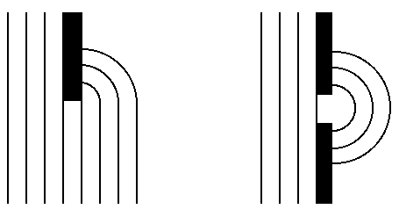When light hits the edge of a barrier it will bend around it. If the barrier is small compared to the wavelength of light the light will pass the barrier uninterrupted. Like water flowing around a buoy. But, if the barrier is large compared to the wavelength of light the waves will bend around the edge of the barrier in a circular fashion. Imagine water waves hitting the end of a jetty, or going through a hole in a jetty.

Huygen’s Principle: Every point on a wave front can be considered as a source of tiny wavelets that spread out in the forward direction at the speed of the wave itself. The wave front is formed by the constructive interference of the circular wavelets.

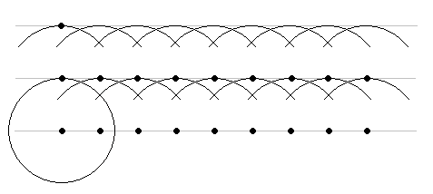So, if the barrier has a hole in it, the particles of the wave create new circular wave fronts when they exit on the other side. This is why you get the circular patterns shown on the previous page.

The particles of light that create this diffraction pattern are the photons. Each photon generates circular wave fronts that constructively interfere to generate linear wavefronts.

##### **Slit Width**: If waves move thru an opening or slit the circular wave pattern is more pronounced when the slit is small.

### ***Young’s Double Slit Experiment***

Uses ***monochromatic*** light source to since white light consisting of all the colors would result in a rainbow refraction. Light showed the same characteristic pattern as water waves and is ***evidence that light behaves as a wave***.

Light from two slits interferes with each other. As a result you get dark and light bands if the pattern is shown on a screen.

Interference Fringes  

m =3

Dark

Light

Dark

Light

***xm***

***L***

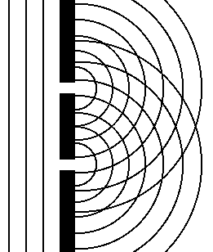

***m*** = 0

***m*** = 1

***m*** =2

***d***

***θ***

***L***

d is the distance between the slits.

m is the fringe number. m = 0 is the central maximum. It is also the path difference in wavelengths.

Whole numbers are used for the bright Constructive Interference Fringes. m = 0.0, 1.0, 2.0, 3.0, etc.

Half numbers are used for the dark Destructicve Interference Fringes. m = 0.5, 1.5, 2.5, 3.5, etc.

θ is the angle from the midline (from the middle fringe)

L is the distance from slits to the screen.

xm is the distance from the midline (center fringe) to the fringe being measured.

Thin Films: Reflection revisited. Most people are familiar with the rainbow effect seen when a thin oil or soap film is floating on top of water. The thickness of the film, and the density of the substances work together to cause this effect.

***A reflected ray will change phase by 180o when going from a medium with a low n to a medium with a high n.***

***If oil is suspended on water.*** Light moving from air to oil hits a higher ***n*** and is reflected with a 180o phase change. Light moving from oil to water hits a smaller ***n*** and its phase is unaltered.

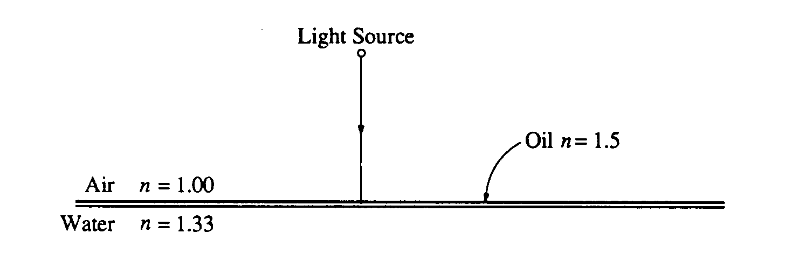

For what wavelengths in the visible spectrum will the intensity be a maximum in the reflected beam?

Maximum intensity occurs when waves reflecting off the oil and those reflecting off the water join and constructively interfere. The waves reflecting off the oil have their phase changed by 180o. Those reflecting off the water follow the same wave pattern out as they did in. To meet with the rays reflecting off the oil they need to go ½ a wavelength (or a multiple of ½) and then rebound traveling back the same distance. So they must travel a total of 1, 2, or 3, … wavelengths (***m*** wavelengths). So if the film is 1x10-7 *m* thick, what wavelengths will results in maximum intensity.

Needs to travel ½ wavelength to match other wave

# Reflected rays constructively interfere



Any multiple of 200 *nm* will result in maximum intensity.

 where ***m*** is an integer. The rainbow effect depends on where you are standing in relation to the light source. Remember refraction is also happening for the light entering the oil. And the colors are separating with blue bending more. And the oil may not have the exact same thickness everywhere. So a rainbow pattern is seen, which depends on a combination of all these factors.

Day 27

Coffee Filter Drag

EQUPMENT:

10 coffee filters

Timer on phone

Go to <https://incompetech.com/graphpaper/lite/> for printable graph paper

PROCEDURES:

1. From the height of 3 feet time the drop of a coffee filter. Calculate the terminal velocity (coffee filters reach terminal velocity in less than 0.05s) Repeat adding 1 coffee filter each time until you have dropped all 10 simultaneously.

2. Construct a Mass v Terminal Velocity Graph.

CONCLUSIONS:

1. How is density and terminal velocity connected? Explain.

2. What errors, which are very small, were a part of this lab?

3. What lifesaving equipment uses the principles from this lab?

**Day 28 - Rates of Diffusion**

**1. Equipment**

Obtain 3 different colors of food coloring

Stopwatch on phone

Ruler

Thermometer

Go to <https://incompetech.com/graphpaper/lite/> to print free graph paper.

3 bowls of water: #1 very cold water (ice water), #2 warm water, #3 Very hot water (be caerful)\

**2. Procedure**

a. determine which bowl is which (label)

b. measure the determine which bowl is which (label)\

c. place the thermometer in each boand recoddwl starting in the ice water and ending with hot, measuring their temperature and record.

d. Put a drop of food color in the center of each bowl and time how long it takes to diffuse tom the edge of the bowl.

**3. Conclusions**

Write a statement that explains the results.

**Day 29**

**METEOR IMPACT!**

**Equipment:**

Ruler, yard stick, 3 different sized marbles or pebbles, 2 or more cups of flour, camera, and steel bowl.

**Hypothesis:**

1. Which combination of , marble and height will make the biggest crater?, Why?

**Procedure:**

1. Pour the flour in the bowl and tap the bowl until the flour is nearly level.

2. Make a table. (crater sizes, marble size of and the height it dropped). 3. Start dropping each marble from 1 foot into the center of flour.

4. Repeat with the various sizes of marbles (or pebbles).

5. Increase height by 1 foot and repeat. Continue until all are dropped from every height.

6. Make a table of **crater sizes**, **marble size** of and the **height it dropped**.

**Conclusions:**

1. Which pairings of marble size and height had the same size crater?

2. Which paring created the largest crater?

3. Referring to the previous question, name two reasons it caused the largest crater.

4. If the marble was traveling at an angle, what evidence for that might you find?

Physics Day 30 Energy Worksheet I Name:

Date: _____________ Per:

* Draw Energy Pie Charts for each position.

* Label each section in the pie chart with the appropriate energy label.

* If more than one energy, the pies should be divided up as accurately as possible to match that positions energy division.

1. A ball is held above the ground, and then is dropped so it falls straight down. The last position is just BEFORE the ball hits the ground. (Ignore air resistance.)

A

B

A B C

C

2. A ball swings on a string.

A B C

3. A baseball is thrown straight up in the air with an initial velocity of Vo at point A.

(Ignore air resistance.)

C

B

D

A

A B C D

4. A wind up car is wound up, and initially at rest. It is released and takes off, but eventually comes to a rest.

A

C

B

A B C

5. A ball is at rest on a compressed spring. Then the spring in released and the ball is shot upward. The last position is the highest point the ball reaches. (Ignore air resistance.)

C

B

A B C

A

6. A superball is dropped from rest and bounces up and down. At each ground position the ball is at rest. (Ignore air resistance.)

C

A

A B C D

D

B

7. A piece of clay is dropped from rest to the floor.

A

B

A B C

C

8. A cart starts from rest at the top of a ramp. It rolls down the ramp and on to a level floor where it rolls to a stop due to friction.

B

D

C

A

v = 0

A B C D

9. A cart is rolling along with an initial speed, and runs into a spring, compresses the spring, and comes to a stop.

A B

A B

**Day 31 - Rates of Diffusion**

**1. Equipment**

Obtain 3 different colors of food coloring

Stopwatch on phone

Ruler

Thermometer

Go to <https://incompetech.com/graphpaper/lite/> to print free graph paper.

3 bowls of water: #1 very cold water (ice water), #2 warm water, #3 Very hot water (be caerful)\

**2. Procedure**

a. determine which bowl is which (label)

b. measure the determine which bowl is which (label)\

c. place the thermometer in each boand recoddwl starting in the ice water and ending with hot, measuring their temperature and record.

d. Put a drop of food color in the center of each bowl and time how long it takes to diffuse tom the edge of the bowl.

**3. Conclusions**

Write a statement that explains the results.