Portfolio: PEP Plans
Go to EHS website
-Click on Career Concentrations

-Discuss CTE vs. Non-CTE Options

-Use at least one PEP as an example to explain:
-explain required courses and elective courses.
-College Entrance Exams
-Career Plans
-Postsecondary Plans
-Signatures
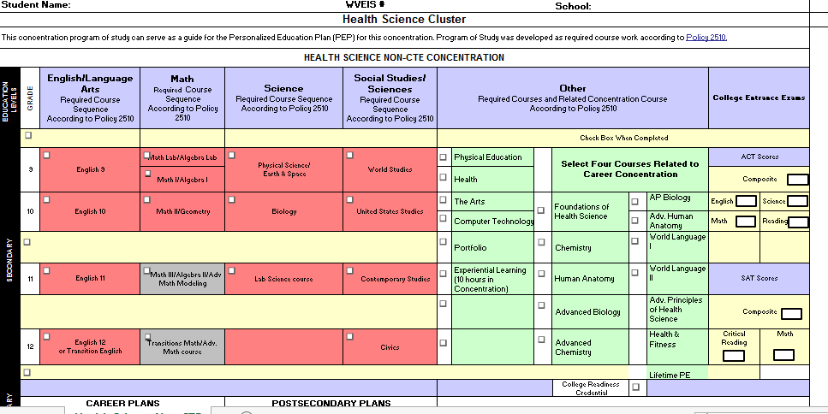
-Ask students to log on to a computer and select PEP plans.
-Take a count of how many for each concentration or send a sign-up sheet around that students write down their concentrations for you to print for them to fill out required parts for their grade level and get signatures.
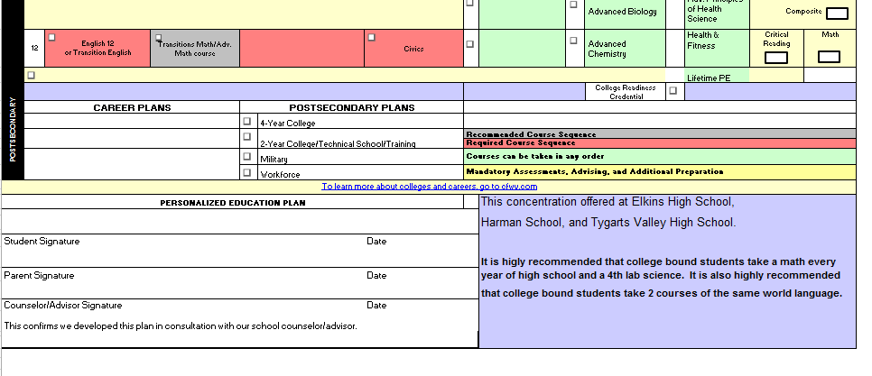
-Set a due date for the return of the PEP Plan (students will need time to upload Plan to portfolio next work day.

